The accompanying image can be downloaded here:
https://publitekltd.sharepoint.com/:f:/s/PublitekFTP/IgDvA9i7XD3iS6V0N4A8pu_VASE6E4iHKBcL-TpIXQ-BCrk?e=v8K18Z

BEUMER Group launches BEUMER robotpick to transform inbound parcel automation

- BEUMER robotpick automates 99.9% of bulk parcel picking and singulation for more efficient CEP operations.
- Already proven in live customer environment: BEUMER robotpick has processed 1.75 million parcels.
- Modular, scalable automation helps operators adapt quickly to changing parcel volumes and diverse parcel streams.
- Fully autonomous end-to-end BEUMER solution integrates seamlessly with existing parcel handling systems and is backed by comprehensive lifecycle support.

Beckum, Germany, 23 September 2026 – Increasingly diverse parcel streams and persistent labour shortages are creating new operational challenges for courier, express and parcel (CEP) operators, with growing parcel volumes placing even greater pressure on existing processes. To help address these challenges, BEUMER Group has launched BEUMER robotpick, a fully autonomous robotic picking and singulation solution capable of automating 99.9% of bulk parcel handling with the correct parcel mix and operating conditions. This addresses one of the most labour-intensive stages of parcel processing while improving operational flexibility and reducing operating costs. Already proven in a live customer environment, BEUMER robotpick has processed more than 1.75 million parcels.
As the latest addition to BEUMER Group's end-to-end parcel automation portfolio, BEUMER robotpick has been developed to help CEP operators overcome one of the key challenges in modern parcel hubs: dynamically transforming unpredictable bulk parcel streams into a continuous flow ready for automated sortation. By combining autonomous robotic picking, intelligent parcel singulation and seamless downstream induction, BEUMER robotpick automates 99.9% of bulk parcel handling, reducing reliance on manual labour while enabling operators to maintain efficient parcel flows despite changing parcel mixes and seasonal fluctuations.
BEUMER robotpick combines BEUMER Group's proprietary computer vision, intelligent robot control and adaptive vacuum gripping technology to identify, pick and place a wide variety of parcels, including cardboard boxes, carton bags, polybags and letters. Designed specifically for the dynamic nature of CEP operations, the system continuously adapts its picking strategy to different parcel sizes, shapes and packaging types, maintaining a continuous parcel flow for downstream processing. Each robot cell can process up to 1,600 parcels per hour¹, with multiple cells working together to provide the flexibility to match capacity to operational requirements.
Automation that scales with demand
Unlike conventional automation systems with fixed capacities, BEUMER robotpick has been designed with scalability at its core. Its flexible system architecture enables integration into a wide variety of parcel hub layouts, supporting different conveyor configurations and destination belt arrangements without compromising operational performance.
The modular solution can be configured with between one and four robot cells as standard configuration on a single bulk feeding line, with further cells added as demand grows, providing a clear pathway for future expansion. Each robot cell operates independently, allowing maintenance, software updates or servicing to be carried out without stopping the remaining cells, maximising system availability and operational resilience.
BEUMER robotpick has also been engineered to handle the realities of modern parcel operations. Intelligent recirculation and automated handling of non-pickable items minimise operational interruptions and maintain continuous parcel flow, reducing the need for manual intervention. Dynamic robot movements automatically adapt to different parcel sizes, shapes and packaging types, helping maintain consistently high picking performance across mixed parcel streams.
"Parcel operations are becoming more demanding every year," said Mathias Höwer, Global Sales & Systems Director, BEUMER Group. "It's not simply a question of processing more parcels. Operators must also manage far greater variation in parcel sizes, shapes and packaging, while dealing with ongoing shortages of skilled labour. BEUMER robotpick has been developed specifically to meet these challenges. It brings autonomous picking and singulation to one of the most labour-intensive parts of the parcel handling process, helping operators build more resilient, adaptable operations while allowing skilled employees to focus on higher-value tasks. As a fully integrated BEUMER solution, it also gives customers the confidence of working with a single partner throughout the entire system lifecycle."
An integrated approach to parcel automation
Unlike solutions assembled from multiple suppliers, BEUMER robotpick has been developed as an integrated solution, bringing together a BEUMER-owned vision system, robot controls, vacuum technology, parcel feeding and system interfaces. The result is seamless integration with BEUMER's wider parcel automation portfolio, enabling customers to benefit from a single, fully supported solution encompassing hardware, software and lifecycle services. The system also integrates operational monitoring through BEUMER SCADA and data-driven maintenance insights via BG Insight, helping customers maximise performance while reducing scheduled maintenance requirements.
Proven performance in live CEP operations
BEUMER robotpick is already proven in a live customer environment, having processed more than 1.75 million parcels. It has demonstrated the ability to automate 99.9% of bulk parcel singulation processes².
The launch of BEUMER robotpick further strengthens BEUMER Group's ability to deliver integrated automation solutions across the entire parcel handling process, from bulk induction and robotic singulation through to high-performance sortation and final dispatch. Supported by comprehensive lifecycle services, including data-driven performance analysis, system optimisation and predictive maintenance, BEUMER Group helps CEP operators maximise system availability, optimise operational performance and reduce total cost of ownership throughout the lifecycle of their parcel handling systems.
ENDS

Notes to editors:
- Performance depends on parcel mix, flow consistency and operational configuration.
- The figure of 99.9% automated bulk parcel singulation is based on BEUMER Group customer trials under representative operating conditions. Actual performance depends on parcel mix, parcel characteristics and operational configuration.
6218 characters (including spaces)

Captions:

Image 1:
BEUMER robotpick for dynamic picking of bulk items

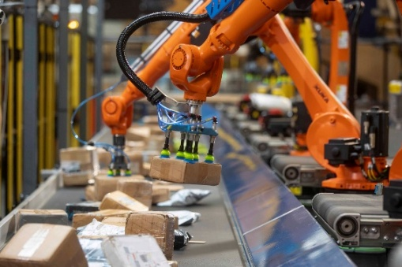

Image 2:
Fully autonomous robotic picking and singulation

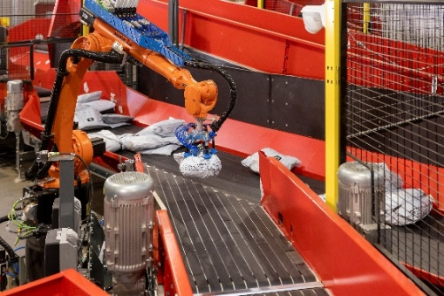

Photo Credit: BEUMER Group GmbH & Co. KG
Click here to download a high-res version of the image.

About BEUMER Group
BEUMER Group is a global manufacturer of material handling solutions. As a third-generation family-owned business, the company offers high-quality system solutions and comprehensive customer support worldwide and is a “Partner of Choice” for the mining, cement, building materials, petrochemical, consumer goods, postal, e-commerce, fashion, and baggage handling industries. With around 6000 employees worldwide, BEUMER Group generates an annual order intake of around 1.83 billion euros. In line with the company motto "Made Different", BEUMER commits to the highest standards of quality, innovation and sustainability. For more information, please visit www.beumer.com

Press Contacts
Peter Elmvang: Phone + 45 (0) 2721 43 61, Mail: peter.elmvang@beumer.com
Carsten Otte (Agency): Phone +49 (0) 4181 9273594, Mail: carsten.otte@pretzl.com

