The accompanying image can be downloaded here:
https://publitekltd.sharepoint.com/:i:/s/PublitekFTP/IQAirBvSQkNCTaP7Oapo1L-WAegFcWx9lP07E-Svibi21Rg?e=Zje2Ml

Tradition meets “Made Different” – BEUMER Group becomes main partner of FC Gelsenkirchen-Schalke 04 e.V.

- Long-term partnership: Main and jersey partnership starting in the 2026/27 season, running through at least 2029, valid for all professional leagues
- Shared values: Two traditional brands with strong regional roots and a distinct approach
- Regional commitment: Industry and football jointly creating opportunities for the region and its people
Beckum, 22 April 2026 – BEUMER Group has entered into a multi-year partnership with FC Schalke 04. Starting with the 2026–27 season, the family-owned company based in Beckum will become the Royal Blues' main and jersey partner. The agreement runs until at least 2029 and applies to all leagues. This long-term partnership is based on shared values and strong regional ties.

“BEUMER Group and Schalke 04 are a perfect match. We share fundamental values such as reliability, hard work and innovation. Both partners have a strong regional identity that remains evident to this day. With great ambition and absolute passion, the BEUMER Group and Schalke 04 successfully hold their own against fierce competition in their respective business sectors,’ says Matthias Tillmann, Chairman of the Executive Board of FC Schalke 04. "BEUMER Group has locations in more than 70 countries and is a champion in its field. We are proud to have such a strong partner on our jerseys in future.”
As a family-run business with a 90-year history, BEUMER Group follows its own unique path under the slogan "Made Different". This approach prioritises long-term thinking and responsible action over short-term trends and has shaped the company’s development over the decades, forming the basis for partnerships that prioritise substance and sustainability over expediency.

Two strong brands with shared roots
Both BEUMER Group and FC Schalke 04 have deep roots in the region and a history shaped by industrial change. BEUMER Group started out in 1935 as a manufacturer of conveyor technology for the local cement industry and mining sector. The company shares part of its history with the 'Knappen', who were once established in the shadow of the Consolidation Colliery, through its work in underground and opencast mining. Together, the two partners can look back on more than 200 years of history.

"Our family, our company and Schalke 04 have a long-standing connection. We started out 90 years ago manufacturing conveyor technology for the mining industry, so we are familiar with the strong, unifying values of the Ruhr region's culture. Hans Klodt, who played as a goalkeeper for Schalke 04 for ten years, also worked for us for a further twenty-five years. ‘Reliable’, ‘down-to-earth’, ‘ambitious’ and ‘collaborative’ – these four values form the foundation of the corporate culture that we live by”, says Dr Christoph Beumer, BEUMER Group’s Chairman of the Advisory Board, when describing the partnership.

In challenging economic and social times, stability is becoming an increasingly important factor for success. While many companies are scaling back or relocating their investments, BEUMER Group is firmly committed to the region and Germany as a business location. This sense of responsibility and continuity is also reflected in the partnership with FC Schalke 04: transcending league standings and based on the belief that we will overcome the challenges together. “Schalke 04 has enormous emotional appeal,” says Dr Christoph Beumer. “We want to live this partnership. You win and lose together. That is precisely what makes it credible and strong.“

Regional strength with an international outlook
BEUMER Group is an independent third-generation family-owned business that ranks among the world's leading providers of material handling solutions, headquartered in Beckum.
With over 6,000 employees in more than 70 countries worldwide, BEUMER Group now offers a broad portfolio: From conveying and loading systems for bulk materials, through palletising and packaging systems for bagged goods, to sorting and distribution systems for parcels, baggage and other general cargo, BEUMER Group serves sectors such as mining, the cement and building materials industry, the petrochemical industry, courier, express and parcel (CEP) services, e-commerce and logistics sectors, as well as airports around the world. Although the company has a global focus, its headquarters in Beckum remain at the heart of the business, symbolising its close ties to the region.

Innovation is a central component of the company’s strategy. Alongside in-house development, BEUMER Group actively seeks partnerships and new formats, such as through its company builder, BEAM, based in Berlin. The aim is to build on existing foundations and adapt them for the future.

FC Schalke 04 also stands for successfully combining tradition and innovative strength, as demonstrated by its consistent development of football, youth talent, and the comprehensive Schalke experience. The club's established identity and history form the basis for building on what already exists and shaping the future. “This partnership highlights our commitment to the region while raising our company’s profile,’” says Rudolf Hausladen, CEO of BEUMER Group. “As a global material handling solutions specialist, we need people who take responsibility and help shape the future with conviction. Schalke 04 and its fans embody precisely this attitude.”

A partnership that makes a difference – on and off the playing field
This collaboration is a key element in strengthening the region. FC Schalke 04 has always brought people from all backgrounds together as a community, standing for solidarity and a sense of belonging. This unifying force meets a company that offers long-term prospects: for customers, partners and all employees worldwide.

For the BEUMER Group, this partnership sends a clear message both internally and externally, as it stands for reliability, team spirit and a commitment to actively shaping the future – rooted in the region, yet with an international outlook.

Tradition meets 'Made Different'. Two partners who draw on their history to take responsibility and look to the future together. The regional strength and solidarity of both partners creates genuine local pride and a strong sense of community.

Caption:
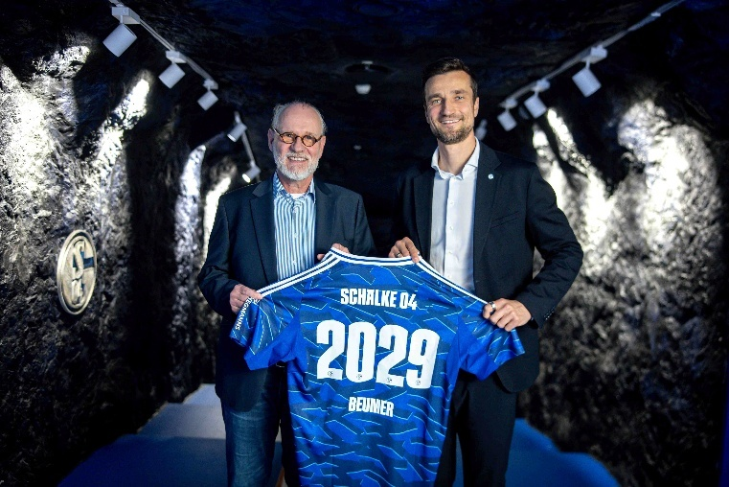
Image 1: BEUMER Group and FC Schalke 04 announce a new main sponsorship partnership from the 2026/27 season. From left to right: Christoph Beumer, BEUMER Group’s Chairman of the Advisory Board, and Matthias Tillmann, Chairman of the Board of FC Schalke 04

Photo Credit: BEUMER Group GmbH & Co. KG
Click here to download a high-res version of the image.

About BEUMER Group
BEUMER Group is a global manufacturer of material handling solutions. As a third-generation family-owned business, the company offers high-quality system solutions and comprehensive customer support worldwide and is a “Partner of Choice” for the mining, cement, building materials, petrochemical, consumer goods, postal, e-commerce, fashion, and baggage handling industries. With around 6000 employees worldwide, BEUMER Group generates an annual order intake of around 1.83 billion euros. In line with the company motto "Made Different", BEUMER commits to the highest standards of quality, innovation and sustainability. For more information, please visit www.beumer.com

Press Contact
Jonas Jungmann: Phone + 49 (0) 151 70226871, Mail: jonas.jungmann@beumer.com

