BEUMER Group at MODEX 2026 (13–16 April): Atlanta, GA, Booth B8713

BEUMER Group Highlights Scalable Sortation Strategies for Operational Resilience at MODEX 2026

- Sortation solutions enable operations to scale without overinvestment
- Insights into the latest automation and software solutions
- Celebrating 90 years of shaping the future of high-speed sortation

Somerset, NJ USA, 31 March 2026 – Logistics companies are facing persistent pressure to increase efficiency and predictability as customer expectations for rapid and reliable service continue to rise. BEUMER will use MODEX 2026 (April 13–16, Atlanta, GA, Booth B8713) to demonstrate how data-driven sortation solutions can help warehousing, fulfillment, and distribution businesses increase resilience under pressure.

Marking 90 years of shaping the future of high-speed sortation, the company will showcase a portfolio of data-driven sortation and automation solutions designed to adapt to fluctuating volumes and ongoing labor challenges. Through interactive presentations and dynamic discussions with in-house experts, visitors will learn how the company’s automation systems, innovative technologies, and dedicated support make BEUMER a true partner of choice.

Reliable, Capable Partner for Conveying and Sortation Solutions
As BEUMER marks 90 years of business, the company is highlighting its capability, expertise, and experience as a reliable partner customers can count on to deliver turnkey conveying and sortation solutions. BEUMER is a pioneer in high-speed sortation technology, using its proprietary, state-of-the-art cross-belt technology, designed, manufactured, and implemented with in-house expertise. In North America alone, BEUMER high-speed sortation systems serve customers at more than 100 sites.

“We are well known globally, and especially in North American markets as a quality leader, assuring robust and reliable cross-belt technology deployments," says Markus Schmidt, CEO & President, BEUMER Corporation. "Our customers trust us when it comes to automating their high-speed sortation operations, as our technology delivers and our company culture supports successful implementation."

MODEX attendees will be able to explore BEUMER's offerings and receive guidance from its experts on selecting sortation technologies that match their operational needs. The team will also share insights into modular sortation approaches that enable phased expansion, as well as the benefits of integrated solutions within a collaborative ecosystem.

Visitors will also be able to learn about the BG Pouch System for high-throughput sequencing and returns handling, and software tools that provide real-time operational insights. The company will also highlight its comprehensive Customer Support, combining on-site services, advanced diagnostics, and proactive lifecycle management to help ensure continuous system availability and long-term operational performance.

Building for peak performance seminar
BEUMER Group will host a seminar on Monday, April 13, at noon in Theatre I. The 45-minute session, led by Vishal Ahuja, Director of Sales, and Perry Fourrier, Senior Sales Manager Parcel, reveals how leading operations use sortation as a central element to manage complexity at scale.

Titled “The Sortation Backbone: How Top Companies Outperform at Peak,” the seminar is ideal for companies approaching or operating at higher throughput who need to understand how modern sortation and storage automation stabilize operations before peak breaks them. It will explore how automation systems – including loop sorters, pouch systems, and line sortation – can help:
- Maintain speed and accuracy in omnichannel fulfillment
- Handle rising returns volumes more efficiently
- Stabilize outbound flows despite demand fluctuations
- Optimize labor use in constrained environments

Drawing on real-world applications, this session will demonstrate how the right sortation approach reduces operational friction and enables more predictable performance during peak periods.

Moving forward
As BEUMER Group celebrates 90 years of innovation, its focus remains firmly on the future and helping customers build systems that can evolve alongside their operations. MODEX attendees are invited to stop by booth B8713 on Monday, April 13, from 3:00–5:00 p.m., to celebrate nine decades of progress and discuss how we can continue to move the industry forward.

4,379 characters (including spaces)

Captions:
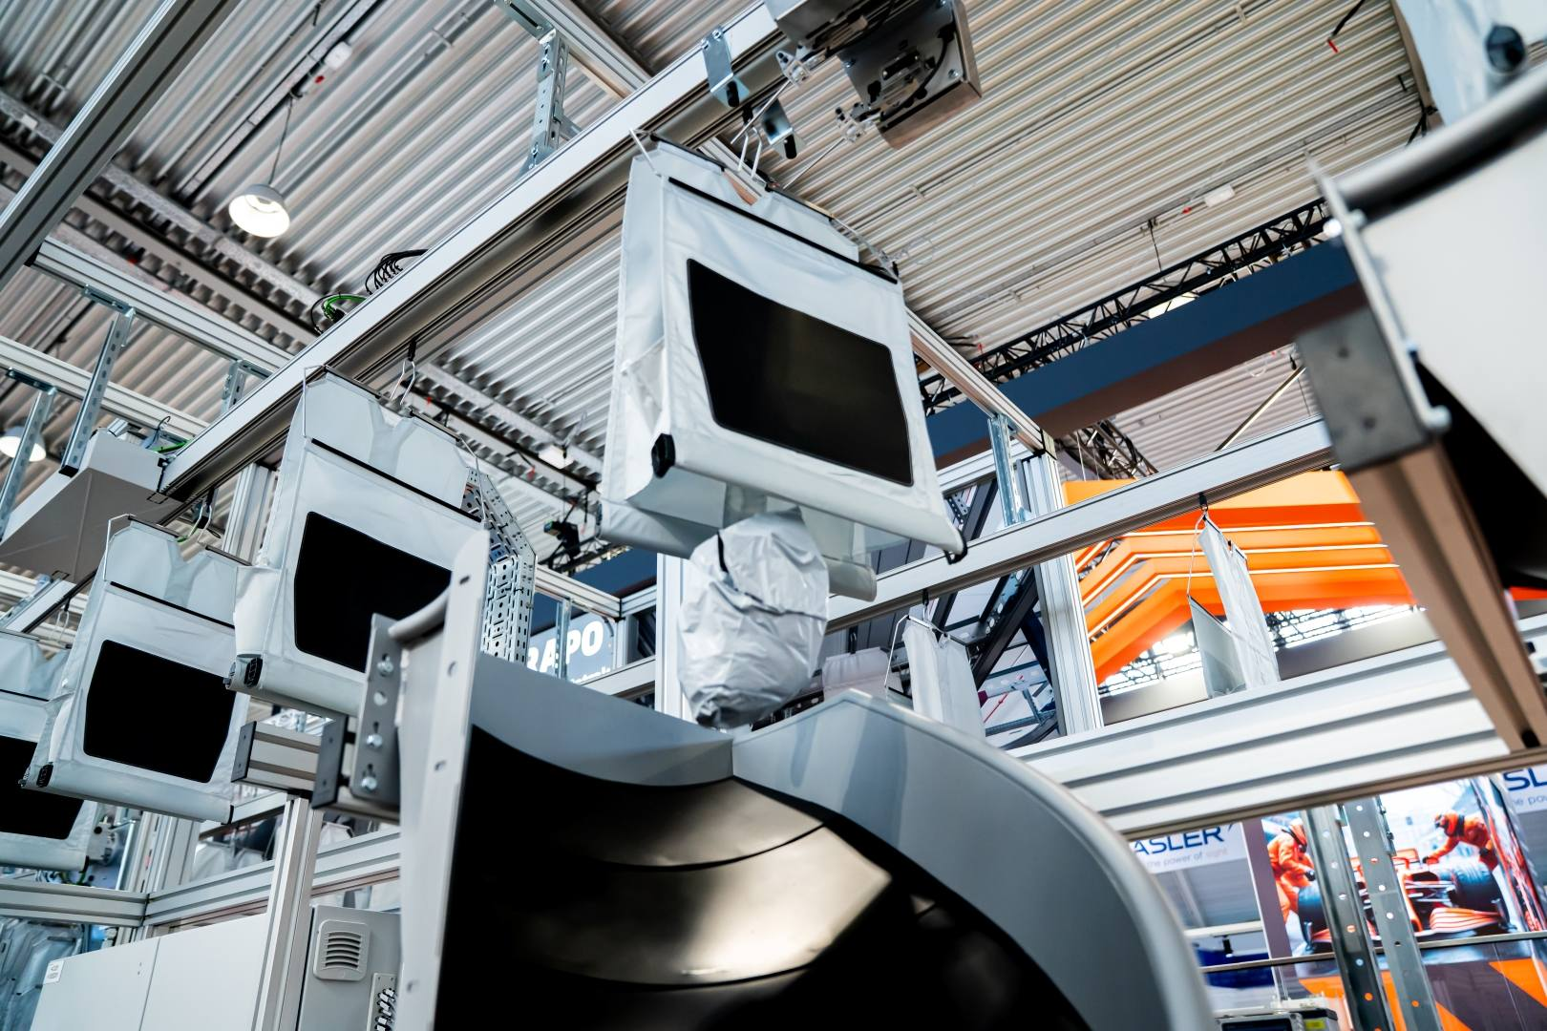
Image: BG Pouch System enables higher throughput and efficient returns handling.

Photo Credit: BEUMER Group GmbH & Co. KG
Click here to download a high-res version of the image.

About BEUMER Group
BEUMER Group is a global manufacturer of material handling solutions. As a third-generation family-owned business, the company offers high-quality system solutions and comprehensive customer support worldwide and is a “Partner of Choice” for the mining, cement, building materials, petrochemical, consumer goods, postal, e-commerce, fashion, and baggage handling industries. With 6,000 employees worldwide, BEUMER Group generates an annual order intake of around 1 billion euros. In line with the company motto "made different", BEUMER commits to the highest standards of quality, innovation and sustainability.
For more information, please visit www.beumer.com

Press Contact
Jackie Sessler: Phone +1 (816) 245-7262, Mail: jackie.sessler@beumer.com
Carsten Otte (Agency): Phone +49 (0)4181 968098 80, Mail: carsten.otte@pretzl.com

