The accompanying images can be downloaded here:
https://publitekltd.sharepoint.com/:f:/s/PublitekFTP/IgBwzykvQL2zSIuVaJigDlacAWRPOtGnLTgrNxX03-JBh5A?e=SamSJY

BEUMER Group inaugurates new state-of-the-art manufacturing facility in Taicang, China
Multi-million-euro investment strengthens BEUMER’s global manufacturing network and deepens commitment to China, while BEUMER China celebrates 20 years

Taicang, China – 8 January 2026 – BEUMER Group, a leading provider of material handling solutions, has officially opened a new state-of-the-art manufacturing facility in Taicang, China, marking a major expansion of the company’s presence in China. The grand opening ceremony on 10 December 2025, held in Taicang, coincides with BEUMER China’s 20th anniversary and the BEUMER Group’s 90th anniversary globally. This new high-tech plant is set to significantly enhance BEUMER’s global production capabilities and underscores the family-owned company’s long-term commitment to the Chinese market.

The newly inaugurated Taicang facility occupies a land area of about 33,350 square meters, with a built-up manufacturing space of roughly 23,000 square meters across two large-scale workshops and additional auxiliary facilities. Construction was completed in an exceptionally swift timeframe of just 12 months – from the start of ground works in July 2024 to the handover in June 2025. This rapid execution was made possible through efficient project management and strong support from local authorities in Taicang, enabling BEUMER to bring its vision to reality on schedule. The new site is now fully integrated into BEUMER’s global manufacturing network, allowing the company to serve customers across Asia-Pacific and worldwide more efficiently from China. As part of establishing this new base, BEUMER Group also set up two new Wholly Owned Foreign Enterprises (WOFE) in Taicang, China, to anchor its expanded operations, reflecting a deepening of local operational roots.

“This opening is a proud moment for our team in China and for BEUMER Group as a whole,” said Rudolf Hausladen, CEO of BEUMER Group, during the opening ceremony. “It is a great pleasure to celebrate our new Taicang facility in the presence of the local leadership of Taicang and Suzhou – especially as it coincides with 20 years of BEUMER in China and 90 years of BEUMER globally. We believe this state-of-the-art manufacturing facility strengthens our ability to serve our customers in China and the region with even more responsive support and innovation. As a family-owned business, we think in decades, not quarters, and this investment reflects our confidence in the continued growth and long-term partnership with our customers and the community here in China.”

Two decades of growth for BEUMER China: The inauguration of the Taicang facility comes as the capstone to BEUMER China’s 20-year growth journey. Established in 2005, BEUMER’s presence in China began with delivering a single product line. Over the past two decades, the company’s footprint in China has expanded steadily into a comprehensive organization that delivers a full portfolio of solutions across multiple industries, including airport baggage handling systems, logistics systems and overland conveyor systems, as well as equipment for the cement, minerals, and mining sectors. BEUMER China has grown in both scale and capabilities – from a modest start to a workforce of around four hundred today – reflecting the sustained success of BEUMER’s solutions in the Chinese market. This journey illustrates BEUMER’s long-term commitment to China, developing local expertise and infrastructure to support its customers.

Advanced, sustainable manufacturing: The new Taicang facility is designed as a modern, digital manufacturing base that aligns with BEUMER’s global standards for innovation and sustainability. Outfitted with cutting-edge production technology and smart factory principles, the plant will help increase efficiency and ensure high quality across all products manufactured on site. BEUMER Group built the facility with an eye toward sustainability and future readiness, aiming to minimize environmental impact in its operations. By building a modern, eco-conscious production hub in China, BEUMER is aligning with both national and global sustainability goals and ensuring the facility is well-prepared for future industry developments and expansions.

Commitment to long-term partnership: By investing in local manufacturing and embracing advanced digital production techniques in China, BEUMER is strengthening its role as a long-term partner to customers in the region, offering them not only technologically advanced solutions but also the reliability of local support and supply. The company’s approach in China – as in other markets – is to build enduring relationships: with customers who can count on world-class products and services, with employees who benefit from growth and development opportunities, and with local communities and authorities who find in BEUMER a committed, responsible corporate citizen. Rudolf Hausladen noted that the foundation built over the past twenty years in China has been critical to the company’s success: “Our journey in China has always been about building trust and delivering excellence. This new facility is not just an investment in production capacity; it’s an investment in the next decades of partnership with our customers and in the development of our BEUMER footprint in China.”

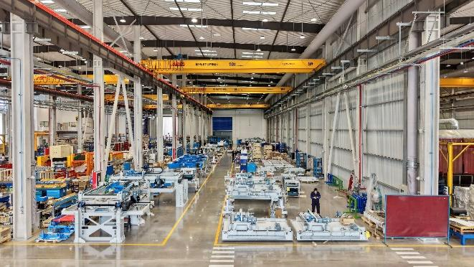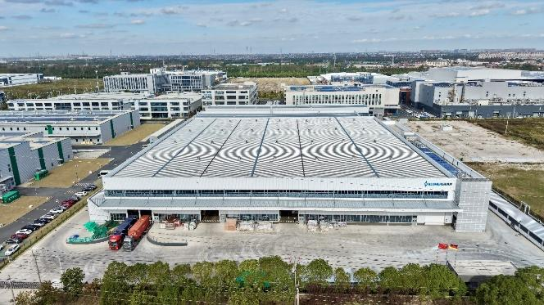
Caption 1: New facility in Taicang, China, strengthens BEUMER’s global manufacturing network
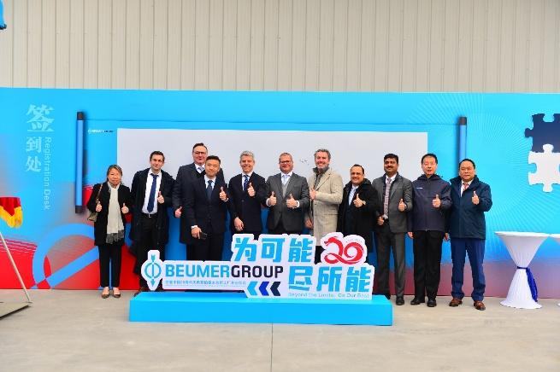
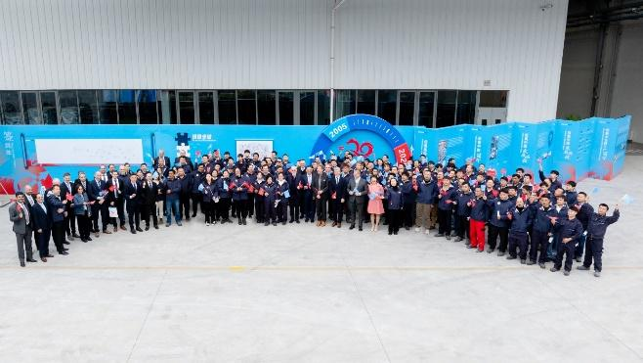
Caption 2: Official opening of the factory in the presence of BEUMER Group management & employees
Photo credits: BEUMER Group GmbH & Co. KG
Click here to download a high-res version of the images.
About BEUMER Group
BEUMER Group is a global manufacturer of material handling solutions. As a third-generation family-owned business, the company offers high-quality system solutions and comprehensive customer support worldwide and is a “Partner of Choice” for the mining, cement, building materials, petrochemical, consumer goods, postal, e-commerce, fashion, and baggage handling industries. With around 6,000 employees worldwide, BEUMER Group generates an annual order intake of around 1.7 billion euros. In line with the company motto "made different", BEUMER commits to the highest standards of quality, innovation and sustainability. For more information, please visit www.beumer.com

Press Contacts
Jonas Jungmann (Press):
Tel.: + 49 (0) 151 70226871
Mail: jonas.jungmann@beumer.com
Verena Breuer (Trade Press):
Tel.: + 49 (0) 151 14781593
Mail: verena.breuer@beumer.com

