LogiMAT 2026: BEUMER Group focuses on innovation, automation and data-driven Customer Support
- Building on its theme "Your Partner of Choice", BEUMER Group presents high-quality, integrated solutions for efficient order fulfilment in modern distribution centers.
- The Innovation Corner brings together industry experts to discuss current developments in robotics, software and data analysis.
- The stand features a live demonstration of the BG Pouch System with AutoDrop, alongside insights into robot-assisted loading, intelligent software solutions and data-driven diagnostic concepts, showing the seamless interaction of modern intralogistics technologies.

Beckum, 6 January 2026 – At LogiMAT 2026 in Stuttgart, BEUMER Group presents innovative technologies and integrated concepts (Hall 5, Stand 5C51) designed to enhance efficiency and future-proof warehousing and distribution operations. Visitors can see the solutions in action through live demonstrations and explore current trends and future developments in intralogistics with BEUMER Group experts at the Innovation Corner.
Innovation is deeply embedded in BEUMER Group's DNA and drives the company's strategic direction. The company invests in new technologies, digital business models and continuous portfolio development to anticipate the evolving needs of the intralogistics industry. The Innovation Corner at LogiMAT 2026 brings this commitment to life. Visitors can explore the latest advances in robotics, software and data analysis, and discuss the future of warehouse and distribution logistics with BEUMER Group's experts.

System expertise for transparent and efficient logistics
Another highlight at the stand is the live demonstration of the BG Pouch System with AutoDrop function. This combination enables fully automatic and contactless unloading of pouches. As a result, order throughput times are significantly shortened and the space required in the unloading area is reduced. BEUMER Group also demonstrates how robot-assisted loading concepts for pouch and sorting systems integrate seamlessly with intelligent software such as the Warehouse Control System (WCS). The company's stretch hood technology for B2B applications completes the order fulfilment process by providing efficient, sustainable protection for goods in transit thanks to its maintenance-friendly design and environmentally responsible material options.

The BEUMER Customer Diagnostic Center (CDC) provides data-driven support for continuous system optimisation and predictive maintenance. Advanced diagnostic models monitor system performance in real time, flagging potential issues before they become problems. Customer data models update continuously throughout the day, detecting adverse trends early and enabling targeted intervention to prevent downtime. At the exhibition stand, visitors can see how these systems work together to create transparency and efficiency across distribution center operations.

Tailored solutions across industries
BEUMER Group's portfolio directly addresses the specific needs of companies in the fashion, e-commerce, e-pharma, and courier, express and parcel (CEP) services sectors, as well as third-party logistics (3PL) providers. The solutions are designed to overcome the key challenges faced by modern distribution centers, such as the flexible handling of diverse product ranges, the automation of complex sorting and packaging processes, and the reliable system availability that is essential for smooth-running operations.

"The Innovation Corner demonstrates how advanced technology, proven products and deep system expertise come together to deliver real value for our customers," explains Dr Volker Jungbluth, Head of Innovation & Development at BEUMER Group. "We are committed to shaping the future of intralogistics with our partners, developing innovative, scalable solutions that meet their specific requirements."

Captions:
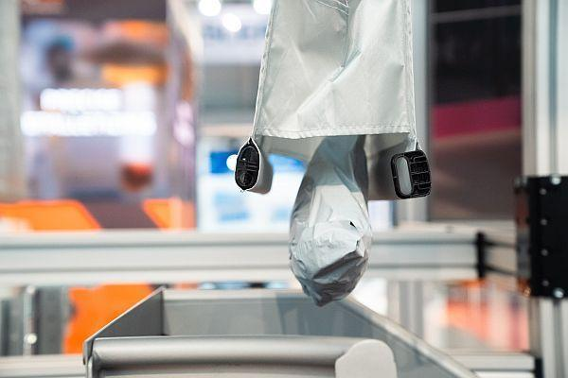
Image 1: The AutoDrop function fully automates the unloading process in the BG Pouch System.

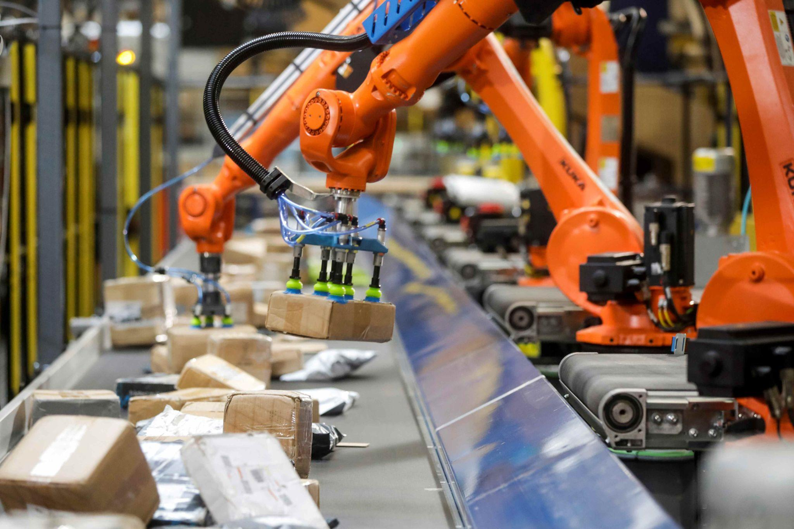
Image 2: Robot-assisted loading eliminates the manual or semi-automatic loading of loop sorters.

Photo credits: BEUMER Group GmbH & Co. KG
Click here to download a high-res version of the images.

About BEUMER Group
BEUMER Group is a global manufacturer of material handling solutions. As a third-generation family-owned business, the company offers high-quality system solutions and comprehensive customer support worldwide and is a “Partner of Choice” for the mining, cement, building materials, petrochemical, consumer goods, postal, e-commerce, fashion, and baggage handling industries. With around 5,700 employees worldwide, BEUMER Group generates an annual order intake of around 1.39 billion euros. In line with the company motto "made different", BEUMER commits to the highest standards of quality, innovation and sustainability. For more information, please visit www.beumer.com
Press Contacts
Jonas Jungmann (Press):
Tel.: + 49 (0) 151 70226871
Mail: jonas.jungmann@beumer.com
Verena Breuer (Trade Press):
Tel.: + 49 (0) 151 14781593
Mail: verena.breuer@beumer.com
Carsten Otte (Agency):
Tel.: +49 (0) 4181 9273594
Mail: carsten.otte@publiktek.com

