BEUMER Group inaugurates new state-of-the-art manufacturing facility in India
Strategic INR 2 billion investment expands BEUMER’s global manufacturing network with first production hub in Reliance MET City, India
- The facility strengthens BEUMER’s global manufacturing network, enabling faster delivery and expanded production for key sectors including airports, logistics, cement, and minerals & mining.
- The expansion marks a major milestone in BEUMER India’s 20-year growth journey and reaffirms the company’s long-term commitment to innovation, reliability, and partnership in India and beyond.

Jhajjar/Haryana, 19 December 2025 – BEUMER Group, a leading provider of material handling solutions, has officially inaugurated a new state-of-the-art manufacturing facility at Reliance’s Model Economic Township (MET City) in Jhajjar, Haryana. The grand opening ceremony on 12 December 2025 marks a major strategic expansion for the family-owned company in India. The high-tech plant – a INR 2 billion investment – is set to significantly enhance BEUMER’s global production capabilities and long-term presence in the region. BEUMER is proud to be the first German company in MET City, an emerging industrial smart city development, underscoring the group’s commitment to India’s growth story.
The newly inaugurated facility occupies a land parcel of 42,508 square meters (over 10 acres) with a built-up manufacturing area of 22,285 square meters. Construction was completed in a remarkably short span of around 15 months – from the project’s foundation stone laying in June 2024 to the start of operations in December 2025. This swift execution was made possible by MET City’s robust infrastructure and support, enabling BEUMER to quickly bring the vision to reality. The new factory will integrate seamlessly into BEUMER’s global manufacturing network, allowing the company to serve customers worldwide more efficiently from India.
"This expansion reflects BEUMER Group’s strategic focus and commitment to long-term success in India. The new production site plays an important part in our global factory footprint, strengthening our position as a quality leader and partner of choice for our customers," said Rudolf Hausladen, CEO of BEUMER Group. Hausladen emphasized that the investment in MET City is a key milestone for the company, enabling BEUMER to better serve its customers with local expertise while upholding the highest standards of quality and innovation.
Two Decades of Growth for BEUMER India
The opening of the Jhajjar facility comes as the culmination of BEUMER India’s impressive growth journey since its establishment in 2003. What began as a modest two-person office in Mumbai has evolved into a dynamic organization with over 400 full-time employees and an annual business volume of EUR 150 million. Over the past two decades, BEUMER India steadily expanded its capabilities across all of BEUMER Group’s business segments. Key milestones included the acquisition of ENEXCO Technologies India (strengthening its cement industry solutions) and FAM India (enhancing offerings in minerals/mining), as well as the launch of a modern manufacturing unit in Naurangpur, Haryana. In 2023, BEUMER India inaugurated a new head office in Gurugram, reflecting its growing footprint. The state-of-the-art Jhajjar plant now adds significant manufacturing capacity, positioning BEUMER India to meet increasing demand and reinforcing the company’s long-term commitment to the Indian market.
Sustainable and Future-Ready Manufacturing
Sustainability and innovation are at the heart of the new facility’s design and operations. BEUMER Group has built the Jhajjar plant to meet best-in-class global standards, aiming for certification by the Indian Green Building Certification (IGBC) – equivalent to the internationally recognized USGBC LEED standard, aligning with national and global ESG goals. The facility is engineered to minimize its environmental impact: it is expected to achieve 20–30% savings in energy consumption and 30–50% savings in water usage compared to conventional industrial buildings. To reach these goals, the site will incorporate renewable energy sources for its power needs.

Expanded Production Capabilities to Serve Global Markets
The new Reliance MET City facility broadens BEUMER’s production capabilities, enabling the company to locally manufacture equipment for all of its major business segments. The plant will produce airport baggage handling systems, logistics conveying and sorting equipment, cement packing and loading machinery, and components for mineral and mining machines. By manufacturing these products in India, BEUMER can better serve local customers with shorter lead times and also support global projects with additional production capacity.

Commitment to Partnership and Excellence
This new chapter in India underscores BEUMER Group’s enduring values of innovation, reliability, and partnership. By investing in local manufacturing and sustainable practices, BEUMER reaffirms its dedication to building long-term partnerships with customers, employees, and local communities. “As a family-owned business, we think in generations, not quarters, and this guides our strategy in India and beyond,” Rudolf Hausladen noted. The Jhajjar facility exemplifies this philosophy, combining cutting-edge technology with a value-driven approach.

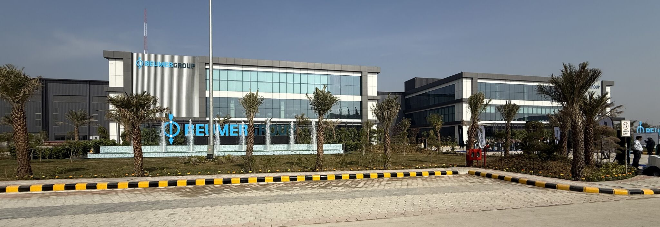Caption 1: New facility in Reliance MET City/Jhajjar strengthens BEUMER’s global manufacturing network
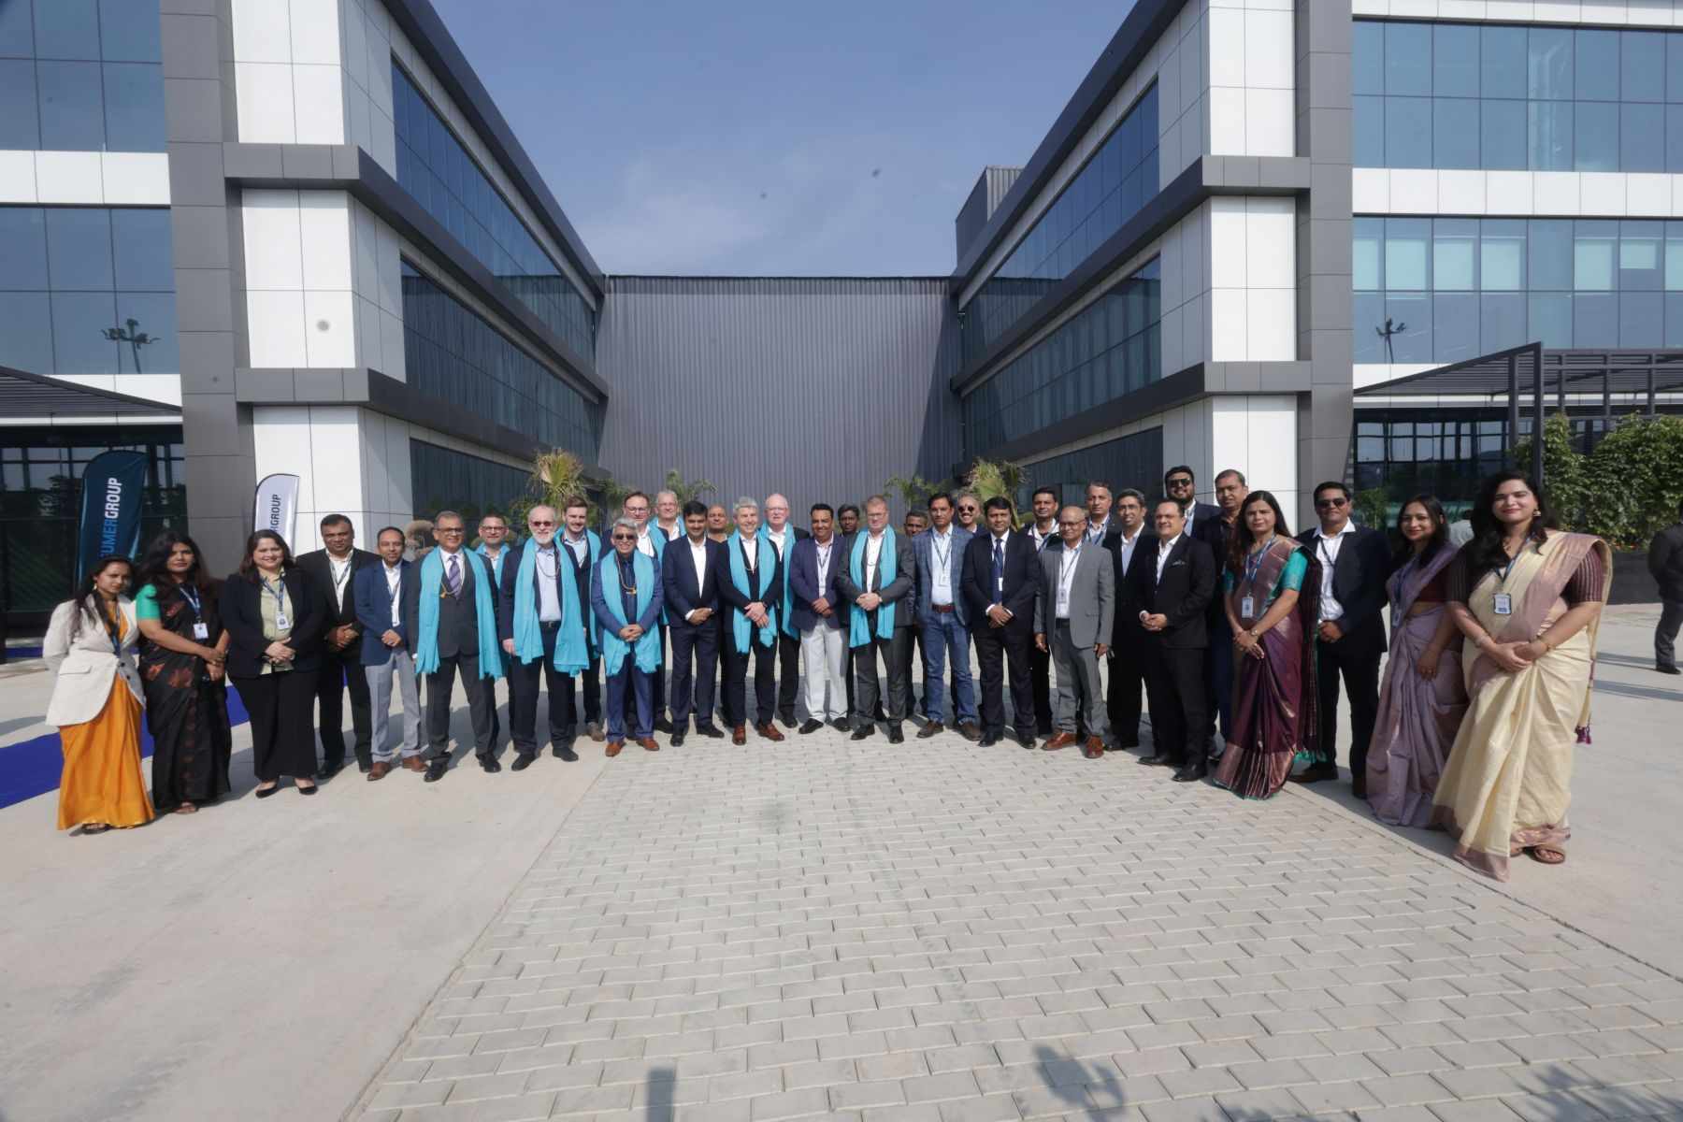Caption 2: Official opening of the factory in the presence of BEUMER Group management
Photo credits: BEUMER Group GmbH & Co. KG

About BEUMER Group
BEUMER Group is a global manufacturer of material handling solutions. As a third-generation family-owned business, the company offers high-quality system solutions and comprehensive customer support worldwide and is a “Partner of Choice” for the mining, cement, building materials, petrochemical, consumer goods, postal, e-commerce, fashion, and baggage handling industries. With around 6,000 employees worldwide, BEUMER Group generates an annual order intake of around 1.7 billion euros. In line with the company motto "made different", BEUMER commits to the highest standards of quality, innovation and sustainability. For more information, please visit www.beumer.com
Press Contacts
Jonas Jungmann (Press):
Tel.: + 49 (0) 151 70226871
Mail: jonas.jungmann@beumer.com
Verena Breuer (Trade Press):
Tel.: + 49 (0) 151 14781593
Mail: verena.breuer@beumer.com

