**BEUMER Group strengthens digital capabilities by bringing Codept and Elara into the corporate fold**

* BEUMER Group brings digital companies Codept and Elara – both developed within its in-house company-builder Beam – fully into the corporate structure
* The integration positions BEUMER to actively drive transformation across the logistics industry alongside its customers
* Customers gain access to enhanced solutions delivering greater efficiency, seamless integration and improved transparency across logistics and maintenance operations.

**Beckum, 4 September 2025 –** **BEUMER Group is bringing two digital companies, Codept and Elara, fully under its corporate umbrella. Both companies were developed within Beam, BEUMER's in-house company-builder. This strategic move represents a significant milestone in BEUMER's innovation roadmap. Codept and Elara have successfully developed cutting-edge products and business models that directly address evolving market demands. By formalising their integration, the intralogistics systems manufacturer is opening new avenues for customers to tackle today's most pressing logistics challenges. Users can expect more streamlined processes, superior digital solution integration and enhanced transparency across their logistics and maintenance operations.**

Launched in 2018, [Beam](https://beamberlin.com/) serves as BEUMER Group's innovation engine and forms a cornerstone of the company's systematic innovation efforts, which are consolidated under the "Innovation & Development" business division. Through Beam, the company has successfully identified, developed and brought innovative business concepts to market readiness. The focus centres on digital products and novel business models that strategically complement the traditional core business whilst delivering genuine value to BEUMER customers.

**Enhanced customer value through efficiency and transparency**

Through [Codept](https://www.codept.de/), Beam's inaugural start-up launched in 2019, BEUMER Group is unlocking significant digital potential within logistics operations. Codept's integration platform seamlessly connects logistics service providers with online retailers, regardless of their existing shop, ERP, WMS or marketplace systems. The BEUMER subsidiary streamlines data and process harmonisation throughout the entire order fulfilment cycle, whilst its no-code platform reduces operational burden for logistics professionals. Existing Codept customers will continue to experience the same high-quality service and support, whilst benefiting from enhanced connectivity through over 40 system integrations, reduced onboarding times and access to a highly scalable platform.

[Elara](https://getelara.de/), established within Beam in 2020, now also joins BEUMER Group's expanding digital portfolio. Its cloud-based maintenance management platform brings a proven solution already deployed across airports, logistics centres and manufacturing facilities. The platform empowers maintenance teams to prevent downtime, maintain transparent spare parts management and reduce operational costs. This translates into smoother operations, more satisfied teams and consistently reliable outcomes for customers.

**Reinforcing innovation leadership**

Both Codept and Elara will operate as BEUMER Group subsidiaries whilst maintaining their distinct organisational structures. The founding teams will continue in their management roles, ensuring operational continuity and preserving the entrepreneurial spirit that has driven their success. This approach allows BEUMER Group to strengthen the innovative core of these emerging companies whilst guaranteeing seamless customer service continuity.

The integration of both companies reinforces BEUMER Group's unwavering commitment to innovation. The "Innovation & Development" division continuously works to develop, evaluate and bring new innovations to market. Through consistent portfolio expansion with forward-thinking solutions, the company sustainably strengthens its competitive position whilst cementing its reputation as a dependable partner for its customers.

"Innovation shouldn't be left to chance – we drive it forward systematically with genuine entrepreneurial spirit," explains Volker Jungbluth, Chief Technology Officer Innovation & Development at BEUMER Group. "We are committed to delivering at least one market-ready innovation annually, supported by a continuously replenished pipeline of ideas. Our vision centres on developing innovations that inspire both our organisation and our customers, delivering real added value. By bringing Codept and Elara fully into our corporate structure, we're demonstrating our commitment to actively shaping the future of logistics alongside our customers."

*4,671 characters (including spaces)*

**Captions**:

**Image 1:** Codept dashboard

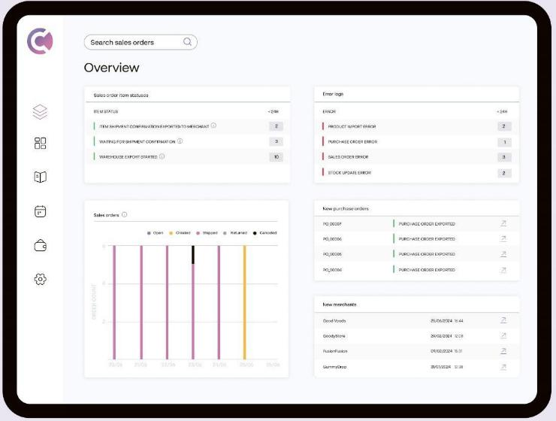

**Image 2:** Elara dashboard

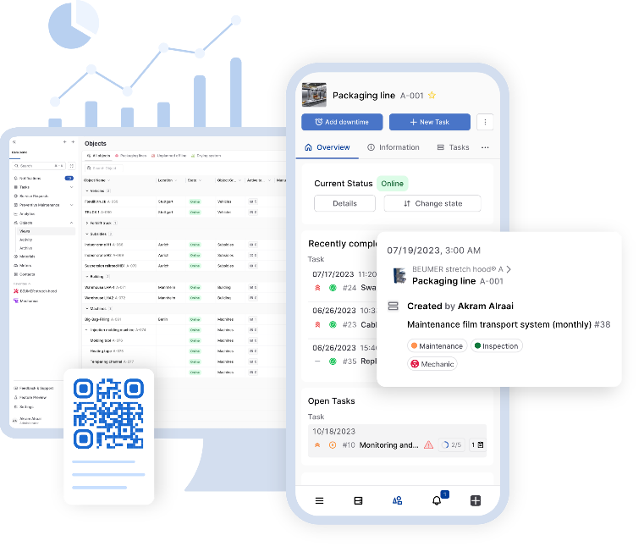

**Image credit**: BEUMER Group GmbH & Co. KG

Click [here](https://publitekltd.sharepoint.com/:f:/s/PublitekFTP/Etafmm3wTyhItCaKYsemqLcBnrFSdVczf5vMs8_8pEI7iQ?e=JTvHzE) to download a high-resolution version of the image.

**About BEUMER Group**  
BEUMER Group is a global manufacturer of material handling solutions. As a third-generation family-owned business, the company offers high-quality system solutions and comprehensive customer support worldwide and is a “Partner of Choice” for the mining, cement, building materials, petrochemical, consumer goods, postal, e-commerce, fashion, and baggage handling industries. With 5,700 employees worldwide, BEUMER Group generates an annual order intake of around 1.39 billion euros. In line with the company motto "made different", BEUMER commits to the highest standards of quality, innovation and sustainability. For more information, please visit [www.beumer.com](http://www.beumer.com)

**Press Contact**

**Jonas Jungmann (Press):**  
Fon.: + 49 (0) 151 70226871  
Mail: [jonas.jungmann@beumer.com](mailto:jonas.jungmann@beumer.com)**Verena Breuer (Trade media):**  
Fon.: + 49 (0) 151 14781593  
Mail: [verena.breuer@beumer.com](mailto:verena.breuer@beumer.com)**Carsten Otte (Agency):**   
Fon.: +49 (0) 4181 9273594  
Mail: [carsten.otte@publiktek.com](mailto:carsten.otte@publiktek.com)