BEUMER Group Successfully Delivers High-Speed FFS Packaging Lines to Packwell

- BEUMER Group supplies three high-speed FFS (Form, Fill and Seal) packaging lines to Packwell
- Full-line delivery includes FFS baggers, palletizers, and stretch hood machines tailored for polymers packaging
- Project directly addresses Packwell’s need to increase production capacity
Somerset, NJ, 15 September 2025 – BEUMER Group, a leading provider of chemical materials handling solutions, announces the successful implementation of three complete high-speed FFS packaging lines for Packwell. The new multi-million-dollar lines tailored for the petrochemical industry, and specifically designed for handling polymers across all categories will transform Packwell’s packaging operations and substantially increase its production capacity.

Based in La Porte, Texas, Packwell is a multi-generation, family-owned company specializing in packaging, warehousing, and logistics. Since its founding in 1986, the company has grown to become one of the largest resin bagging companies in North America. Driven by rapid growth and rising market demand, Packwell pursued an innovative solution to unlock higher production capacity and strengthen its competitive edge.

BEUMER Group responded by offering a comprehensive suite of new high-speed packaging equipment tailored to meet this challenge. The delivery of the complete lines includes state-of-the-art FFS baggers, industrial palletizers, stretch hood machines and conveyors, all optimized for handling the demanding requirements of polymer products. Designed to meet the specific safety, efficiency, and material-handling standards of petrochemical operations, the solution ensures seamless end-to-end logistics and enables Packwell to handle increased volumes with reliability and precision.

“We are incredibly proud to have been chosen as Packwell’s partner of choice for this project,” says Marvin Krampe, Head of Sales Petrochemicals, BEUMER Group. “This successful implementation underscores BEUMER's commitment to delivering tailored, high-performance packaging solutions that directly address our customers’ needs for increased capacity and operational efficiency. Our strong working relationship with Packwell was a key factor in this achievement, demonstrating our dedication to being a trusted partner.”

Al Duran, Chairman of Packwell, comments, “To enable our strategic growth in the North American market, partnering with Beumer made good sense in deploying their state-of-the-art, high-speed packaging machines for our operations. BEUMER Group’s proven expertise in high-speed packaging technology and its reputation as a reliable partner made it the clear choice for this investment. These new packaging lines have significantly boosted our throughput and operational efficiency, strengthening our position in the market.”

The project highlights BEUMER Group’s market position in delivering disruptive innovations and new technologies within the industrial packaging sector, specifically for clients such as Packwell.

For further information on BEUMER Group's solutions for the chemical industry, please visit https://www.beumergroup.com/industry/chemical-industry/.

3,019 characters (including spaces)

Captions:
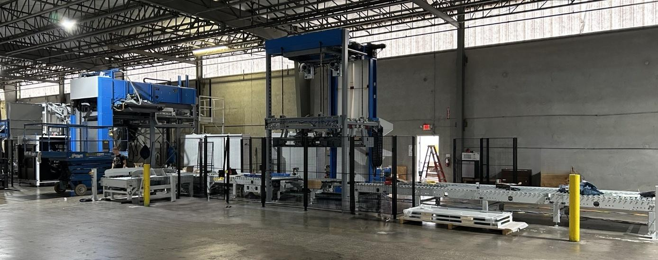
Image 1: BEUMER Group delivers three high-speed FFS packaging lines to Packwell

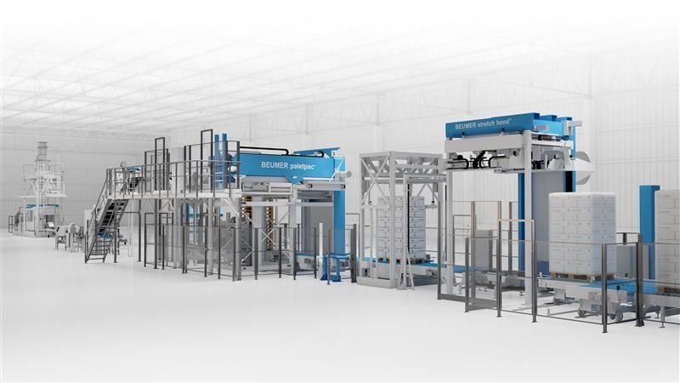
Image 2: Complete BEUMER Group's end-of-line packaging system with FFS bagger (far left), BEUMER paletpac® high-performance palletizer (middle), and BEUMER stretch hood® (right).

Photo Credit: BEUMER Group GmbH & Co. KG

Click here to download a high-res version of the image.

About BEUMER Group
BEUMER Group is a global manufacturer of material handling solutions. As a third-generation family-owned business, the company offers high-quality system solutions and comprehensive customer support worldwide and is a “Partner of Choice” for the mining, cement, building materials, petrochemical, consumer goods, postal, e-commerce, fashion, and baggage handling industries. With around 5,700 employees worldwide, BEUMER Group generates an annual order intake of around 1.39 billion euros. In line with the company motto "made different", BEUMER commits to the highest standards of quality, innovation and sustainability. For more information, please visit www.beumer.com

About Packwell
Packwell is a trusted expert in bagging polymers across all categories, using industry-leading equipment and proprietary technology to ensure the safe handling of customers' products and timely, efficient delivery. The company is ISO 9001:2015 certified and a proud member of Operation Clean Sweep. For more information, please visit www.packwell.com

Press Contacts
Jackie Sessler: Phone +1 (816) 245-7262, Mail: jackie.sessler@beumer.com
Carsten Otte (Agency): Phone +49 (0)4181 9273594, Mail: carsten.otte@publiktek.com

