The accompanying image can be downloaded here: <https://publitekltd.sharepoint.com/:f:/s/PublitekFTP/EjRLDsJ-hGBKkuG0zE8rIeMBWUKpk5r-ITGTswVi2clq7A?e=9GU4EM>

BEUMER Group at [LogiMAT 2025](https://www.logimat-messe.de/en) (11-13 March), Stuttgart: Hall 5, Stand 5C51  
  
**BEUMER Group expands the Customer Diagnostic Center to improve data insights and eliminate risk for customers large and small**

* Customer Diagnostic Center leverages billions of global data to provide customers with insights from all sites
* New Monitoring Center analyses suspicions 24/7 from diagnostic models to reduce risks at customer sites all over the world
* Diagnostic services expand to include new cyber security and Peak Programme service

**Beckum, 11 March 2025 –** **BEUMER Group has added a host of new options for customers of its data-driven diagnostic services, which have proved exceedingly successful since their launch at LogiMAT last year. The BEUMER Customer Diagnostic Center (CDC) holds a knowledge base of 60,000 diagnostic cases and is continuously analysing more than 6,000 diagnostic models. This year, BEUMER Group is showcasing new services under the motto "Your Partner of Choice" at LogiMAT 2025 (Stand 5C51 in Hall 5). Chief among the new developments is the 24/7 CDC Monitoring Center that analyses anomalies and trends across diagnostic models developed by the BEUMER diagnostic experts, so emerging issues that could impact productivity can be spotted even earlier. The CDC has also added new services that can further improve customers’ cyber security and predictive maintenance capabilities, based on real-time data from their operations.**

“The new services have been developed to meet ongoing requirements for better data security and diagnostic capabilities in logistics and e-commerce operations,” explains Merete Hoe, Director of the CDC for BEUMER Group. “Analysing and interpreting data is a complex and resource-intensive task and requires a great deal of investment, which can detract from your core business. BEUMER’s Customer Diagnostic Center provides a trusted data analytics resource for businesses of all shapes and sizes. Our powerful setup with efficient real-time data collection and diagnostic experts can anticipate issues and act proactively — remotely and on-site — to ensure operational performance is continuously optimised. Customers can sign up for an individual service or any combination of services to build a tailored data support package for their business and their budget.”

**Comprehensive data support**

BEUMER’s diagnostic services are arranged under three main categories:

* **Improve** services comprise BG PREDICT, a series of monitoring programmes at operational, system or field bus level, and the BG INSIGHT range of dashboards for easy management and tracking of operational and maintenance data.
* **Prevent** services comprise BG ACCESS for safe and secure data logging and analytics and BG SECURE through which BEUMER manages and updates customers’ cyber security systems, including patch management and anti-virus updates.
* **Ensure** services provide efficient access to BEUMER support in an emergency. They include the BG HOTLINE, which connects customers directly with an accredited expert 24/7, and BG SITEPRO, which covers all on-site advice, support and training.

All CDC services aim to improve efficiency and system performance through real-time data insights, prevent unplanned downtime by anticipating failing machines and components, and provide responsive support following an incident to get operations up and running again with minimal downtime.

The BEUMER Customer Diagnostic Center currently comprises 300+ data streaming sites processing 500+ TB of diagnostic data. In addition to this powerful diagnostic capability, it gives customers access to more than 100 qualified BEUMER Group experts. BEUMER customers have accessed diagnostic information 143,000+ times in the last 12 months.

**New CDC Monitoring Center**

The new CDC Monitoring Center adds an extra layer to the existing CDC capabilities. It takes data analytics to a new level, using advanced algorithms and artificial intelligence (AI) to continuously monitor all the critical assets, material handling systems, hardware, software, and overall site performance. It analyses anomalies using CDC-developed diagnostic models, to verify what action is required, and by when, and to spot wider trends that could impact operational efficiency.

“The Monitoring Center can deliver valuable insights way beyond SCADA,” says Merete. “It can identify external data anomalies coming towards your business before anything is triggered at the site level. This intelligence equates to more predictability and more uptime, boosting profitability.”

Data anomalies identified by the Monitoring Center can save considerable time when trying to pinpoint an individual component error. Consider a scenario where a motor in a conveyor is working loose due to some incorrectly tightened bolts. This small error could potentially develop into a larger breakdown. The Monitoring Center will see that the motor is using more power than normal and instruct the customer that this particular motor needs to be investigated, to avoid the situation escalating and causing an unplanned shutdown.

**Strengthening cyber security**

Sharing information between companies and platforms is an essential part of digitalisation, but data security is an ongoing concern for any business. BEUMER has added a new Vulnerability Management option to its BG SECURE family of CDC services, enabling customers to outsource continuous evaluation of data security risks and ensure that any potential data vulnerabilities are prioritized and corrected in the optimal sequence. This is a valuable addition to BEUMER’s existing inspection, patch and anti-virus management services, all of which are certified to ISO 27001, the international standard for information security management.

**Improving data visibility**

Other new additions to BEUMER Customer Diagnostic Center services focus on improving data gathering and interpretation. They include a Diagnostics Dashboard that allows customers to track how fixes are being implemented, and their effect on performance. This improves visibility and expands on the existing Operations, Maintenance and Management dashboards.

**Boosting on-site support**

Data insights need to be actionable, and BEUMER already offers customers on-site advisory and diagnostic training as well as on-site emergency support. However, there are still occasions where pressures on existing staff and systems can be overwhelming. For these situations, BEUMER expanded its BG SITEPRO suite with a Peak Programme service. It offers additional on-site systems support to logistics and e-commerce customers during times of extreme operational stress, such as Black Friday.

Find out more about BEUMER customer support services here: <https://www.beumergroup.com/customer-support/overview/>

*6,610 characters (including spaces)*

**Captions**:

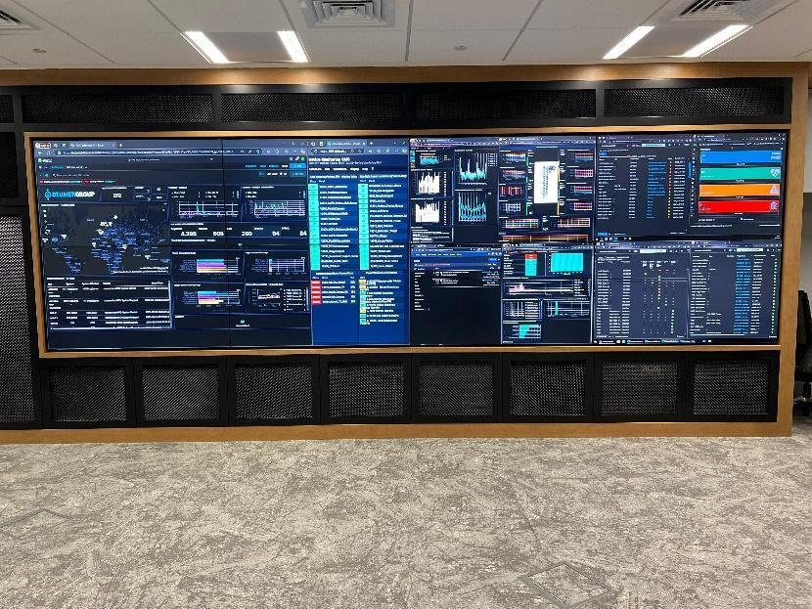

**Image 1:** BEUMER Group’s new Monitoring Center takes data analytics and insights to a new level.

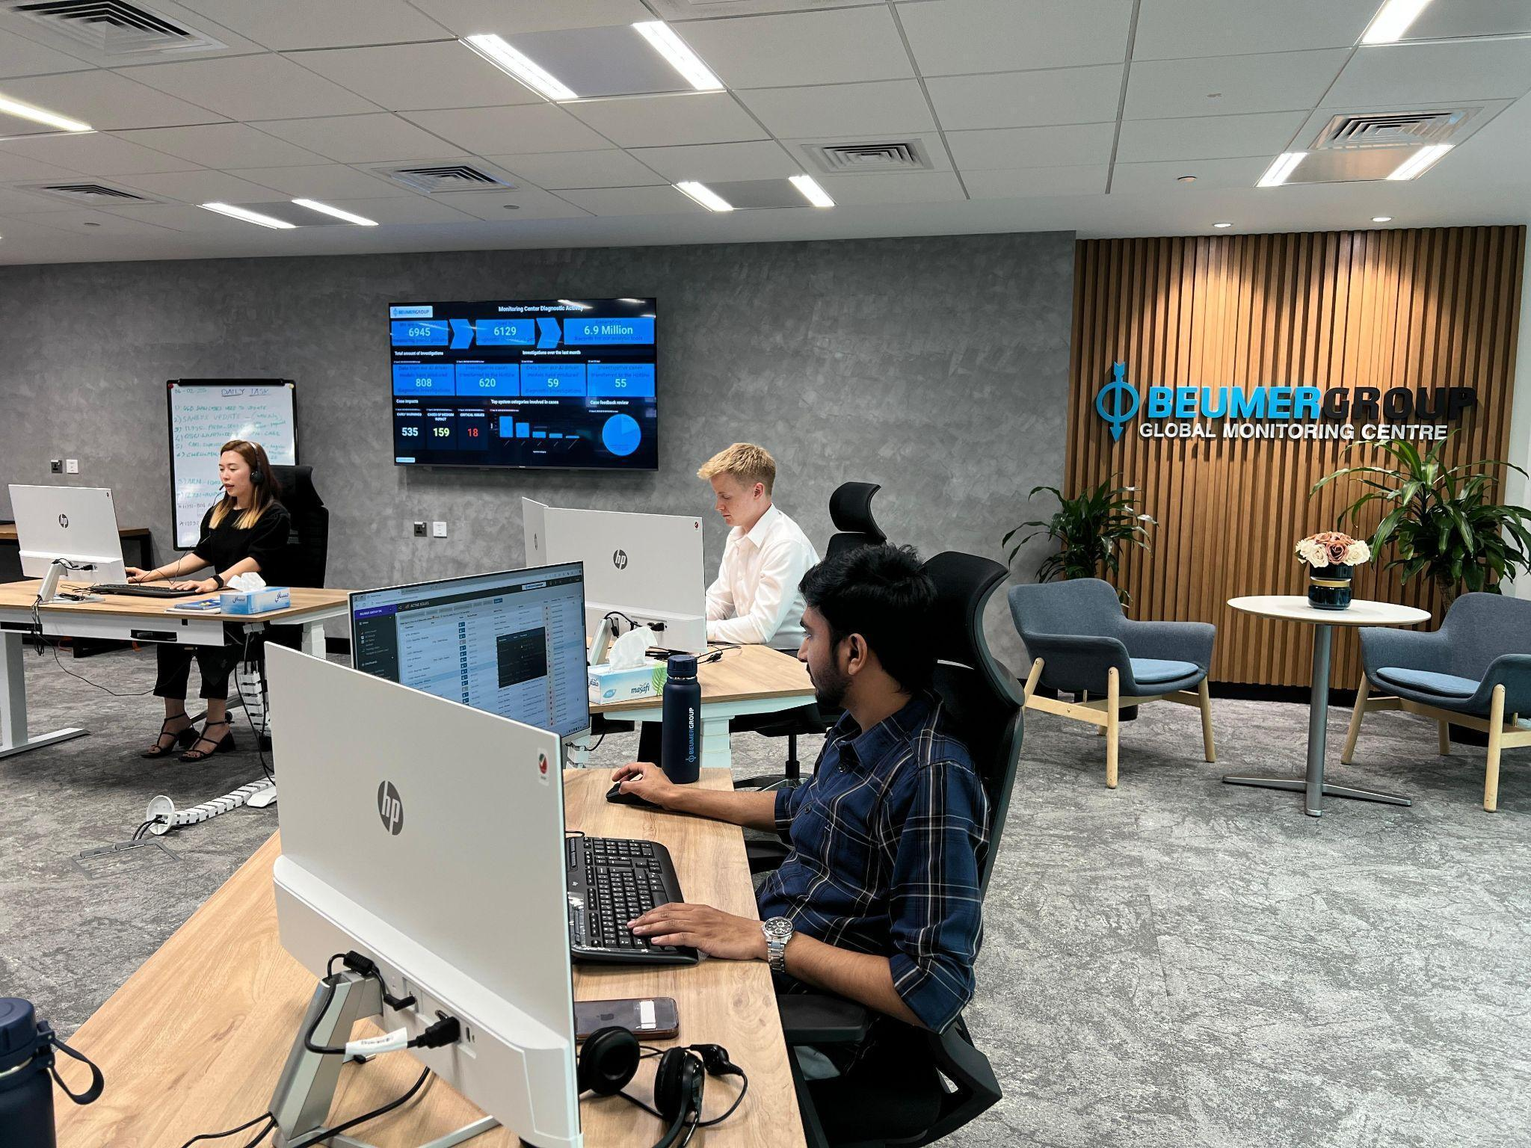

**Image 2:** BEUMER experts interpret operational data and can guide customers on implementing improvements.

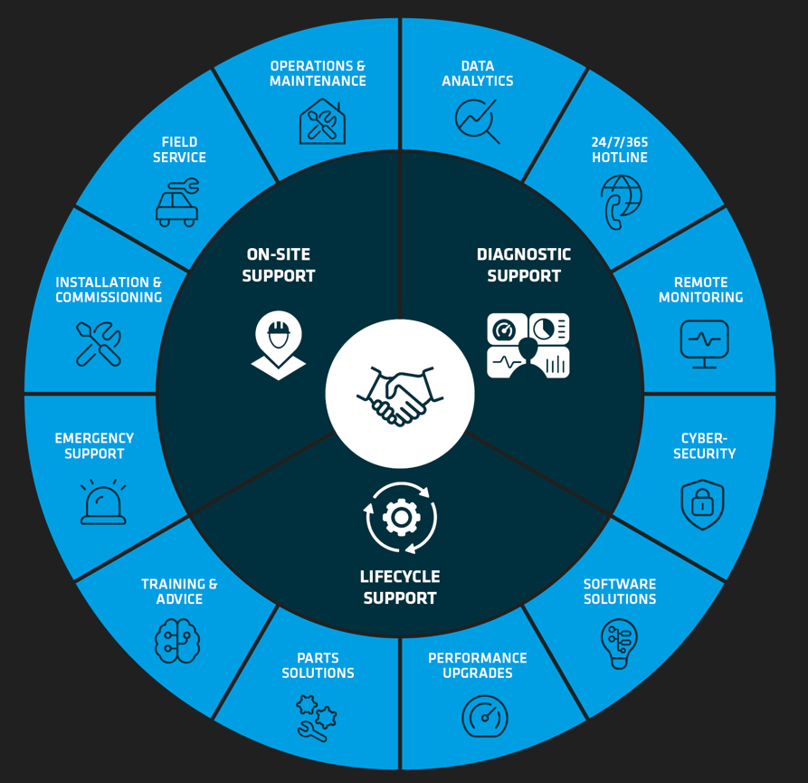

**Image 3:** The Customer Diagnostic Center, including the new Monitoring Center, forms part of a comprehensive suite of customer support services from BEUMER.

**Photo Credit:** BEUMER Group GmbH & Co. KG

Click [here](https://publitekltd.sharepoint.com/:f:/s/PublitekFTP/EjRLDsJ-hGBKkuG0zE8rIeMBWUKpk5r-ITGTswVi2clq7A?e=9GU4EM) to download a high-res version of the image.

**About BEUMER Group**BEUMER Group is a global manufacturer of material handling solutions. As a third-generation family-owned business, the company offers high-quality system solutions and comprehensive customer support worldwide and is a “Partner of Choice” for the mining, cement, building materials, petrochemical, consumer goods, postal, e-commerce, fashion, and baggage handling industries. With 5,600 employees worldwide, BEUMER Group generates an annual order intake of around 1.25 billion euros. In line with the company motto "made different", BEUMER commits to the highest standards of quality, innovation and sustainability. For more information, please visit [www.beumer.com](http://www.beumer.com)

**Press Contact**

Peter Elmvang:     Phone + 45 (0) 2721 43 61, Mail: [peter.elmvang@beumer.com](mailto:peter.elmvang@beumer.com)