**BEUMER Group secures double contract win for FAM iron ore mining equipment in Brazil**

* FAM equipment will be built at the stockyards of Gerdau's steel mills plant
* Flagship site produces over eight million tonnes of steel annually
* Project scope includes engineering, equipment manufacture, delivery, and site services

**Belo Horizonte, Brazil, 22 April 2025** **–** **Automated materials handling specialists BEUMER Group South America has been awarded two contracts by Gerdau S.A. to supply stockyard machines to the Gerdau Açominas Ouro Branco steel plant. The double win will see BEUMER Group South America supply a new FAM bridge type bucket wheel reclaimer, one stacker and one reclaimer boom type for use in the stockyards of Gerdau's steel plant. The project scope, aimed at enhancing the steel plant's operational efficiency, also includes engineering, purchasing, fabrication (including inspection), transport to site and site services.**

Gerdau S.A. is one of the leading long steel producers in the Americas and one of the largest recyclers and special steel suppliers in the world. The Gerdau Açominas steel plant in Ouro Branco/MG is the company's flagship facility in Brazil with a production capacity of over eight million tonnes of steel per year.

The steel plant has been operational for more than 30 years and needed to install new machines and replace some in its stockyard to ensure the continued efficiency of its iron ore operations. Under one contract, BEUMER South America will supply a new FAM bucket wheel reclaimer – bridge type with two bucket wheels and a 36-meter bridge conveyor. The plant is designed for a capacity of around 1,200 tonnes per hour. The other order is for an iron ore stacker with a boom of 30 meters, which is designed for an output of 1,700 tonnes per hour, and reclaimer with a boom of 43 meters, which is designed for an output of 975 tonnes per hour.

The significant contract award follows BEUMER Group’s acquisition and integration of the former FAM operations in Brazil, Peru and Chile. Commenting on the win, Bruno Rocha Ribeiro, Head of Project Management, BEUMER Brazil, says: “Securing both contracts from Gerdau S.A. for this steel plant upgrade against stiff international and local competition is testament to the expertise and professionalism of our team in Brazil. By combining the skills and expertise inherent in the FAM and BEUMER brands, we excel in mining and handling iron ore in challenging environments. We are continuing to deploy solutions that improve efficiency and drive down operational costs for our customers. We look forward to further developing the relationship with Gerdau S.A. and supporting their aim to modernise iron ore operations at this flagship site.”

*2,730 characters (including spaces)*

**Captions**:

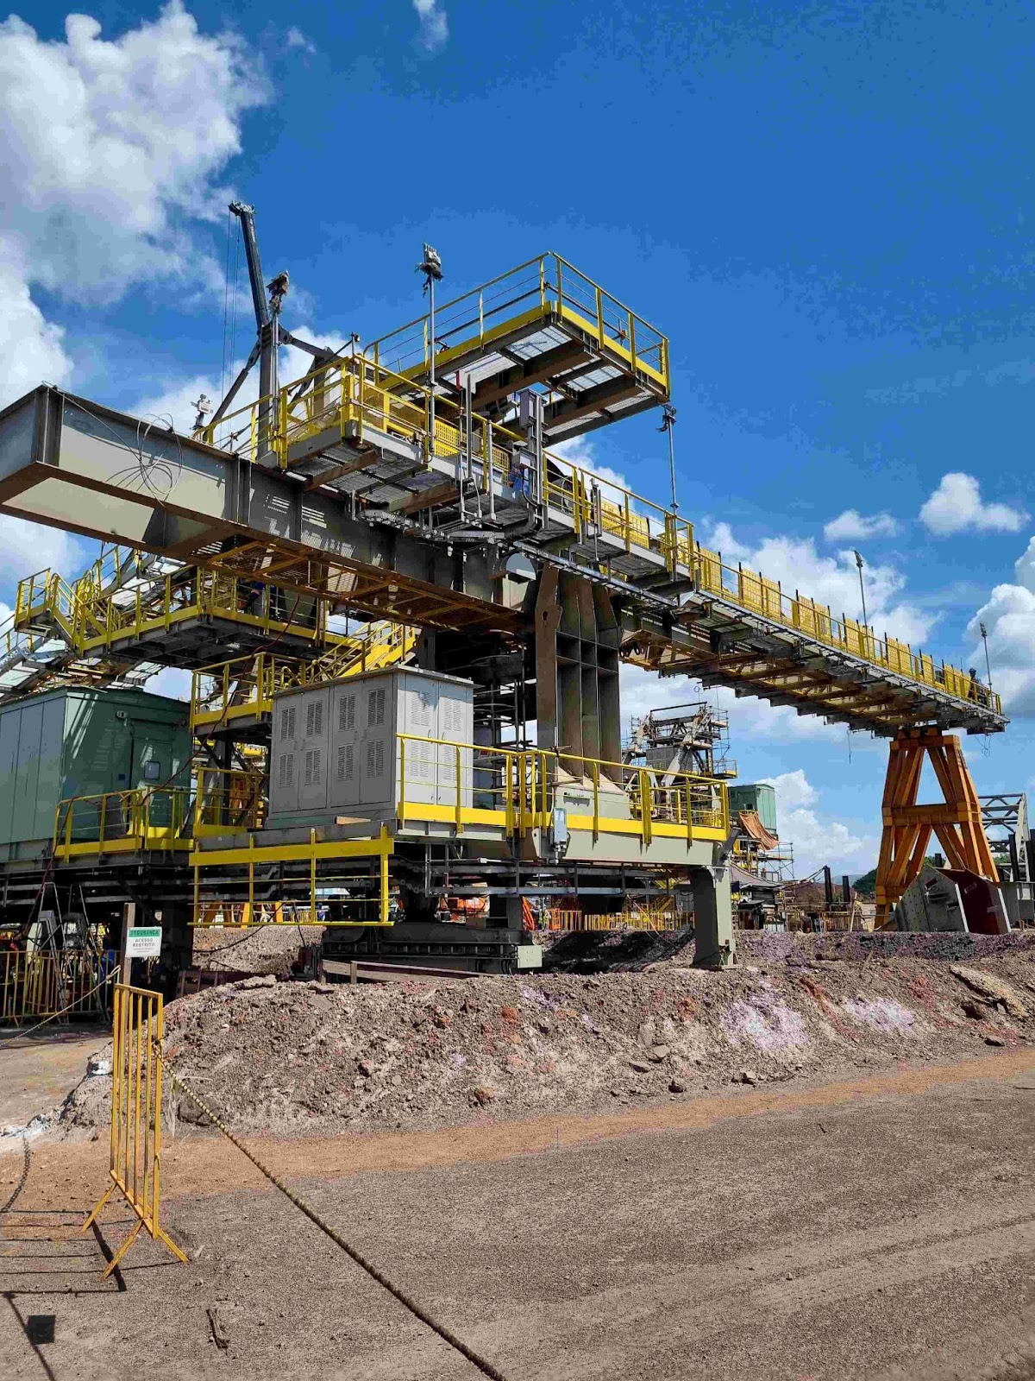

**Image 1:** BEUMER Group South America has been awarded two contracts to supply iron ore mining equipment for the Gerdau Açominas Ouro Branco steel plant.

**Photo Credit:** BEUMER Group GmbH & Co. KG

Click [here](https://publitekltd.sharepoint.com/:i:/s/PublitekFTP/EdHgMcAyv6ZGkKyh0SXonVMBHLmtepwzqZrTyICppnXo7g?e=YF33iE) to download a high-res version of the image.

**About BEUMER Group**BEUMER Group is a global manufacturer of material handling solutions. As a third-generation family-owned business, the company offers high-quality system solutions and comprehensive customer support worldwide and is a “Partner of Choice” for the mining, cement, building materials, petrochemical, consumer goods, postal, e-commerce, fashion, and baggage handling industries. With 5,600 employees worldwide, BEUMER Group generates an annual order intake of around 1.25 billion euros. In line with the company motto "made different", BEUMER commits to the highest standards of quality, innovation and sustainability. For more information, please visit [www.beumer.com](http://www.beumer.com)

**Press Contact**

Verena Breuer:     Phone + 49 (0) 2521 24 317, Mail: [verena.breuer@beumer.com](mailto:verena.breuer@beumer.com)

Jackie Sessler:      Phone +1 (816) 245-7262, Mail: [jackie.sessler@beumer.com](mailto:jackie.sessler@beumer.com)

Carsten Otte (Agency): Phone +49 (0)4181 968098 80, Mail: [carsten.otte@publiktek.com](mailto:carsten.otte@publiktek.com)