BEUMER Group at MINExpo 2024 (24-26 September), Las Vegas, Nevada: Booth #11227

BEUMER Group to showcase digitalization breakthroughs in mining at MINExpo 2024

- Find out why BEUMER is ‘your partner of choice in Minerals & Mining’
- Discover how digitalization is transforming the mining sector
- Engage with BEUMER experts to discuss digital integration for a competitive edge
- Learn about the tailor-made products and services from FAM Minerals & Mining (member of BEUMER Group)
Denver, CO, 09 September 2024 - BEUMER Group will outline the considerable advantages in efficiency, safety, and sustainability of digitalization in mining at the MINExpo exhibition in Las Vegas, Nevada, from 24 to 26 September 2024.
Visitors to the event can find out how digitalization can be a catalyst for change. Digitalization in mining enables organizations to collect and analyze data and to test the machines under new operational conditions, i.e. using a digital twin model. These unique options enabled by digitalization lead to a data-driven and more informed decision making process. Mining plants can also benefit from cost reductions and increased efficiencies as digitalization supports the implementation of material tracking systems. Companies are able to automate and streamline mining processes and closely monitor resources through sensor data providing insights into bulk material handling and transport processes – therefore enabling more intelligent routing.

Digitalization can also underpin stockyard management systems, streamlining and automating scheduling, monitoring and documenting material handling and storage for more efficient operations. It can provide the foundation for smart mine connectivity, consolidating data from all machines and equipment into a single front-end dashboard for a wider scope of visibility and the enablement of predictive maintenance scheduling for minimal unexpected downtime. The same digitalization principles can be applied to other essential mining tasks, such as train loading systems.

As well as advanced anti-collision systems combining mapping technology, digital mining solutions can improve safety by protecting personnel and assets. It also enhances the remote operation of equipment.

In addition to these benefits, the effective application of digital solutions can mitigate the workforce retention issues currently facing the mining industry. With an aging workforce leading to a widening skills gap, digitalization could change how the mining industry approaches tasks that were once thought of as exclusively manual.

BEUMER Group offers completely tailor-made solutions for digitalization in mining and bulk material handling, acting as your digital integrator. Our experts will be available at the booth at MINExpo to discuss your requirements and how digital technologies can blend with existing solutions and processes for commercial advantage.

Visitors can discover more about the full package of products and services from bulk materials specialist FAM Minerals & Mining, part of BEUMER Group since 2022. FAM offers machines along the complete transport chain for bulk materials, from the pit, to the plant, to the port, including extraction, conveying, processing, storage, loading and unloading of various raw materials. It provides end users with a comprehensive service, including development of customized technical solutions, detailed planning, delivery, installation, commissioning and maintenance of the machines. Experts will be on hand to discuss how implementing digitalization can enhance FAM’s portfolio of products and services.

“Digitalization is a term most often associated with smart factories, but it can also have a transformative effect on heavy industries like mining,” says Bruno Castro, Global Head of Digital Technology, Minerals & Mining at BEUMER Group. “Our experts can help the mining industry realize the tangible benefits of digitalization to improve efficiency, productivity and safety. We’re looking forward to welcoming visitors to our booth during MINExpo to discuss how best to unlock the power of digital technologies.”
The MINExpo event takes place over three days and brings professionals, experts, and decision-makers from the global mining industry together to collaborate, learn, and engage. It will feature keynote presentations, interactive panels, hands-on demos, and more.
BEUMER Group will be located at Booth #11227 at MINExpo. Click here to schedule a time to meet one of our experts at the booth.
4417 characters (including spaces)

Captions:
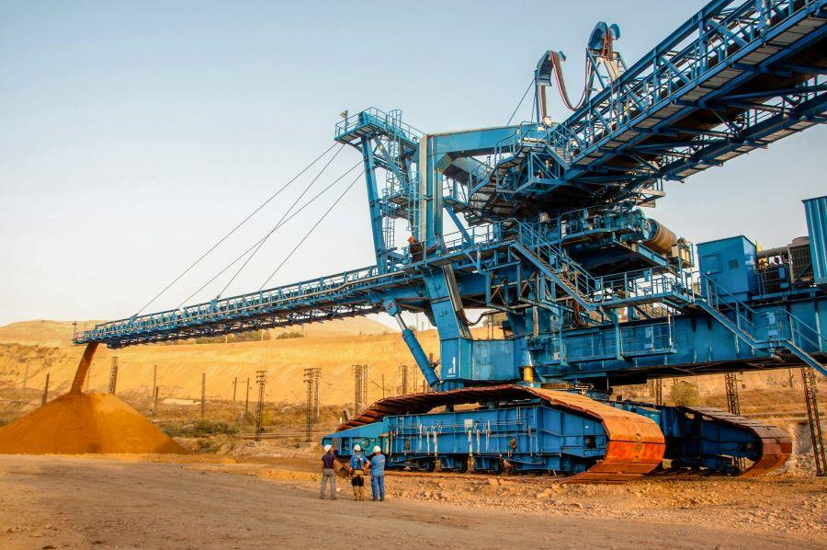
Image 1: BEUMER Group to showcase innovations in mining digitalization at MINExpo 2024

Photo Credit: BEUMER Group GmbH & Co. KG
Click here to download a high-res version of the image.

About BEUMER Group
BEUMER Group is a global manufacturer of material handling solutions. As a third-generation family-owned business, the company offers high-quality system solutions and comprehensive customer support worldwide and is a “Partner of Choice” for the mining, cement, building materials, petrochemical, consumer goods, postal, e-commerce, fashion, and baggage handling industries. With 5,600 employees worldwide, BEUMER Group generates an annual order intake of around 1.25 billion euros. In line with the company motto "made different", BEUMER commits to the highest standards of quality, innovation and sustainability. For more information, please visit www.beumer.com

Press Contact
Verena Breuer: Tel. + 49 (0) 2521 24 317 Mail: verena.breuer@beumer.com
Jackie Sessler: Tel. +1 (816) 245-7262 Mail: jackie.sessler@beumer.com

