**BEUMER Group Secures Contract to supply 2 km Pipe Conveyor to Port of Saguenay, Canada**

* Pipe conveyor is central to delivery of new $111 million multi-user bulk transport system at Saguenay port.
* Customer attributes contract win to BEUMER Group’s experience, engineering capabilities and strong partnership approach.

**Calgary, April 18, 2024 – BEUMER Group has secured a contract to supply a large 2-way pipe conveyor system for a strategic development project at the Port of Saguenay in Quebec, Canada. The conveyor will connect the port with customers in the new industrial port zone, boosting economic growth and supporting the region’s commitment to a more sustainable maritime supply chain.**

The Port of Saguenay is located 500 km north of Montreal. The BEUMER Pipe Conveyor is central to the port’s new Multi-User Bulk Transport System, which will increase the port’s ability to both import and export iron ore, pellets, wood ships, salt, aggregates and other ores. It will attract further investment in the region of Saguenay–Lac-Saint-Jean. On awarding BEUMER Group the contract, the Port of Saguenay Authority commented that they were particularly impressed with the company’s “engagement, commitment, and flexibility in understanding our requirements, especially regarding the importance to work with the community."

The pipe conveyor will be roughly two km long with a downhill (export) capacity of 4,150 t/h and an uphill (import) rate of 2,750 t/h. It runs along an existing steep and curvy road, reducing the need for truck transport and any associated carbon, dust and noise emissions. Because the pipe conveyor is fully enclosed, it reduces any environmental impacts and protects bulk materials from the sun, rain, snow, and wind. The scope of the contract includes all mechanical, structural and electrical equipment including prefabricated electrical buildings and the control system.

Markus Schmidt, CEO BEUMER Group North America, says: “The Saguenay pipe conveyor project represents a very important milestone, both for this region of Canada and for BEUMER Group’s Minerals & Mining business. The expertise inherent in our global team enables us to deliver a conveyor solution on this scale, meeting the client’s criteria for improving capacity in bulk handling while reducing environmental impacts.”

The pipe conveyor is expected to be fully operational in 2025.

For more information about BEUMER Group pipe conveyors, visit: <https://www.beumergroup.com/pd/conveyors-technology/pipe-conveyors/>

*2,509 characters (including spaces)*

*BEUPR013 Image 1*

**Caption**: BEUMER Group is executing a contract to supply a 2 km pipe conveyor to the Port of Saguenay in Canada, increasing its bulk handling capabilities while reducing environmental impacts.

**Photo Credit:** Port of Saguenay

Click here to download a high-res version of the image.

*BEUPR013 Image 2*

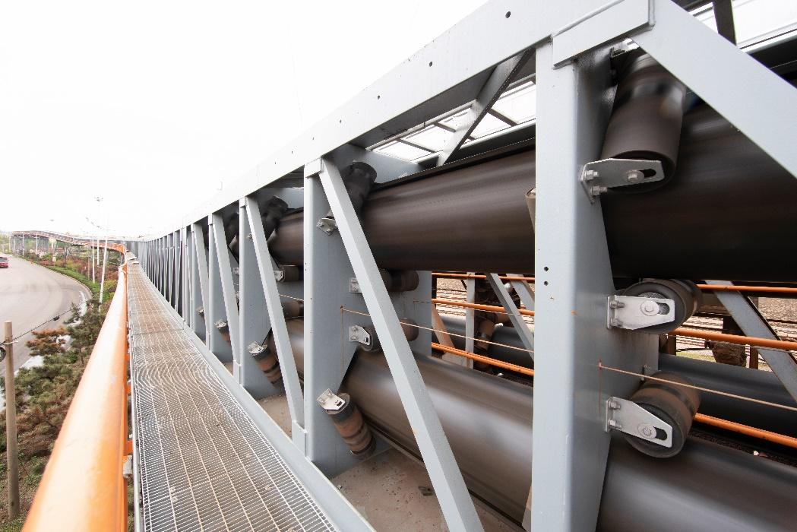

**Caption:** BEUMER Group is supplying a 4,150 t/h bi-directional pipe conveyor to the Port of Saguenay. The system will be installed inside an enclosed gallery structure for ease of maintenance during the winter months.

**Photo Credit:** BEUMER Group GmbH & Co. KG

Click here to download a high-res version of the image.

**About BEUMER Group**  
BEUMER Group is a global manufacturer of material handling solutions. As a third-generation family-owned business, the company offers high-quality system solutions and comprehensive customer support worldwide and is a “Partner of Choice” for the mining, cement, building materials, petrochemical, consumer goods, postal, e-commerce, fashion, and baggage handling industries. With 5,500 employees worldwide, BEUMER Group generates an annual order intake of around 1,25 billion euros. In line with the company motto "made different", BEUMER commits to the highest standards of quality, innovation and sustainability. In 2022, the group acquired FAM Minerals & Mining, an international supplier for bulk materials, process supplier for bulk materials, processing and conveying systems for open-cast mining, stockyards, and ports.

For more information, please visit [www.beumer.com](http://www.beumer.com)

**Press Contact**

**Jackie Sessler:**   Phone +1 (816) 245-7262, Mail: [jackie.sessler@beumer.com](mailto:jackie.sessler@beumer.com)