BEUMER Group at LogiMAT 2024 (19 - 21 March)

Order intake up 17.1 percent: Record year for the
BEUMER Group

- Successful major projects in several business divisions
- Group CEO Rudolf Hausladen: "On a very good course overall"
- Commitment to Germany as a business location

Beckum, 20 March 2024 – BEUMER Group has made a successful start into the new year with the tailwind of very good development in the Airport and Customer Support divisions. The global manufacturer of material handling solutions recorded an order intake of 1.25 billion euros in 2023 – an increase of 17.1 per cent compared to 2022 and thus the best figure in the history of the family-owned company. The number of employees worldwide rose by around 2.1 per cent to 5,500.

The main reasons for the good result in the Customer Support division were the consistent focus on customer needs and the launch of the global Customer Diagnostic Centre. In the Airport division, several major projects were successfully completed at Singapore-Changi, Doha and Helsinki airports. The same applies to the Logistic Systems division with projects for Swiss Post and Poczta Polska as well as the Minerals & Mining division. In addition to other major projects, the successful completion of the integration of the FAM Group, which was acquired in 2022, is particularly noteworthy here.

Optimising processes, rolling out new strategy
"BEUMER Group is overall on a very good course," says Group CEO Rudolf Hausladen. In view of the global challenges of recent months and years, particularly around supply chains, the company's shareholders and management are very satisfied with what has been achieved. For the future, it is important to strengthen and further optimise internal processes, increase efficiency in all areas of the company and successfully implement a new strategy. "We see ourselves as a 'partner of choice through differentiation and collaboration'," Hausladen continued. The aim is to continue to position BEUMER Group as a global quality leader and material handling trailblazer in the future.

Commitment to Germany as a business location
Although BEUMER Group's very good result last year was mainly generated abroad, the family-owned company is committed to its locations in Germany and in particular to its headquarters in Beckum/North Rhine-Westphalia in the long term. "We are observing the current economic conditions with great concern," adds Rudolf Hausladen. Significantly rising costs, noticeable uncertainty, including on the customer side, and not least escalating regulatory measures have led to a competitive disadvantage, which must now be offset by innovative, customer-orientated solutions and internal efficiency measures. "If we want to secure Germany as an industrial location and secure jobs in the long term, we should critically scrutinise current socio-political developments with a view to our competitiveness," Hausladen continued.

2,653 characters (including spaces)

Pictures:

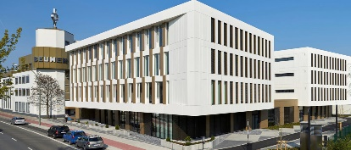
Picture 1: BEUMER Group's company headquarters in Beckum / Germany.

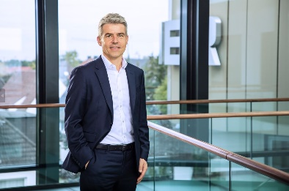
Picture 2: Rudolf Hausladen, CEO BEUMER Group

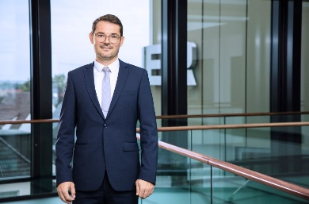
Picture 3: Dr. Jörn Fontius, CEO BEUMER Maschinenfabrik

Photo Credit: BEUMER Group GmbH & Co. KG
Click here to download a high-res version of the image.

About BEUMER Group
BEUMER Group is a global manufacturer of material handling solutions. As a third-generation family-owned business, the company offers high-quality system solutions and comprehensive customer support worldwide and is a “Partner of Choice” for the mining, cement, building materials, petrochemical, consumer goods, postal, e-commerce, fashion, and baggage handling industries. With 5,500 employees worldwide, BEUMER Group generates an annual order intake of around 1,25 billion euros. In line with the company motto "made different", BEUMER commits to the highest standards of quality, innovation and sustainability. For more information, please visit www.beumer.com

Press Contact

Carsten Lucassen: Phone + 49 (0) 2521 24 2183, Mail: carsten.lucassen@beumer.com
Verena Breuer: Phone + 49 (0) 2521 24 317, Mail: verena.breuer@beumer.com

