BEUMER Group at LogiMAT 2024 (19 - 21 March)

BEUMER stretch hood improves end-of-line packing efficiency and in transit security

- Secure seal prevents tampering or damage during storage and transit
- Electric automation reduces energy consumption
- Custom-designed for ease of implementation as an integrated or stand-alone solution

Beckum, 20 March 2024 – Packing pallets economically, safely and automatically - with the patented BEUMER stretch hood, BEUMER Group offers a customised solution, preventing tampering, damage or other impacts during storage and transportation. Each system is custom designed by BEUMER to meet individual application requirements and can be integrated into the customer's conveyor system or supplied as a separate stand-alone solution.

Jörg Spiekermann, Head of Sales Division Consumer Goods at BEUMER Group, says: “Making sure that goods are stable, secure and protected as they enter storage or leave the warehouse is critical to maximising profitability, minimising waste and avoiding returns. Putting film over a pallet is the easy part – making sure that the contents are centred, accurately weighed and measured before they are finally sealed requires repeatable accuracy and consistency that can only be achieved with automation. Our stretch hood technology makes it easy to deploy an automated solution at the end of the line. Our solution minimises the opportunity for human error during this critical phase and applies a stretched protective seal that guards against spoilage or pilfering.”

With applications ranging from high-quality electronic items to food & beverage packaging to palletised loads of construction materials, the BEUMER stretch hood is suitable for securing incoming goods on pallets in front of the high rack, and for final packaging at goods issue for dispatch and transportation. It is equally proficient at applying transparent film, which allows the palletised product to be visible, or opaque (non-transparent) film for sealing high value goods where security is paramount. The BEUMER stretch hood achieves maximum load stability using a combination of vertical and horizontal contracting forces on the film, which is highly flexible to accommodate many different product sizes. Thanks to the use of cold-stretchable films, the BEUMER stretch hood does not involve heat exposure, so there is no possibility of the film sticking. No air-cooling of the film sealing seam is necessary either, which means this film packaging machine has very low operating costs.

Minimising product loss
Once applied, the plastic hood protects against moisture and dirt ingress while holding products securely in place so that the pallets can be safely moved and stacked without slippage. The hood also dramatically reduces the likelihood of goods becoming ‘lost in transit’. Jörg Spiekermann explains: “Normal static film wrapping is a temptation because it can be undone and replaced, but with stretch hoods any tampering is immediately evident.” One BEUMER Group customer recently reduced losses from 4 percent to virtually zero (0.03 percent) by introducing a BEUMER stretch hood system from point of dispatch to point of destination.

Custom solutions
The individual system design is dependent on other customer handling aspects, such as use of forklifts and carts, manual lifting requirements, and the height to which the pallets must be elevated. These elements will determine whether conventional or low-level roller conveyors and integral lifting systems should be incorporated, for example.

The BEUMER stretch hood can be supplied as a linear system or designed to turn corners to fit into a smaller footprint. Third party equipment, such as labelling systems or platform scales, can be accommodated. The design may also include a compressor where the customer has no existing compressed air supply.

Continuous innovation
According to Jörg Spiekermann, there are many more innovations to come for end-of-line packaging. “Manual interventions are still necessary for labelling and during loading and offloading, but in future we are likely to see AGVs (automatically guided vehicles) being used for transportation. BEUMER customised solutions are already working towards a fully automated scenario which will extend dark warehouse principles to cover end-of-line activities as well.”

4,466 characters (including spaces)

BEUPR010 BEUMER stretch hood Image 1
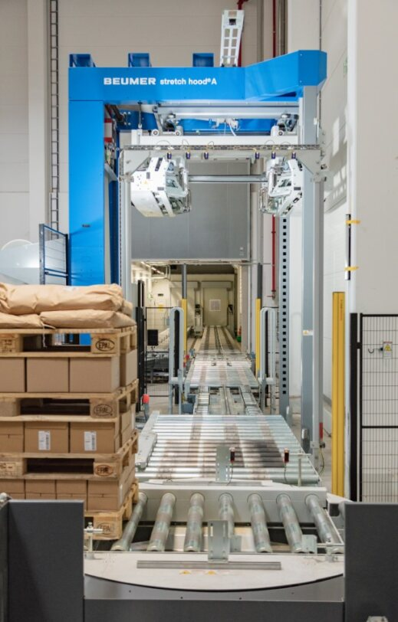
BEUPR010 BEUMER stretch hood Image 1.a 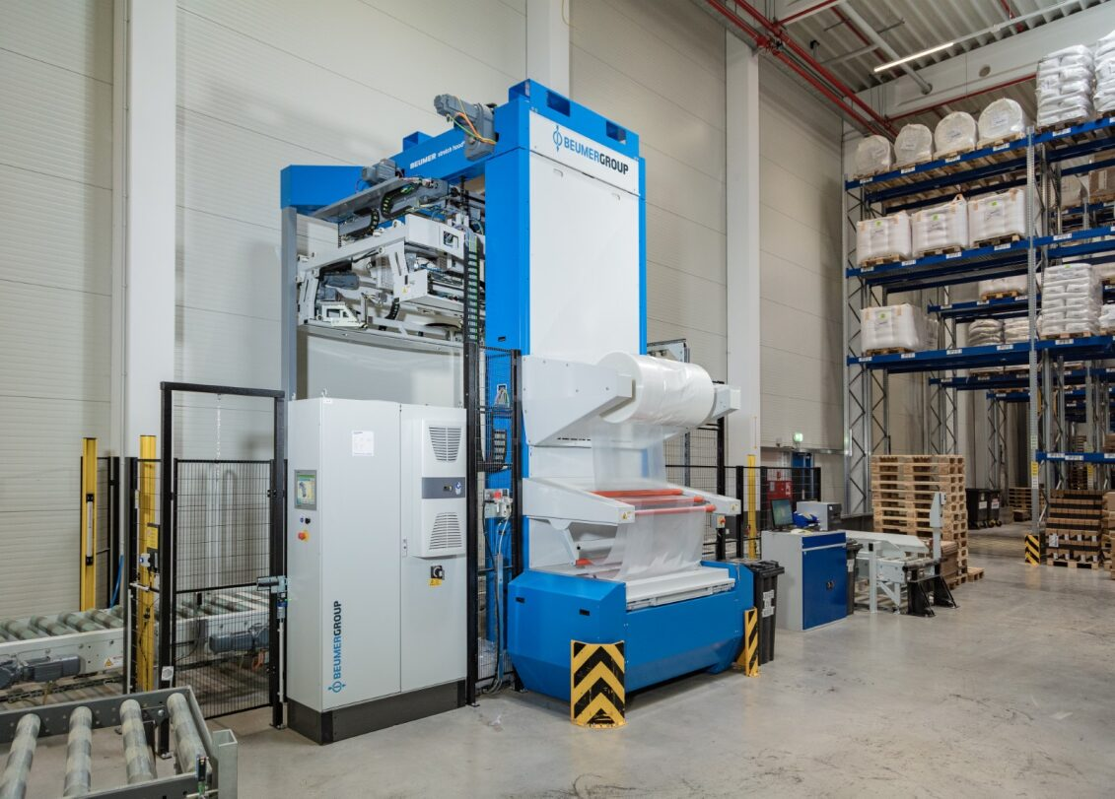
Caption 1 & 1a: BEUMER stretch hood can be integrated into the customer's conveyor system or supplied as a separate stand-alone solution.

BEUPR010 BEUMER stretch hood Image 2
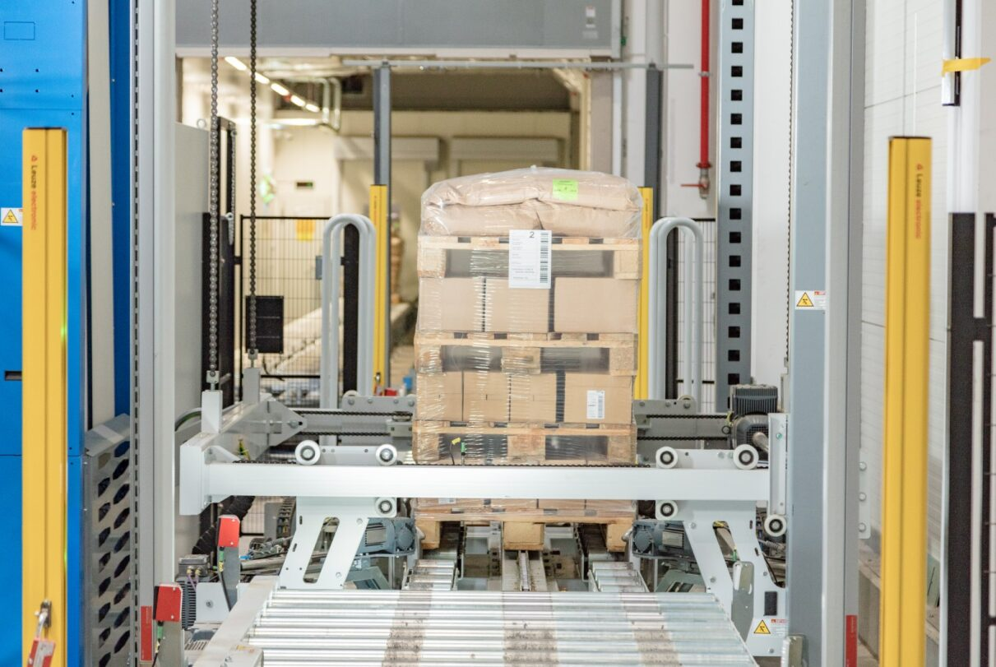
Caption 2: BEUMER stretch hood seals pallets economically and securely with highly flexible stretch film.

BEUPR010 BEUMER stretch hood Image 3
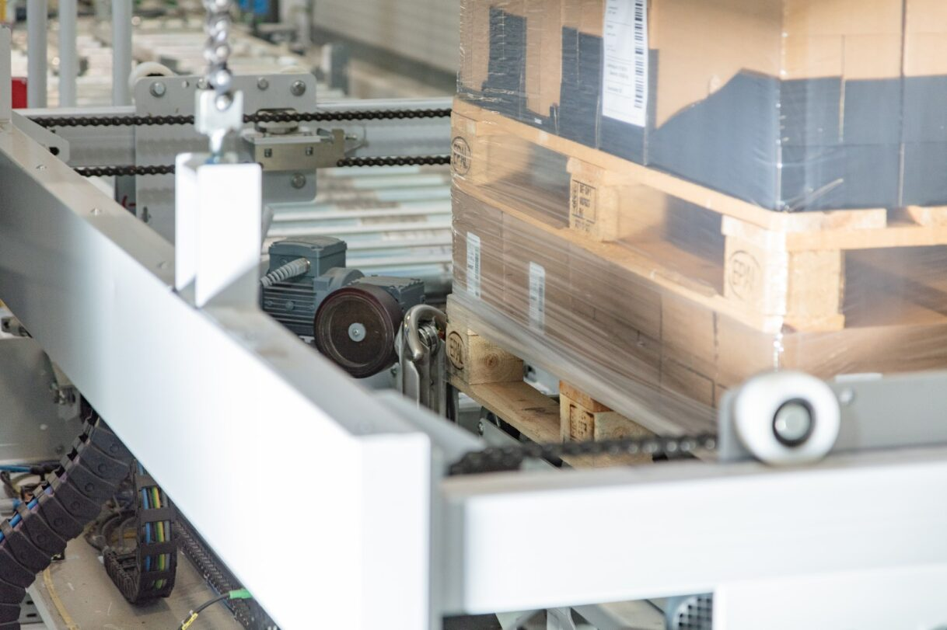
Caption 3: BEUMER stretch hood is equally proficient at applying transparent film, which allows the palletised product to be fully visible.

BEUPR010 BEUMER stretch hood Image 4
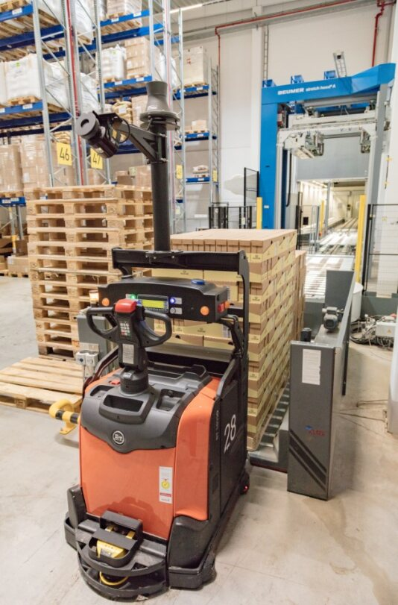
Caption 4: BEUMER stretch hood is suitable for final packaging at goods issue for dispatch and transportation.

Photo Credit: BEUMER Group GmbH & Co. KG
Click here to download a high-res version of the image.

About BEUMER Group
BEUMER Group is a global manufacturer of material handling solutions. As a third-generation family-owned business, the company offers high-quality system solutions and comprehensive customer support worldwide and is a “Partner of Choice” for the mining, cement, building materials, petrochemical, consumer goods, postal, e-commerce, fashion, and baggage handling industries. With 5,500 employees worldwide, BEUMER Group generates an annual order intake of around 1,25 billion euros. In line with the company motto "made different", BEUMER commits to the highest standards of quality, innovation and sustainability. For more information, please visit www.beumer.com

Press Contact

Verena Breuer: Phone + 49 (0) 2521 24 317, Mail: verena.breuer@beumer.com

