BEUMER Group at LogiMAT 2024 (19 - 21 March)

‘Easy to do business with’: BEUMER Groups ensures customer success by removing complexity and offering certainty

- Proven partner: Almost 65% repeat business in 2023
- Family ownership enables long-term customer relationships
- Emphasis on being ‘easy to do business with’

Beckum, 20 March 2024 – BEUMER Group recognises that volatile markets, geo-political upheavals and disruptions to the global supply chain continue to present complex challenges for businesses trying to invest and grow. The company has therefore put reducing complexities to give customers more certainty at the heart of its business strategy. This approach is achieving results, with repeat custom now accounting for almost two-thirds of BEUMER Group’s business. That’s why the motto of the company’s trade fair appearance at LogiMAT 2024 in Stuttgart is ‘Easy to do business with’.

BEUMER Group is a large organisation operating on a global scale, with locations in more than 50 countries, but is determined to avoid organisational complexities and local variations in quality and service. The goal is to always offer the best possible service or product, and the motto of being ‘easy to do business with’ encompasses everything from allocating customers a consistent point of contact from project start to completion to providing data insights via its Customer Diagnostic Center that enable customers to make better operational and investment decisions.

Stephan Heessels, Divisional Director, Logistic Systems at BEUMER Group, says: “We recognise the challenges and uncertainties that our customers face and do what we can to mitigate them. We focus on making BEUMER Group easy to do business with by simplifying our organisational structure, our communications and our relationships with customers. The automated materials handling solutions we offer are designed to be easy to integrate, operate and maintain. Essentially, our business aim is to provide our customers with certainty in an uncertain world.”

“You should always think about the customer experience, about how easy or difficult you are to work with,” advises Heessels. “Brand loyalty and repeat business are fostered by providing the best customer experience and trust, not at the lowest cost.” According to BEUMER Group, it is often the small details that make the biggest difference. For example, one international CEP customer recently benefited from the fact that BEUMER does not use internally generated codes on their technical drawings: they are labelled clearly and descriptively to avoid any confusion.

Global outlook, family values, customer satisfaction
Despite its global presence, BEUMER Group is still a family-owned business, aiming to deliver the highest levels of customer satisfaction and being a trusted “Partner of Choice”. The company is dedicated to delivering long-term success rather than short-term profit. “Although we are experts in materials handling and have total faith in our own technology, we are never complacent,” explains Heessels. “Every customer site is treated as a reference site and an opportunity to learn. The resulting customised solution may be relevant only to that customer, while another may have wider applications – but the same effort and dedication goes into developing both. “We will always try to find the right solution, regardless of the technology.”

From system design to obsolescence
Ensuring BEUMER Group is ‘easy to do business with’ permeates every aspect of the customer relationship. From the outset, customers are assigned a consistent point of contact so they develop a personal relationship with someone who has the relevant experience and understanding of their business and challenges. This same contact is present during system installation for total continuity.

During system development, BEUMER Group conducts FAT tests with every customer so that they can experience their new material handling system first-hand. In this process, an emulation is used for testing the software solution with the specific mechanical system. This approach eliminates any surprises on site.

The ’customer first’ philosophy is also evident in the way BEUMER Group conducts itself on site. The way its materials handling systems are packaged and delivered is organised meticulously to minimise the time spent on unpacking and assembly. In addition, all waste is removed from site for recycling or disposal once the installation is completed. The company also prides itself on never letting a customer down: they do not leave the site until the job is finished.

Providing customers with certainty extends into maintenance and obsolescence management. BEUMER Group offers a minimum of 15 years parts support, simplifying maintenance and giving customers confidence that their material handling system will perform reliably with minimal downtime over its lifetime. Indeed, such is the quality of BEUMER’s automated solutions that they are still maintaining and updating systems that are more than 25 years old.

Better, not bigger
Heessels concludes: “We want to be the best, not the biggest, at what we do. Our manageable size means we are quicker to mobilise and can pull resources together quickly to support customers when they need help most. The fact that customers are coming back to us time after time is an indication that we are succeeding in our quest to be ‘easy to do business with’.”

Find out more about all other BEUMER Group press releases at LogiMAT 2024
- Order intake up 17.1 percent: Record year for the BEUMER Group
- Think 2035: BEUMER Group brings the future of dark warehouse operations to LogiMAT 2024
- BEUMER Group launches new 24/7 Customer Diagnostic Center to support customers
- BEUMER stretch hood improves end-of-line packing efficiency and in transit security

5,855 characters (including spaces)

BEUPR009 Stephan Heessels_BEUMER Group
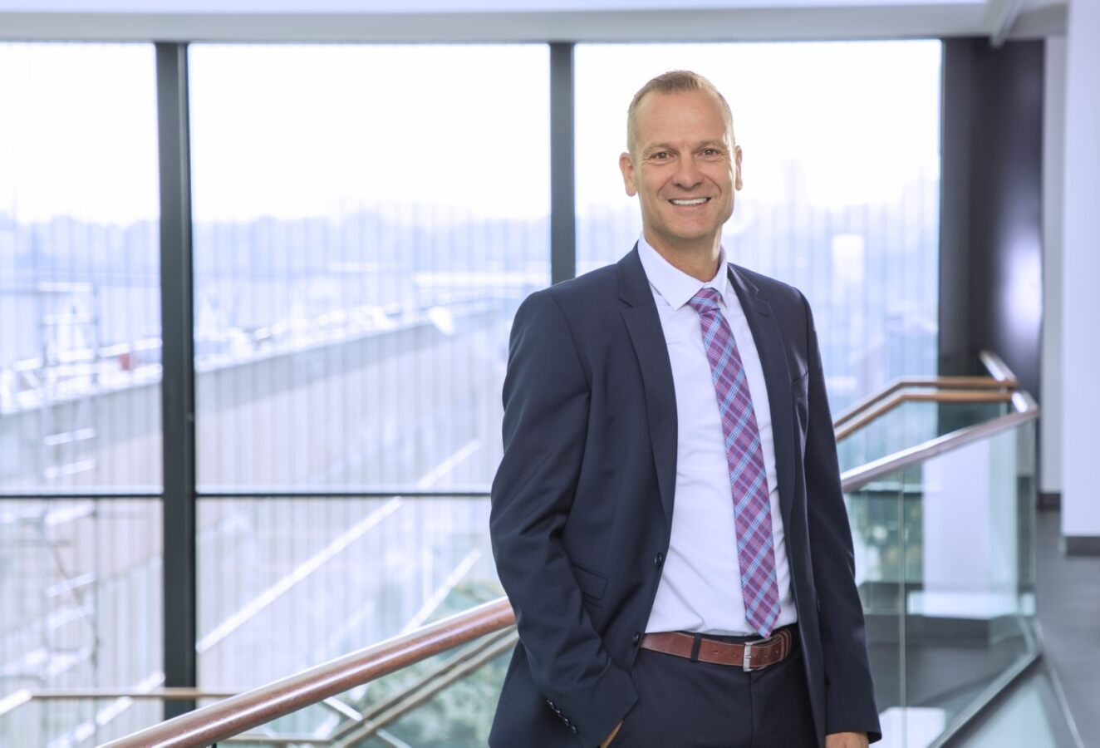
Caption: Stephan Heessels, Divisional Director, Logistic Systems at BEUMER Group

Photo Credit: BEUMER Group GmbH & Co. KG
Click here to download a high-res version of the image.

About BEUMER Group
BEUMER Group is a global manufacturer of material handling solutions. As a third-generation family-owned business, the company offers high-quality system solutions and comprehensive customer support worldwide and is a “Partner of Choice” for the mining, cement, building materials, petrochemical, consumer goods, postal, e-commerce, fashion, and baggage handling industries. With 5,500 employees worldwide, BEUMER Group generates an annual order intake of around 1,25 billion euros. In line with the company motto "made different", BEUMER commits to the highest standards of quality, innovation and sustainability. For more information, please visit www.beumer.com

Press Contact
Peter Elmvang: Phone + 45 (0) 2721 43 61, Mail: peter.elmvang@beumer.com

