BEUMER Group: Andreas Backs is the new Director of Global Sustainability
Sustainability learned from scratch

Andreas Backs is the new Director of Global Sustainability at the BEUMER Group. In this role, he is responsible for the development and implementation of the Group’s global sustainability strategy. His responsibilities include formulating a vision and goals, evaluating key issues and developing a roadmap that measures and improves performance in this area. He is also responsible for communicating with stakeholders and training of employees.

Backs joined the BEUMER Group in September 2022. Prior to that, he worked for almost two years at an international management consultancy, among other posts as a sustainability expert. He was employed by the TÜV Nord Group for just over four years: first as a project manager, then as a product manager for sustainability. Finally, he led the sustainability report audit program. Andreas Backs completed his bachelor’s and master’s degrees in environmental science and technology at the Technical University of Berlin.

“Global sustainability offers a special opportunity for the BEUMER Group,” says Andreas Backs. “That’s because we supply our products to industries and markets that are not considered sustainable.” He is also attracted by the opportunity to contribute to greater sustainability and solve global problems. The new Director of Global Sustainability takes on the role of an intermediary, as he says. “With our customers, I would like to evaluate our performance in key sustainability topics and improve it in the long term.” The aim is to create added value not only for users but also for the company’s own employees. Only with attractive and inviting workplaces can sustainable solutions for intralogistics be developed.

1,789 characters incl. blanks

Meta-Title: BEUMER Group: Andreas Backs is the new Director of Global Sustainability

Meta-Description: Andreas Backs is the new Director of Global Sustainability at the BEUMER Group. In this function, one of his tasks is to formulate a vision and goals for sustainability.

Keywords: Andreas Backs; BEUMER Group; Director of Global Sustainability; Sustainability

Social Media: Andreas Backs is the new Director of Global Sustainability. In this role, he is responsible for the development and implementation of the BEUMER Group’s global sustainability strategy. His responsibilities include formulating a vision and goals for sustainability, evaluating key issues, developing a roadmap that measures and improves performance in this area, communicating with stakeholders and training employees.

Caption:
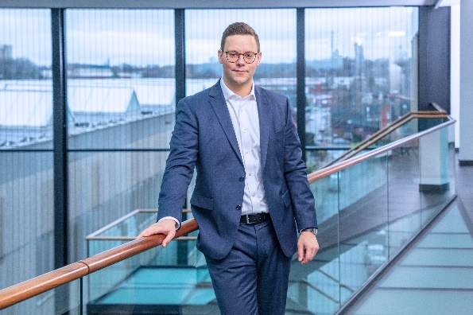
Andreas Backs is the new Director of Global Sustainability at the BEUMER Group.

Photo credits: BEUMER Group GmbH & Co. KG

The high-resolution picture can be downloaded here.

BEUMER Group is an international leader in the manufacture of intralogistics systems for conveying, loading, palletising, packaging, sortation, and distribution. With 5,400 employees worldwide, BEUMER Group has annual sales of about EUR 1 billion. BEUMER Group and its group companies and sales agencies provide their customers with high-quality system solutions and an extensive customer support network around the globe and across a wide range of industries, including bulk materials and piece goods, food/non-food, construction, mail order, post, and airport baggage handling.

For more information visit www.beumer.com.

