Rudolf Hausladen and Dr. Christoph Beumer inform about the future of BEUMER Group:

Innovation from tradition

With Rudolf Hausladen, the BEUMER Group has a new CEO. What does this mean for the group of companies? And what is planned for the future? Together with Dr. Christoph Beumer, the new CEO answered questions about the industry and current topics at a global Media Meeting.

"I want to continue to lead the company in the same tradition and spirit of the BEUMER family," Rudolf Hausladen promises. He has been the new CEO since 1st of June 2022 and succeeds Dr. Christoph Beumer, who has led BEUMER Group as CEO for more than 20 years and will move to the Advisory Board by the end of the year. Under the title "Change of Management at BEUMER Group", the group organised an international Media Meeting at the beginning of August. Trade press journalists from five continents were represented, reporting to the cement and building materials industries as well as to sectors such as mining, intralogistics, packaging technology, chemicals and petrochemicals.

What is the market situation in the individual industries? What strategies does the BEUMER Group have, and what developments and innovations is the systems provider currently working on? Dr. Christoph Beumer and Rudolf Hausladen will deal with these important topics for the future.

Under the leadership of Dr. Christoph Beumer, the company has developed from a German mechanical engineering company into an international systems supplier and plant manufacturer. The focus is always on quality leadership in order to provide customers with the best possible solutions for their business. With now more than 5,000 employees representing the BEUMER culture worldwide, the business volume amounts of about 1.1 billion euros. Long-term and far-sighted decisions, such as anti-cyclical acquisitions, have had a lasting positive impact on the business. This also includes the acquisition of FAM Magdeburg. This expands the BEUMER Group's portfolio in bulk solids technology.

"We are only successful with a deep understanding of our customers' business and processes," Rudolf Hausladen is convinced. "This is the key to understanding their challenges and being able to offer the best solutions for them."

Rudolf Hausladen wants to use this knowledge and also strategically align the BEUMER Group's digital offering with the ever-growing market requirements. Customers should benefit from clear added value through smart software solutions. The aim is to achieve the best possible results in optimising customer processes, for example in e-commerce, in the CEP sector, in materials handling technology or in baggage handling at airports. Data analytics is playing an increasingly important role in generating further information in real time. "The demand for software solutions in intralogistics is immense and will continue to increase in the coming years," adds Hausladen.

2,924 characters incl. spaces

Meta title: Rudolf Hausladen and Dr. Christoph Beumer inform about future topics

Meta-Description: The new CEO Rudolf Hausladen together with Dr. Christoph Beumer informed about the future of the BEUMER Group in a worldwide Media Meeting

Keywords: BEUMER; CEO; Rudolf Hausladen; Dr. Christoph Beumer; Media Meeting

Social Media: With Rudolf Hausladen, the BEUMER Group has a new CEO. What does this mean for the group of companies? And what is planned for the future? Together with Dr. Christoph Beumer, the new CEO provided information on the important future topics at a global Media Meeting. Hausladen wants to continue to lead the company in the same tradition and spirit of the BEUMER family.

Captions:

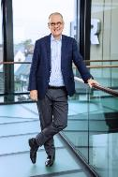

Fig. 1: Dr. Christoph Beumer, as managing partner, has steered the fortunes of the group of companies for more than 20 years.

Fig. 2: Rudolf Hausladen has been the new CEO of the BEUMER Group since June 1.

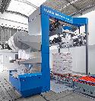

Fig. 3: The BEUMER stretch hood A offers load stability. Due to the highly flexible film, it is possible to different product sizes can be packed on the same pallet.

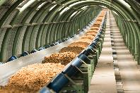

Fig. 4: In the case of the Pipe Conveyor, the conveyor belt, which is shaped into a closed pipe, prevents material loss and odor nuisance along the route and protects the conveyed material from rain, sun and wind.

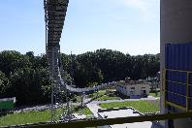

Fig. 5: With the U-shape conveyor, tighter curve radii than with a troughed belt conveyor and higher mass flows than with a tubular belt conveyor can be implemented.

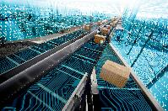

Fig. 6: Data analytics enables BEUMER Group to increase the availability and performance of its sorters.

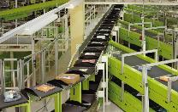

Fig. 7: Different articles can be handled with efficient sorting technology.

Photo credits: BEUMER Group GmbH & Co. KG

The high-resolution pictures can be downloaded here.

BEUMER Group is an international leader in the manufacture of intralogistics systems for conveying, loading, palletising, packaging, sortation, and distribution. With 5,100 employees worldwide, BEUMER Group has annual sales of about EUR 1.1 billion. BEUMER Group and its group companies and sales agencies provide their customers with high-quality system solutions and an extensive customer support network around the globe and across a wide range of industries, including bulk materials and piece goods, food/non-food, construction, mail order, post, and airport baggage handling.

For more information visit www.beumer.com.

