BEUMER Maschinenfabrik is again among the top one percent of German training companies in 2022:
Inspiring young people to pursue vocational training

This year, the Institute of Research & Data Aggregation GmbH honored BEUMER Maschinenfabrik for the quality and individuality of its Promotion of Young Talent scheme. This anchors the systems provider from Beckum in the top one percent of training companies in Germany. Various employers from all industries and regions were compared in an independent survey as part of the “Top Trainers” study.

This year again, BEUMER Maschinenfabrik in Beckum showed that it was one of the best training companies in Germany. The Düsseldorf Institute of Research & Data Aggregation confirmed the result in its “Top Trainers” study, which determines the top one percent of the best training centers in Germany.

“We are very proud that we have again won a prestigious award. We aim to inspire as many young people as possible to start an apprenticeship with us in the future,” says Michael Dilla, Head of Technical Vocational Training at BEUMER Maschinenfabrik. The company trains young adults to become industrial management assistants, IT specialists, industrial and construction mechanics and mechatronics and electronics technicians (m/f/X) . August 2022 will see twenty-two young people launch their careers at BEUMER. As part of a planned joint training program, two more trainees from partner companies will also complete part of their apprenticeships with BEUMER.

The categories in the study included the company’s internal and external communications, former, current and potential trainees’ evaluations, exceptional auditing results, and voluntary self-reporting. Potential trainees receive orientation with the help of freely available data. The data sources include the rating portal Kununu, Capital, Ausbildung.de, Territory, Bertelsmann, Deutschlandtest, Focus and Great Place to Work.

1,931 characters incl. blanks

Meta title: BEUMER Maschinenfabrik is one of Germany’s best training companies

Meta description: BEUMER Maschinenfabrik received an award from the Institute of Research & Data Aggregation GmbH in 2022 for its outstanding promotion of young talent.

Keywords: BEUMER; training company; Institute of Research & Data Aggregation; promotion of young talent; Top Trainer

Social media for editors: It doesn’t get much better than this: Top trainer for industrial management assistants, IT specialists, industrial and construction mechanics, mechatronics and electronics technicians (m/f/X) wanted? BEUMER Maschinenfabrik received an award from the Institute of Research & Data Aggregation GmbH in 2022 for its outstanding promotion of young talent. This award anchors the systems provider from Beckum, Westphalia, in the top one percent of training companies in Germany. The “Top Trainers” study compared companies from all industries and regions of Germany.

Caption:
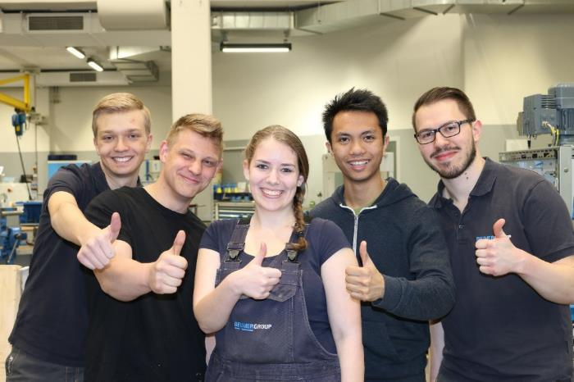
Photo: The quality of training at BEUMER Maschinenfabrik is at a very high level.

Photo credits: BEUMER Group GmbH & Co. KG

BEUMER Group is an international leader in the manufacture of intralogistics systems for conveying, loading, palletising, packaging, sortation, and distribution. With 5,100 employees worldwide, BEUMER Group has annual sales of about EUR 1,1 billion. BEUMER Group and its group companies and sales agencies provide their customers with high-quality system solutions and an extensive customer support network around the globe and across a wide range of industries, including bulk materials and piece goods, food/non-food, construction, mail order, post, and airport baggage handling.

For more information visit www.beumer.com.

