Holocene makes cross-border Supply Chain stable and predictable
Towards a borderless Supply Chain

Constantly growing demands for quality and sustainability have led to industries focusing more intensively on supply chain transparency and traceability. The company Holocene offers an AI-driven software (SaaS) that enables customers to optimize cross-border supply chain processes. The software brings visibility and traceability, and it builds trust between all trade stakeholders. Founders and Managing Directors Romain Fayolle and Navneet Lekshminarayanan received funding from BEUMER Group to support their venture.

How can cross-border Supply Chain be made more stable, transparent and predictable? The Berlin-based company Holocene has been working on finding the solution for this multi-faceted problem, which involves compliance with various trade agreements, regulations, and customs classifications, all of which are constantly changing. Companies use many different sources and often hire experts to keep up to date with these changes. Shippers often manually prepare documents that are unfortunately based on outdated regulations and on frequently unreliable information from the staff of various departments under extreme time pressure. In the worst-case scenario, important shipping documents may be incomplete or incorrectly filled out.

“Our Holocene software is based on state-of-the-art cloud and AI technologies,” says Romain Fayolle. “This means we can ensure that our customers safely comply with trade regulations and streamline their document creation processes.” His team includes supply chain, logistics & tech engineers, advised by trade compliance experts. Beam, the start-up incubator of the BEUMER Group, also based in Berlin, provided the founders with financial support. The incubator aims to solve unique logistics problems. Holocene is the seventh company to be incorporated under the Beam umbrella. It took seven months from the idea to the foundation of the company.

Holocene is a software that provides customers with cloud and AI technologies applied to trade compliance. Since it is a plug-and-play solution, customers can connect it to their ERP systems with hardly any IT effort, saving them costs and providing them with flexibility and the benefits of easy handling.

The customer can upload all scattered, manually created trade and customs instructions into Holocene. The software then converts these into digitalized, standardized, and actionable business rules stored in a secured database, to which only the customer’s shipping team has access. The Holocene software automatically checks shipping documents for compliance with trade regulations such as import duties, import licenses, and export permit requirements, internal taxation, and technical declarations of conformity in 191 countries. It automatically updates the policies and notifies the responsible employees should changes occur. The software makes recommendations if a change affects the shipping documents and issues alerts if the regulations cannot be complied with. These rules out problems with customs clearance at the destination. “We work together with leading institutions to regularly provide updates and always be up-to-date,” Fayolle explains. “Our solution is ideal for anyone who wants to ship physical goods from one country to another with no problems. Our customers can reduce their processing time and minimize costs associated with delays.”

More information at www.holocene.eu

3,517 characters incl. blanks

Meta title: Holocene software facilitates cross-border logistics and supply chain operations.

Meta description: Holocene, a Berlin-based company, provides the innovation and vision that enables everyone to do business in a borderless world. The challenge is to bring stability and predictability to the volatile cross-border supply chain, thereby achieving more successful and cost-effective business outcomes.

Keywords: BEUMER; Holocene; Berlin; Germany; cloud; AI; digitalization; automation; logistics; supply chain; cross-border; start-up; innovation; stability; predictability; customs; trade; policy
The company Holocene makes supply chain stable and predictable.

Constantly growing demands for quality and sustainability have led to industries focusing more intensively on supply chain transparency and traceability. The company Holocene offers an AI-driven software that enables customers to optimize cross-border supply chain processes. The software brings visibility and traceability, and it builds trust between all trade stakeholders. The company received financial funding from us to support its venture.

Do you want to learn more? Then visit Holocene at www.holocene.eu or click here.

Caption:
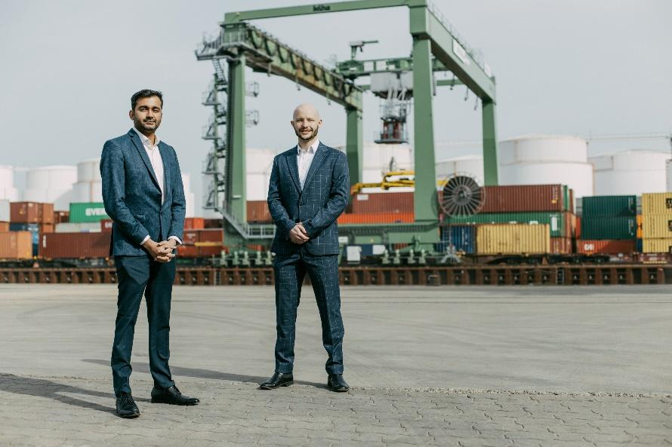
The Holocene team (l-r): Navneet Lekshminarayanan and Romain Fayolle – Founders and Managing Directors.

Photo credits: BEUMER Group GmbH & Co. KG
The high-resolution pictures can be downloaded here.

BEUMER Group is an international leader in the manufacture of intralogistics systems for conveying, loading, palletising, packaging, sortation, and distribution. With 5,100 employees worldwide, BEUMER Group has annual sales of about EUR 1,1 billion. BEUMER Group and its group companies and sales agencies provide their customers with high-quality system solutions and an extensive customer support network around the globe and across a wide range of industries, including bulk materials and piece goods, food/non-food, construction, mail order, post, and airport baggage handling.

For more information visit www.beumer.com.

