Purchase of FAM officially completed:
BEUMER Group acquires full control of the FAM Group of Magdeburg

Beckum/Magdeburg, June 13, 2022 – The FAM Group of Magdeburg, a supplier of conveyor systems and loading technology, is now wholly owned by the BEUMER Group, Beckum. BEUMER is an international leader in the manufacture of intralogistics systems for conveying, loading, palletizing, packaging, sorting and distribution. The purchase agreement was signed in early May and legally concluded on June 9, 2022.

The BEUMER Group has held a stable position in the bulk materials technology market for decades – and with the acquisition of the FAM Group, the systems provider has significantly strengthened its market position in the minerals and mining sectors. The FAM Group is a manufacturer of conveyor systems. It is headquartered in Magdeburg, Germany, and is an internationally operating, medium-sized group with 750 employees. The company is one of the world’s leading full-range bulk handling and processing equipment suppliers. The FAM Group plans, designs and manufactures turnkey plants and systems for mining, extracting, loading and storing minerals, raw materials and goods. In addition to expanding the BEUMER Group’s portfolio, FAM’s know-how and global positioning also complement BEUMER’s competence in the project planning of plants. FAM brings not only planning and engineering, but the entire value chain to the BEUMER Group, including aftersales service.

The BEUMER Group offers FAM a long-term perspective anchored on the highest possible quality, sustainability and innovation: For almost 90 years now, the BEUMER Group, a family-run and wholly self-financed company, has been developing customized system solutions for the mining industry, among others.

1,770 characters incl. spaces

Image selection:
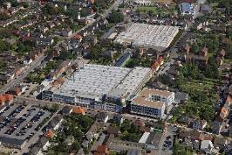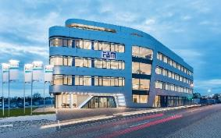
The high-resolution images can be downloaded here.

BEUMER Group is an international leader in the manufacture of intralogistics systems for conveying, loading, palletising, packaging, sortation, and distribution. With 5,100 employees worldwide, BEUMER Group has annual sales of about EUR 1,1 billion. BEUMER Group and its group companies and sales agencies provide their customers with high-quality system solutions and an extensive customer support network around the globe and across a wide range of industries, including bulk materials and piece goods, food/non-food, construction, mail order, post, and airport baggage handling.

For more information visit www.beumer.com.

