Rudolf Hausladen is the new CEO of the BEUMER Group
Change of leadership in the family-run company

Beckum, June 1, 2022 – From 1st of June 2022, there is a change of leadership in the family-run company BEUMER Group, Germany. Rudolf Hausladen is the new CEO and succeeds Dr. Christoph Beumer, who has led BEUMER Group as CEO very successfully since 2000. Dr. Beumer will remain a member of the Management Board until the end of the year and then move to the Advisory Board.

“We are very pleased that we were able to gain such an expert for this position,” says Dr. Christoph Beumer. “With his hands-on style, he’s an ideal match for our company and us.” Rudolf Hausladen adds: “The BEUMER Group is a very modern, dynamic and innovative company. I can contribute all my strength and expertise here. I’m very much looking forward to my new role.”

Rudolf Hausladen (52) has a university degree in Mechanical Engineering as well as an MBA and has held management positions with well-known intralogistics providers, both nationally and internationally before. He has served on the Management Board of BEUMER Group since October 2020.

1,125 characters incl. spaces

Meta title: Change of management at the BEUMER Group – Rudolf Hausladen is the new CEO

Meta description: Rudolf Hausladen is the new CEO of the BEUMER Group. He succeeds Dr. Christoph Beumer, who has led the group of companies as CEO and Managing Partner since 2000.

Keywords: BEUMER Group; Rudolf Hausladen; CEO; Dr. Christoph Beumer; Change of management

Caption
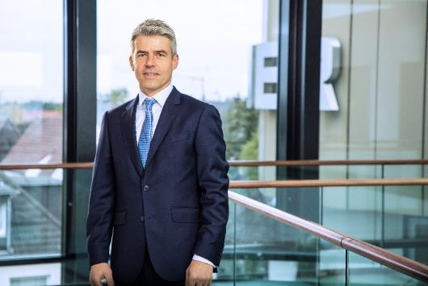
Rudolf Hausladen is the new CEO of the BEUMER Group.

Picture credits: BEUMER Group GmbH & Co. KG
The high-resolution picture can be downloaded here.

BEUMER Group is an international leader in the manufacture of intralogistics systems for conveying, loading, palletising, packaging, sortation, and distribution. With 4,500 employees worldwide, BEUMER Group has annual sales of about EUR 960 million. BEUMER Group and its group companies and sales agencies provide their customers with high-quality system solutions and an extensive customer support network around the globe and across a wide range of industries, including bulk materials and piece goods, food/non-food, construction, mail order, post, and airport baggage handling.

For more information visit www.beumer.com.

