BEUMER Group at LogiMAT 2022:
The e-commerce of tomorrow

In 2022, BEUMER Group will be back in action at LogiMAT (May 31 - June 2, Stuttgart). Among other things, the system provider will present the new BG Pouch System. This is the Group's latest addition to its vast range of solutions to respond to the growing demands for e-commerce fulfillment and distribution. The new BG Sorter Compact will also be show-cased as a "first" public appearance at LogiMAT showing how a loop sortation solution can combine' greater flexibility with a smaller footprint.

BEUMER Group is a family-run business whose product developments and innovative systems have been vouching for outstanding customer satisfaction for more than 80 years. This year, with a long-awaited resumption of the LogiMAT trade show, the international material handling systems provider will present its solutions in a very special location: In Hall 1, Booth OG82/84, and with a perfect view of the hall, BEUMER Group will exhibit the new BG Pouch System, a pouch sorter that meets the many requirements of e-commerce fulfillment and omnichannel operations. The BG Pouch System enables the growing demand for fast, e-commerce driven cycle times to be met by warehouses and third-party logistic (3PL) providers. The persisting problem of reverse logistics is solved by effective and efficient handling of returns using built-in interim storage capacity for returned products. This avoids unnecessary manual handling as returned goods can be sent for shipment directly from the dynamic buffer, without ever being sent back to the main storage area and without having to be re-picked. In an omni-channel environment, the sort and sequence functions are invaluable to facilitate goods sortation for shop delivery to ensure products arrive to stores in a shop-friendly manner and expedite shelf replenishment. The system has a capacity of 7kg which is ideally suited to fashion items from shoes to garments on hangers (GoH), as well as a wider product profile, including print & media, pharmaceuticals & beauty products and electronics.ms.

BEUMER Group is also responding to the growing requirements in the e-commerce field with its new BG Sorter Compact CB. This system is suitable for sorting units of up to 12 kilograms. With this solution, BEUMER Group has focus on the needs of courier, express and parcel services which have to react to the increasing small parcel shipping volume. The compact system design enables a more flexible overall layout, making it particularly easy to integrate the system into existing sorting centers.

In Stuttgart, visitors can also learn more about the BG Line Sorter, a particularly efficient solution for small to mid-capacity mail and distribution centers. This next-generation line sorter solution is the first to combine the simplicity of a line sorter with the gentle handling capabilities of a high-speed cross-belt sorter. This solution reliably conveys flats, bagged items and fragile piece goods with care and precision. The BG Line Sorter is quiet and low-maintenance – and its modular design makes it easily extendable and a secure investment for the future.

Digitalization is essential in order to operate with efficiency and accuracy in an increasingly complicated industry. The use of data analytics represents the process of collecting enormous amounts of information from distribution hubs – equipment and operations included – which is then stored as data. Understanding and working with these data are extremely valuable tools for improving the throughput of a distribution center. BEUMER Group experts will be present to explain what digitalization can for the logistics industry.
The BEUMER Group portfolio includes the BG Software Suite, which allows system owners to control their end-to-end material flows. The suite can be adapted to each operation's specific needs and third-party products can be integrated without difficulty. Users can adapt this modular controls system to their specific solutions and add modules over time in order to further optimize their material flows.

The end-to-end packaging lines which the system provider adapts to the user’s specific products are also digital and networked. These tailor-made solutions are used for consumer goods and other products and handle every aspect from the palletizing of the bags through to the stacked products packaged ready for transport, including the control technology and comprehensive customer support. One component used in these lines is the BEUMER paletpac high-performance palletizer. The BEUMER Group also supplies the BEUMER robotpac for palletizing goods packaged in cartons, boxes, canisters or trays. The high-performance packaging systems from the BEUMER stretch hood series then package the palletized goods in a highly elastic stretch hood, thereby securing them safely on the pallet ready for transport and transshipment and protecting them against dust, rain or other weather influences in the event of outdoor storage.

BEUMER at LogiMAT 2022: Hall 1, Booth OG82/84

5,059 characters incl. spaces

Meta Title: LogiMAT: BEUMER will display pouch sorters for direct shipping to consumers and branches.

Meta Description: In Hall 1, Booth OG82/84, the system provider will display sorting and distribution technology that allows users to react to the growing demands in the e-commerce field.

Keywords: BEUMER Group; LogiMAT; BG Sorter Compact; Sorting technology; Digitalization; Intralogistics systems; BEUMER Smart Glasses; BG Pouch System; Pouch sorter; BG Line Sorter

Social Media: In 2022, we will be back in action at LogiMAT (May 31 - June 2, Stuttgart). Among other things, we will present the new BG Pouch System. In this way, we are responding to the growing requirements in the field of e-commerce fulfillment: Operators can equip themselves with a pouch sorter for direct shipping to consumers and branches. Our new BG Sorter Compact will also be making its first public appearance at LogiMAT. This solution combines greater flexibility with a smaller footprint. Come and see us in Hall 1, Booth OG82/84.

Captions:
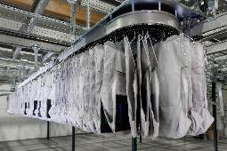
Picture 1: The BG Pouch System is primarily used for fashion logistics – for example, to handle returned products.
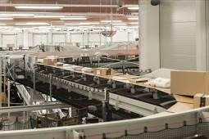
Picture 2: With its sorting and distribution equipment, BEUMER Group offers controlled, high-precision sorting combined with optimized flexibility.

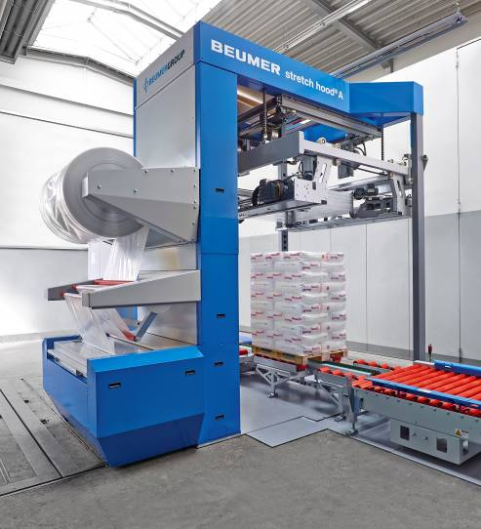
Picture 3: The BEUMER stretch hood A. A product that clients find particularly attractive due to its simple, intuitive and safe operation.

Picture credits: BEUMER Group GmbH & Co. KG

The high-resolution pictures can be downloaded here.

The BEUMER Group is an international leader in the manufacture of intralogistics systems for conveying, loading, palletising, packaging, sortation, and distribution. With 4,500 employees worldwide, the BEUMER Group has annual sales of about EUR 960 million. BEUMER Group and its group companies and sales agencies provide their customers with high-quality system solutions and an extensive customer support network around the globe and across a wide range of industries, including bulk materials and piece goods, food/non-food, construction, mail order, mail and airport baggage handling. For further information visit www.beumer.com.

