BEUMER Group at LogiMAT 2022:
Tomorrow's e-commerce

In 2022, BEUMER Group will be back in action at LogiMAT (March 8-10 March, Stuttgart). Among others, the system provider will present the new BG Pouch System. Thus, the system provider reacts to the growing demands for e-commerce fulfilment and the combination of retail and D2C: The owner receives a sorter for direct shipping to consumers and stores. Also the BG Sorter Compact will celebrate its premiere at LogiMAT and promises more flexibility in a tight footprint.

BEUMER Group is a family-run business that has been standing for high customer satisfaction with its product developments and innovative systems for over 80 years. In hall 1 at booth OG82/84, the system provider will present the new BG Pouch System, a pouch sorter that meets the requirements of e-commerce fulfilment: Fashion companies receive a matrix sorter for direct shipping to consumers and stores. They benefit from simplified returns handling because dynamic buffering eliminates the need for re-stocking and picking. The new sorter increases throughput by 25 percent compared to conventional pouch sorters.

BEUMER Group reacts to the growing demands of e-commerce with the new BG Sorter Compact CB. The system is suitable for sorting units up to 12 kilogram. The system provider wants to address courier, express and parcel services in particular, which have to react to the increasing shipping volume and higher throughputs. Its compact design enables a more flexible overall layout, which makes the system particularly interesting for integration into existing premises.

In Stuttgart, visitors can also learn more about the BG Line Sorter, a particularly efficient solution for mail and distribution centres with small and medium capacity. It reliably conveys letters, bagged and fragile items with care and precision. The BG Line Sorter's quiet operation, low maintenance and modular design makes it a safe long-term investment.

Digitalisation is indispensable in increasing the performance of the sorters sustainably. With the support of data analysis, it is possible to collect large amounts of data on the machines, to evaluate them in a targeted manner and thus detecting where there is potential for improvement. The collected information permits to continuously improve operation, which has a positive effect on product life-cycle costs.

Thus, the needs of customers are also growing with regard to the increasing amount of data. It is important to efficiently map their processes in e-commerce or sorting algorithms. BEUMER Group's Software Solutions division supports its customers in this regard, in order to offer significant added value. Trade visitors can find out more about this at LogiMAT.

If problems occur during operational processes, it may be the result of production bottlenecks which could lead to delays in day-to-day operations. BEUMER Group supports you with its comprehensive customer support and offers, among other things, quick assistance with Smart Solutions to prevent longer downtimes. At LogiMAT, BEUMER Group will present the BEUMER Smart Glasses, an efficient digital solution for maintenance and remote commissioning that avoids time-consuming travel and high additional costs.

With regard to the digitalisation subject, the system provider relies on the support of start-ups, thus extending the range of services for its customers. With a digital marketplace, Sparrow Networks ensures that the participants are supplied with the appropriate spare part as quickly as possible if a component in their production should fail to perform. Elara Digital GmbH offers the right solutions for reduced downtimes and increased machine availability. Relevant information such as work orders, checklists, machine documentation or guides for trouble shooting can be created in an easy and intuitive way and can be accessed at any time via a mobile phone for example. The founders will be at the BEUMER trade fair booth during the show.

BEUMER at LogiMAT 2022: hall 1, booth OG82/84

4,030 characters incl. blanks
Meta Title: LogiMAT: BEUMER presents a matrix sorter for direct shipping to consumers and stores.

Meta Description: In hall 1 at booth OG82/84, the system provider presents sortation and distribution technology, with which the user can react to the growing demands of e-commerce.

Keywords: BEUMER Group; LogiMAT; BG Sorter Compact; sortation technology; digitalisation; intralogistic systems; BEUMER Smart Glasses; BG Pouch System, matrix sorter; pouch sorter; BG Line Sorter

Social Media: In 2022, BEUMER Group will be back in action at LogiMAT (March 8-10, Stuttgart). Among others, the system provider will present the new BG Pouch System. Thus, the system provider reacts to the growing demands for e-commerce fulfilment and the combination of retail and D2C: The owner receives a matrix sorter for direct shipping to consumers and stores. Also the BG Sorter Compact will celebrate its premiere at LogiMAT and promises more flexibility in a tight footprint. Visit us in hall 1, booth OG82/84.

Captions:
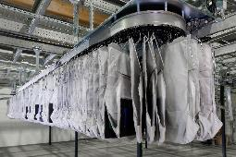
Picture 1: The BG Pouch System is especially used in fashion logistics – for returns handling for instance.

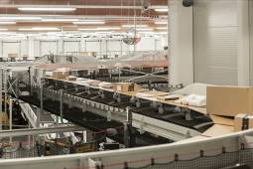
Picture 2: With its sortation and distribution systems, BEUMER Group offers a precise and controlled sortation with maximum flexibility.

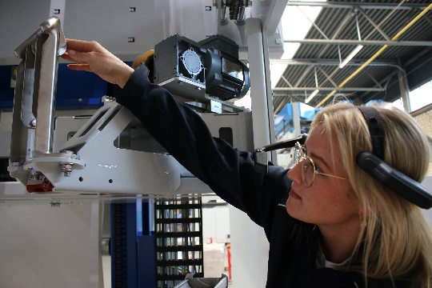
Picture 3: The service personnel has all important information displayed in the live image of the camera via the BEUMER Smart Glasses.
Photo credits: BEUMER Group GmbH & Co. KG

You can download the high-resolution pictures here.

BEUMER Group is an international leader in the manufacture of intralogistics systems for conveying, loading, palletising, packaging, sortation, and distribution. With 4,500 employees worldwide, BEUMER Group has annual sales of about EUR 950 million. BEUMER Group and its group companies and sales agencies provide their customers with high-quality system solutions and an extensive customer support network around the globe and across a wide range of industries, including bulk materials and piece goods, food/non-food, construction, mail order, post, and airport baggage handling.

For more information visit .www.beumer.com

