BEUMER Group supplies adaptable packaging line to Mexican cement manufacturer Cruz Azul:
Fast process from beginning to end

The Cooperativa La Cruz Azul S.C.L, third-largest cement manufacturer in Mexico, required an entire packaging line for the flexible and fully automated filling, palletising and packaging of different types of a new tile mortar. The BEUMER Group solution won out over the competition, providing everything from one single source. This included the BEUMER fillpac R filling system that was adapted for filling different materials. They also included the BEUMER bag placer to ensure a more efficient filling of the high-quality materials. With this new packaging line, Cruz Azul can achieve their projected production capacity.

Gigantic bridges, high-rises, tunnels for roads, subways and sewage systems: some of biggest construction projects in Latin America are currently being built in Mexico. This makes the country the second largest cement market on the continent, right after Brazil. In order to hold their own against national and international competition, Mexican manufacturers are developing more and more high-class materials. Cooperativa La Cruz Azul, headquartered in Mexico City, is one of them. The production of this leading company, founded in 1881, is aimed exclusively towards the domestic market. The manufacturer operates four plants with a yearly production of around eight million tons of Portland cement per year, which is only one of their end products. The main plant is in Jasso in the state of Hidalgo. The city is located in a region that is very rich in limestone. A football club founded by employees of this cement plant in 1927 is now playing in the top level of the Mexican football league, with national and international success.

Decisive factors: supplier reliability and quality
Success plays an important role for Cruz Azul as well. Its cement production represents 22 percent of the national market. With the goal to further increase this share, the cooperative developed high-quality tile mortar in eight different variations as one of their new products. "The quality of the building materials is decisive in order to remain competitive," explains Victor Luna, Managing Director at Cruz Azul in Hidalgo. Distributors and end customers also want the products to arrive by the required date and quantity. A small amount of the mortar is sold in big bags, the majority however is sold in 20- and 25-kilogram bags. This is why the manufacturer needed an entire packaging line that could meet very specific requirements: due to varying material densities, and as a consequence different flow properties of the different variants of the new product line, the filling system had to be adjustable to the different materials as well as to smaller bag sizes without extensive retrofitting of the machine through the employees. The line should then palletise precise and stable bags stacks and package them to protect the content against transport damage and atmospheric influences.

Decision for the right partner
March 2015: after an offer from another supplier had already gone in and the project was already at an advanced stage, employees from the cooperative Cruz Azul responsible for the project reached out to BEUMER Group to also hand in an offer. "We have been working closely together for the last 30 years," says Victor Luna. "We have a long-standing relationship and trust in the BEUMER brand."

This trustful relationship is not surprising. BEUMER Group was already able to convince in 2008. In an extensive major order for the plant in the state of Puebla, the system supplier provided and installed five bucket elevators and two palletising and packaging lines in only 26 months. They consist of BEUMER paletpac palletisers and the BEUMER stretch hood high-capacity packaging systems. As with the current project, one of the requirements for this line was to palletise and package various bagged materials, without extensive retrofitting of the machines. Victor Luna emphasises that BEUMER Group provided them with an adaptable technology with which his colleagues are working efficiently to this day.

Filling technology made in Germany
BEUMER Group presented the BEUMER fillpac R filling system to Cruz Azul. "Changing the required parameters is simple and quick and the different material is filled efficiently into two- to four-ply paper valve bags," explains Ralph Buchholz, Director General at BEUMER de México. Both companies quickly agreed on the scope and scheduling for the entire packaging line, and signed the contract already in April. "Cruz Azul attaches greatest value to the quality seal 'Made in Germany'," explains Buchholz. "Those responsible for the project even travelled to our headquarters in Beckum, Germany to accept the systems in person."

In October 2015, the BEUMER Group provided the systems. Three BEUMER eomployees from Germany and one from Mexico were in charge of installing the system. "We had to integrate the line into the existing building structure and bulk storage technology," reports Buchholz. "My colleagues mastered this challenge because our solutions can be easily adapted to technical and structural conditions." In this case, the engineers had to rework the suspension for the BEUMER fillpac.

Precise degrees of filling
The BEUMER fillpac R operates with with eight rotating filling spouts according to the impeller filling principle. This way it can safely handle even fine-grained tile mortar. The rotating filling impeller is characterised by its speed and maximum material throughput. "The bags are weighed during the filling process," explains Buchholz. The BEUMER fillpac is equipped with an electronic calibration-capable weighing unit. It ensures that the bags are always filled with the same amount of material. A special software enables filling spouts and scale to constantly compare the weight. If the determined weight is incorrect, the bags are automatically removed, discharged on a chute and opened. The collected material is fed back into the process via a spillage screw conveyor and a bucket elevator.

The system has a modular structure. "We equipped the system with the new BEUMER bag placer because the material is so fine and volatile," says Buchholz. A ream magazine for 700 bags was also added. This allows Cruz Azul to further increase the efficiency of the filling system. Servomotors drive the application unit and the suction gripper automatically, precisely and energy-efficiently. The gripping system and the application unit apply the bag from the stack safely onto the filling spout. The system can pack 1,800 25-kg bags or 2,250 20-kg bags per hour with the highest precision. "The operator can also adjust the BEUMER bag placer to other bag formats," explains Buchholz.

For the subsequent fully automatic, reliable and most of all fast palletising, BEUMER Group installed a BEUMER paletpac layer palletiser. Per hour, it gently and reliably stacks 2,200 bags per hour in 10-bag patterns or in 8-bag patterns on pallets of 1,220 x 1,020 x 245 millimetres in size. "A twin-belt turning device brings the bags in the required, dimensionally stable position," explains Buchholz. The position accuracy of this device offers a great advantage compared to conventional turning machines, because the system's components move the bags without mechanically deforming them: two parallel driven belt conveyors move at different speeds and turn the bags quickly into the desired position. The intelligent control of the twin-belt turning device also takes the dimension and weight of the filled bag into consideration. Exact positioning, specified by the preset packing pattern, is achieved. "No adjustement is necessary even with a product change," says Buchholz.

Packed fast and safely
The finished bag stacks are transported over roller conveyors to the BEUMER stretch hood packaging system. It packages 110 pallet stacks per hour with stretch film hoods with film thickness ranging from 40 to 100 micrometers. "It depends on the type of tile mortar," Buchholz explains. "The packaging protects the product against dust and humidity during storage and on long transport routes and ensures that the bags remain stable on the pallet without moving." In order to facilitate the work for the maintenance personnel and to ensure high system availability, the packaging system no longer needs a platform. Maintenance work, such as changing the blades or the sealing bars, is handled at floor level. Additional benefits include the compact design and the resulting low height and small footprint.

"The BEUMER stretch hood A is extremely energy efficient," emphasises Buchholz. A film transport system, which is particularly gentle on the material, introduces the previously cut and sealed film hood into the system. The sealing seam already cools down on the way to the crimping and stretching unit. Crimping can start without any delay. This allows for the elimination of energy-consuming cooling units and efficiency-reducing cooling times. This way the pallets can be packaged at a high bag sequencing.

In June 2016, Cruz Azul put the line into operation. "The new BEUMER packing line brought the project to success," mentiones Victor Luna. Which means that the cement manufacturer can reach its projected production capacity. In order to ensure a trouble-free operation, the system supplier's competent specialists stay in close touch with the customer and help out immediately in case of malfunctions or downtimes. BEUMER Group also provided the necessary spare parts. Ensuring high availability of the systems at all times.

Victor Luna is visibly very pleased with the new solution because this packaging line is tailor-made for their needs. He is particularly impressed by the flexible filling technology. It saves a lot of time and brings great peace of mind, the different types or mortar are getting to the customer a lot faster. With this project, BEUMER Group has installed the first BEUMER fillpac R on the American market. The cooperation with the system supplier will continue. Discussions are currently held regarding new projects in the fields of conveying and loading and palletising technology.

Meta title: BEUMER supplies entire packaging line to cement manufacturer Cruz Azul

Meta description: BEUMER Group supplies adaptable packaging line to Mexican cement manufacturer Cruz Azul.

Keywords: BEUMER Group, packaging line, adaptable filling technology, cement manufacturer, cement, Cruz Azul, palletising, packaging, fillpac, paletpac, stretch hood, bag placer, Mexico, tile mortar

10,620 characters (incl. spaces)

Captions:
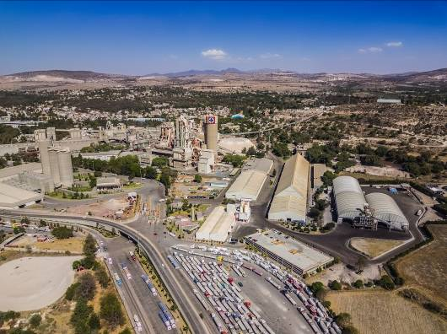
Picture 1: One of the sites of the Cooperative La Cruz Azul is in Hidalgo. Some of the newest products of the cement manufacturer are eight different types of a new tile mortar.

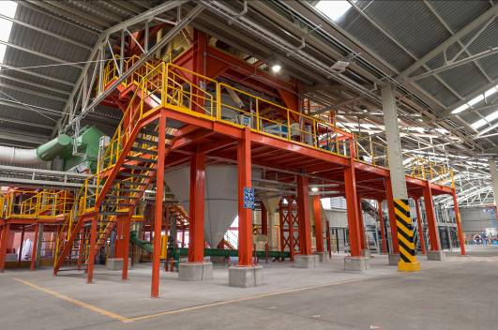
Picture 2: Cruz Azul required an entire line to flexibly bag, palletise and package the different types of tile mortar.

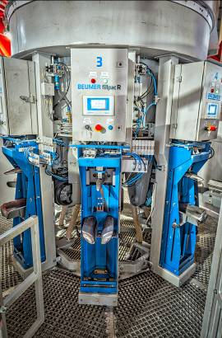
Picture 3: BEUMER Group supplies everything from one single source. This includes the BEUMER fillpac filling system. It can be adjusted to the changing parameters of the different materials.

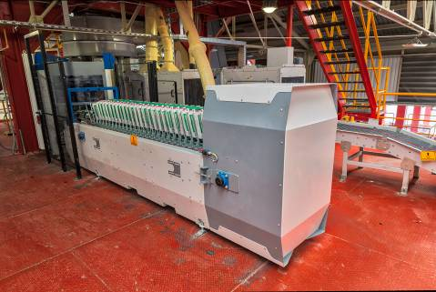
Picture 4: The BEUMER fillpac R is equipped with a ream magazine for 700 bags...
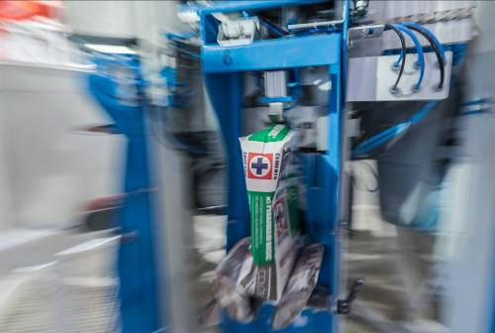
Picture 5: ... and the new BEUMER bag placer. This allows Cruz Azul to further increase the efficiency of the filling system.
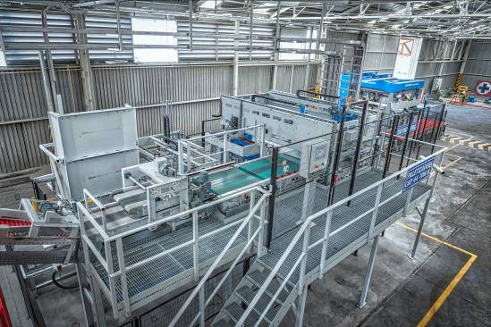
Picture 6: The packaging line operates around the clock. Which means that the cement manufacturer can reach its projected production capacity.

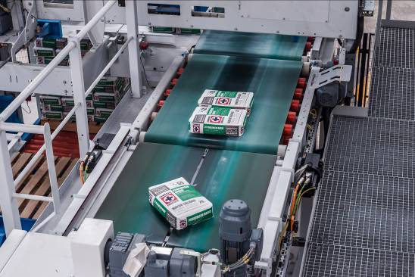
Picture 7: The twin-belt turning device accurately positions the bags quickly and gently.

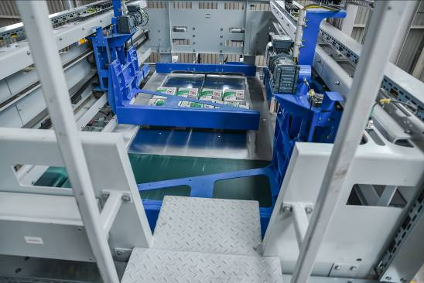
Picture 8: The BEUMER paletpac layer palletiser can stack the bags in a 8- or 10-bag pattern onto pallets of 1,220 x 1,020 x 245 millimetres in size.

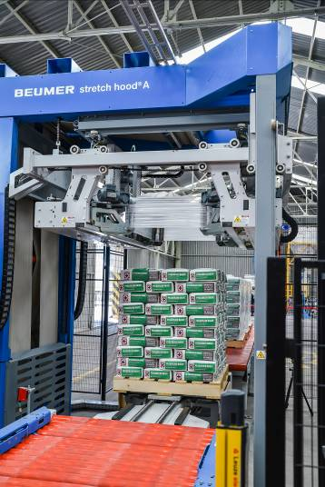
Picture 9: The BEUMER stretch hood A packages the bag stacks with a stretch film hood. This protects the product against damage during transportation and atmospheric influences.

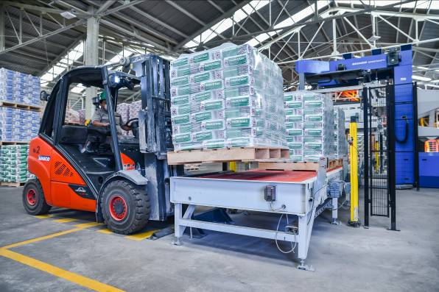
Picture 10: Picking up the palletised and packaged products with a fork-lift truck and delivering them to the outgoing goods.

Link to download high-resolution copies of the photos: https://cloud.a1kommunikation.de/index.php/s/0oa7pT0v2XxzSUh

Picture credits: BEUMER Group GmbH & Co. KG

The BEUMER Group is an international leader in the manufacture of intralogistics systems for conveying, loading, palletising, packaging, sortation, and distribution. With 4,000 employees worldwide, the BEUMER Group has annual sales of about EUR 750 million. The BEUMER Group and its group companies and sales agencies provide their customers with high-quality system solutions and an extensive customer support network around the globe and across a wide range of industries, including bulk materials and piece goods, food/non-food, construction, mail order, post, and airport baggage handling. For further information visit www.beumergroup.com.

