BEUMER Group relies on efficient belt change process on overland conveyors:
For maximum availability

BEUMER Group supplied a complex complete system composed of several belt conveyors to one of the leading cement manufacturers in Thailand, for transporting limestone from the quarry to the blending bed. After approx. four years, the belt of the almost 3.5 kilometres long overland conveyor had to be replaced quickly and efficiently. Instead of exchanging the single belt sections one after the other during long operation stops, BEUMER Group relied on a process, that allows the new belt to be inserted into the system and the old belt to be pulled out only in one go. This results in substantial time saving for the customer and avoids unplanned system failures.

The goals for many building materials companies including TPI Polene Public Company Ltd. are being able to compete with the leading cement manufacturers and to position themselves for profitable construction projects. At this regard, the third largest cement manufacturer in Thailand needs systems that run reliably and can be adapted to the increasing requirements of the market. "TPI commissioned us in 2013 with the installation of a complex conveying system for transporting limestone from the quarry to the blending bed," says Alexander Unruh, project manager for conveying and loading technology at BEUMER Group.

The BEUMER team designed an economically complete system made of several belt conveyors. In addition, the system provider supplied a system control (PLC), transfer stations and filter systems as well as foreign material separators. The system is dimensioned for a conveying capacity of 2,200 tons per hour. The core of the conveying system for limestone consists of two belt conveyors leading downwards, which are run in regenerative mode and are followed by a troughed belt conveyor with horizontal curves. "The material is transported from the crusher discharge conveyor to the first two troughed belt conveyors," explains Unruh. "Afterwards, the material transported is transferred via an acceleration belt conveyor to an overland conveyor with a centre distance of 3,464 metres at a speed of four metres per second. The conveyor is equipped with vertical and horizontal curves and achieves a speed of 4.5 metres per second. Three following conveyors transport the material to the blending bed.

In order to remove the material from the blending bed and to feed the primary hopper of the raw mills, BEUMER Group supplied further belt conveying systems with an overall length of 989 metres. The BEUMER team was able to build and install all the conveyors in only eleven months. The commissioning phase of three months was followed by the performance tests. Finally the system provider handed over the complete system to the customer. "That was in 2015, but the project was not yet terminated for BEUMER Group," emphasises Unruh.

A constantly trouble-free operation
The BEUMER technicians not only accompanied and supervised the installation and the commissioning. The standard scope of supply also included an intensive training of the operation and maintenance personnel – tasks which are performed by the extensive BEUMER customer support team. More than 1,000 employees worldwide now work for this business segment. "We support our customers from the first project meeting up to the running system, but we also make sure that the system runs safely in the long term," says BEUMER expert Unruh. After four years in continuous operation, the risk of a failure increased due to the replacement state of wear of the belt.

The conventional belt change method would mean for the service technicians to replace the belt by changing every belt section separately. Depending on the belt coil, this could imply eight to eighteen belt sections. "Of course this would be very time consuming if the employees perform this work in one go," says Unruh. During this time, the complete system is stopped. Therefore, the cement manufacturer suggested to replace the single belt sections gradually, enabling to arrange the downtimes such to affect the working flow as little as possible. Nevertheless, the total downtime of the conveyor would still be very high and the risk of a failure would persist. "A belt change on a conveyor of this length is always critical," knows Unruh.

Belt change only in one go
In order to keep downtime to a minimum, the BEUMER technicians suggested a new concept that allows them to replace the entire belt at once. "During this process, the single belt coils are joint to form a long belt next to the conveying system and are then connected to the old belt," explains Unruh. "The existing drive technology and further auxiliary means are used to insert the new belt into the system, while the old one is pulled out at the same time".

The BEUMER technicians examined the conveyor in advance to find a suitable place for the new belt. It is important that the location is directly at the system, that it is easily accessible and that the employees have enough space to prepare the belt, because the connection of the belt ends usually implies their vulcanisation; this requires space for the preparation, but also for the materials required. "The belt sections were stored outside and protected against UV-rays by a special film. The belt connections were carried out in an air-conditioned tent," says Unruh. "Why air-conditioned"?, repeats Unruh. Vulcanisation can be made more difficult by environmental conditions such as the nature of the terrain, but above all by the weather. Snow, freeze and ice or rain may imply a forced break for the employees because the process requires not only a lot of heat but also time. I wouldn't plan a belt change during a Monsoon in India for example".

Based on the preparations and on their complex experience, the BEUMER team was able to estimate the total downtime during the belt change. The work itself was carried out by the service personnel of the customer. The supervisor of the belt supplier was on site to supervise the workmanship.

Less downtime, less costs
"If we consider only the costs, the conventional process is less expensive," describes BEUMER expert Unruh. "However, the new process scores with its significantly reduced downtimes". This makes it profitable exactly when you consider the total cost arising for the customer in case of a downtime - for example, in case of conveying systems with a length of a few kilometres, as at TPI Polene Public Company Ltd. "And as we can change the belt only in one go, the user benefits from considerably higher safety: the risk of unplanned downtime is almost non-existent," says Unruh.

6,674 characters incl. spaces

Meta-Title: BEUMER Group: efficient belt change on overland conveyors

Meta-Description: BEUMER Group relied on an efficient process to exchange the belt in an overland conveyor of a Thai cement manufacturer in only one go and to avoid long downtimes.

Keywords: BEUMER Group; cement; overland conveyor; conveying system; limestone; belt change

Captions:
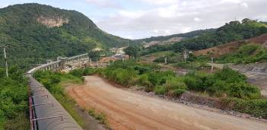
Picture 1: The Thai cement manufacturer TPI commissioned BEUMER Group in 2013 with the installation of a complex conveying system to transport limestone from a quarry to a blending bed.
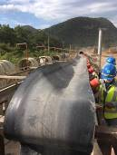
Picture 2: After approx. four years, the old belt of the almost 3.5 kilometres long overland conveyor had to be replaced quickly and efficiently.

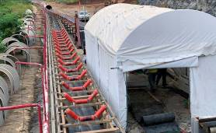
Picture 3: The new belt is stored next to the conveying system.

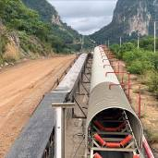
Picture 4: The single belt coils are vulcanised to a long belt next to the conveying system and joint to the old belt.

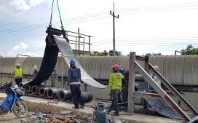
Picture 5: The "flaking": The single belt layers are stacked to a belt stack with a length of just under 7,000 metres.

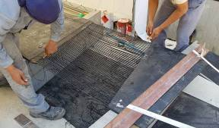
Picture 6: The service technicians prepare the belt enabling the connection of the belt ends.

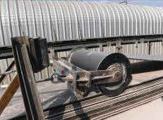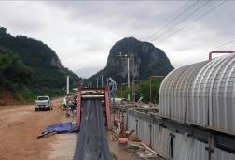
Picture 7 and 8: The new belt is inserted and the old belt pulled out of the system at the same time

Picture credits: BEUMER Group GmbH & Co. KG

The high-resolution pictures can be downloaded here.

The BEUMER Group is an international leader in the manufacture of intralogistics systems for conveying, loading, palletising, packaging, sortation, and distribution. With 4,500 employees worldwide, the BEUMER Group has annual sales of about EUR 950 million. BEUMER Group and its subsidiaries and sales agencies provide their customers with high-quality system solutions and an extensive customer support network around the globe and across a wide range of industries, including bulk materials and piece goods, food/non-food, construction, mail order, mail and airport baggage handling. For further information visit www.beumer.com.

