BEUMER Group supports Lhoist Faxe Kalk with entire packaging line and reliable service
Convincing all along the line

Lhoist Faxe Kalk is Denmark's largest supplier of lime and limestone. In order to be able to react efficiently to future customer demands, the company is opting for a new packaging line. BEUMER Group supplied it completely from one single source. The system provider not only had to adhere to a tight time frame, but also install the line in an almost 100-year-old factory building with numerous columns.

Around 63 million years ago, the Danish island of Zealand was covered by the sea. In this sea a large coral reef was formed in the place of today's city of Faxe. Today the Belgian Lhoist Group operates a quarry there, which is in the immediate vicinity of the Lhoist Faxe Kalk A/S plant. The Danish subsidiary of the Lhoist Group is currently one of Denmark's largest producers of lime and limestone with 68 employees. "The small town of Faxe was the eponym for our company," says plant manager Klaus Rønholt. "Incidentally, the limestone obtained is a rather crumbling stone riddled with corals."

The Lhoist Group is the world's largest manufacturer of lime and dolomite products. It operates around 100 plants in over 25 countries and employs more than 6,400 people. The group is continuously growing. In order to meet the increasing demands of the market and also to be able to meet future customer needs, Lhoist invests in the further development of the product range as well as in new systems and machines – including in Zealand. "Our products have to get to our customers even faster," says Rønholt. "Not only is production increased, the goods also have to be filled into bags at a higher throughput, stacked on pallets, packed with film and transported to dealers and end customers without damage." However, the existing packaging line was already getting old. Lhoist Faxe Kalk was only able to achieve the required throughput by running extra shifts. In addition, there was an increased amount of dust during filling. In order to protect employees and the environment as best as possible, the decision was made to replace the existing filling machines with the latest BEUMER Group systems.

Requirement: everything from one single source
In search of a suitable solution, the managers looked at various providers. “It was important for us to get everything from one source. We only wanted one contact person to avoid interfaces to several suppliers,” reports Rønholt. During the search, the manufacturer came across the BEUMER Group. "As a full-service provider for packaging lines, we were able to convince Lhoist Faxe Kalk", says Dirk Loose. He is sales manager for the Scandinavian market at BEUMER Group and was responsible for the project. "With our modular product range, we tailor our solutions to the requirements of our customers," he explains. The Danish manufacturer wanted a complete line with systems that work reliably, comply with environmental regulations, have a high degree of automation and, above all, be able to safely handle the hydrated lime. The material tends to build up "bridges" in the product feed, which makes filling very difficult. Because the system provider got into the project relatively late, the time frame for the installation was tight. The production stop needed to be as short as possible. BEUMER Group was flexible in meeting this customer requirement: The building was renovated and prepared for the new line while the old line was still running, and the old line was stopped and dismantled only a few days prior to the delivery of the complete line from Beumer. In this way, the downtime could be reduced to an absolute minimum.

“For the filling of the hydrated lime, we delivered our filling machine, the BEUMER fillpac series, an inline filling machine with two adjacent filling spouts. Due to the special requirements for bagging lime products, two turbines are used,” says BEUMER expert Loose. The system provider also equipped the system with the automatic BEUMER bag placer. This shoots the pre-openend valve bags precisely onto the filling spouts. "This allows us to further increase the performance and efficiency of the filling machine," describes the sales manager. Furthermore, the paper valve bags are getting automatically sealed after the filling process has been completed. In order to avoid spillage of material during the filling process, an inflatable rubber sleeve at the filling spout is sealing the bag to the filling spout. Finally, the valve is automatically sealed by ultrasonic sealing. As a result, virtually no material can escape from the bag after the bagging process. These two measures convinced the customer to do the best to protect the health of their employees and the environment.

The product is filled according to the gross weight principle. The bags are permanently weighed during the filling process. For this purpose, the machine is equipped with a verifiable weighing unit. The weighing electronics ensure that the BEUMER fillpac always achieves an exact filling level within the specified tolerances. Special software enables permanent communication between the scale and the filling spout. This ensures that the filling system adjusts itself immediately and automatically if there might be any deviations from the target weight.

Space-saving, reliable and energy-efficient palletising solution
With the BEUMER robotpac, the full-range supplier from Beckum supplied an articulated robot that then stacks the bags fully automatically on pallets. In the inlet to the robot, the bags passing through a bag flattening conveyor. This deaerates the bags and puts them in a stackable form. An ultrasound system measures the bags to be stacked. As a result, the machine calculates the exact position of the bag and places it precisely and carefully. The fork shape of the gripper ensures that the bags keep their rectangular shape when moving and placing them on the pallet. The accuracy ensures an optimal stack image, which not only serves as a quality feature for the end customer, but also ensures a high stability of the stack during transport and storage. "Our BEUMER robotpac palletises up to 350 bags per hour," says Loose. "We have equipped the robotic palletiser with a multi tool for this application." This is not only designed for palletising bagged goods, but also to handle empty pallets as well as cardboards. The palletiser first grabs an empty pallet and then, if required places a cardboard cover sheet on the load carrier in order to protect the goods from below as well in case the pallets are spliced. The bags are then palletised one after the other according to a predetermined stacking pattern.

Compact, fast and practical packaging
The palletised bags reach the high-performance packaging machine BEUMER stretch hood A via roller conveyors. A film transport system, that is particularly gentle on the material, introduces a pre-made film hood into the system. On the way up to the crimping and stretching unit, the sealing seam of the film hood already cools down so that it can be opened without losing time. This also means that no expensive compressed air is required for cooling the seam. The pallets are packed in a faster cycle. "Due to the smooth surface of the transparent and highly flexible film, the palletised goods remain clearly visible to customers," explains Loose. In addition, the film packaging protects the goods from the weather and moisture when stored outdoors, for example on construction sites. The packaging also significantly increases transport security.

In order to control the systems and enable the operator to work more ergonomically, BEUMER Group uses the human machine interface (HMI), an operating device with an optimised user interface and graphic navigation. Almost like on a smartphone, the staff can use this easy to understand and intuitive interaction concept to efficiently design all work processes. The machine control menu is operated with the soft-touch panel using pictograms. "My colleagues can even leave their gloves on during operation," says plant manager Rønholt. All three systems are equipped with the HMI – and connected to each other. If the product to be filled changes, the BEUMER robotpac and the BEUMER stretch hood also will “know” without the operator having to adjust or change anything.

Challenge: existing building
The building where the packaging line is used was built in the late 1920s. Numerous wooden beams support the roof of the factory hall. "These were not optimal conditions for us, but at that time factory halls could not be spanned without supports," Loose suspects. "We had to plan the entire system technology in such a way that the line could subsequently be installed in the specified column grid." The work was carried out while the old line was still in use. The time frame in which it was decommissioned and the new line had to be ready for operation was tight. "We had little time to shut down operations," says Loose. The BEUMER team needed about two weeks to install the complete line, and just one week for the commissioning and training . "As short as this break was, we were in a difficult situation," says Rønholt "because sales increased during this time." In order to be able to safely supply customers, Lhoist Faxe Kalk had produced hydrated lime for stock. It was a perfect fit. Rønholt is therefore very satisfied with the quick installation: "Both teams worked very well together."

For permanently safe operation
For BEUMER Group, as a full-service provider, the project in Denmark did not end with the commissioning. Lhoist Faxe Kalk was concerned with a permanently secure operation and high availability at an early stage. With its extensive customer support, BEUMER Group offers a hotline that is available 24/7/365. "Our service staff provides customers with competent support in troubleshooting," says Loose. So often these can be solved straight away over the phone. This saves the customer a lot of time and money, since there is no need to dispatch a service employee. The sales manager also suggested that the packaging line should be inspected once a year. Together with the ongoing maintenance during the year by Lhoist Faxe staff, the system achieves a very high degree of availability.

Production capacity almost doubled
Plant manager Klaus Rønholt is very satisfied with the way the project has been executed and with the new packaging line. "We were able to almost double our production capacity," he says. "And due to the high level of automation, only one employee is required for complete operation – previously there were two." Faxe Kalk can now use this employee for other tasks. Rønholt is also impressed by the filling machine BEUMER fillpac. There is very little dust, which makes working in this safe environment more pleasant for all employees, and both the system and its surroundings can be faster cleaned. That was a completely different situation before. "I am also very happy that BEUMER Group was able to keep to the tight schedule," says Rønholt. "There were only very slight delays in the operational process."

11,167 characters incl. blanks

Meta title: BEUMER Group supports Faxe Kalk with a complete packaging line

Meta description: BEUMER Group supplies complete packaging line to Lhoist Faxe Kalk, Denmark's largest manufacturer of lime and limestone. The system provider had to adhere to a tight time frame.

Keywords: BEUMER Group; Packaging line; Filling technology; Palletising; Packing; fillpac; stretch hood; bag placer; Faxe Kalk; Lhoist Group; Lime; Dolomite; Minerals

Social Media: Lhoist Faxe Kalk is Denmark's largest manufacturer of lime and limestone. In order to be able to react efficiently to future customer requirements, we have supplied the company with a new packaging line completely from a single source. We not only had to adhere to a tight time frame, we also had to assemble the line in an almost 100-year-old factory building with a half-timbered structure. With our customer support, we ensure permanent, secure operation.

Captions:
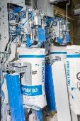
Image 1: For the filling of the hydrated lime, the BEUMER Group supplied a filling machine type BEUMER fillpac R series as an inline filling machine with two filling spouts, turbine technology and sealing of the bag valves.

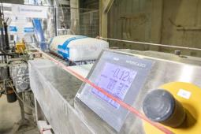
Image 2: The weighing electronics ensures that the BEUMER fillpac always reaches the specified target weight.

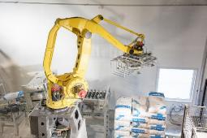
Image 3: The BEUMER robotpac ensures an exact stack configuration.

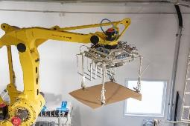
Image 4: The special multi-tool gripper not only picks up bags, but also cardboard boxes and empty pallets.

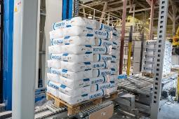
Image 5: The palletised stack is conveyed to the packaging system via a conveyor system.

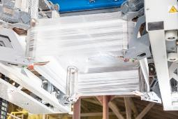
Image 6: The high-capacity BEUMER stretch hood A packaging system covers the palletised goods cost-effectively and secure with a highly stretchable film hood.

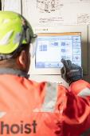
Image 7: Intuitive to operate without the employees having to take off their gloves – the HMI from BEUMER Group
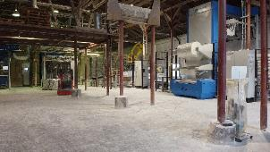
Image 8: Challenge mastered. The old factory hall has numerous columns. However, the new packaging line could be completely integrated very fast.

Picture credits: BEUMER Group GmbH & Co. KG

The high-resolution pictures can be downloaded here.

The BEUMER Group is an international leader in the manufacture of intralogistics systems for conveying, loading, palletising, packaging, sortation, and distribution. With 4,500 employees worldwide, the BEUMER Group has annual sales of about EUR 950 million. BEUMER Group and its subsidiaries and sales agencies provide their customers with high-quality system solutions and an extensive customer support network around the globe and across a wide range of industries, including bulk materials and piece goods, food/non-food, construction, mail order, mail and airport baggage handling. For further information visit www.beumer.com

