BEUMER Group: Loading and transport solutions for ports
Efficient ship loading

A loading and unloading system in a port must be able to handle ships quickly – with minimal dust emissions and without the loss of bulk goods. BEUMER Group provides efficient systems for this purpose, which take into account both different ship sizes as well as the space available at the port. The modular design of the BEUMER Group systems makes it possible to deliver a precisely tailored solution for every requirement.

The right loading technology is crucial for efficient and safe delivery of products to the customers. BEUMER Group offers sophisticated solutions for loading and unloading trucks, railway wagons – and ships. The modular design of the BEUMER systems allows customised solutions for every application. The system provider offers ship loading technology, including quadrant type ship loaders, rail-mounted ship loaders with a luffing and swivelling boom, as well as simple stationary loading towers. All ship loader types can of course be equipped with telescopic chutes.

Coarse bulk materials, such as clinker or lumpy ores, are loaded into bulk carriers efficiently and dust-free with belt conveying systems and a vertical telescopic tube. The loading of powdered goods is handled by fully enclosed loading machines. An emission-free operation is ensured at all times, helping protect the environment.

BEUMER Group has for example installed a ship loader at one of the largest manufacturing plants of urea in Malaysia. This ship loader receives bulk material from belt conveyors and loads ships with up to 1,000 tons of material per hour. The swivel-mounted ship loader runs on rails with a telescopic chute and a throw-off belt conveyor to ensure effective and flexible loading.

1,779 characters incl. spaces

Meta-Title: BEUMER Group provides loading and transport solutions for ports

Meta Description: Ship loaders of BEUMER Group handle ships quickly – without loss of material and with minimal dust emissions

Keywords: BEUMER Group; ship loader; bulk material

Social Media: Loading and unloading machines in ports must be able to handle ships quickly – with minimal dust emissions and without loss of bulk material. We supply efficient systems for this purpose, which take into account both different ship sizes as well as the space available at the port. The modular design of our systems makes it possible to offer a precisely tailored solution for every requirement.

Captions:
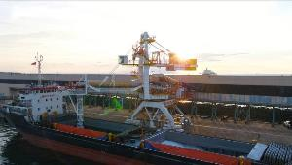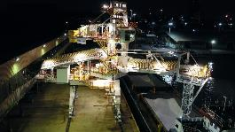
The ship loaders ensure fast and reliable loading of ships in the ports.

Photos: BEUMER Group GmbH & Co.

The high-resolution pictures can be downloaded here.

The BEUMER Group is an international leader in the manufacture of intralogistics systems for conveying, loading, palletising, packaging, sortation, and distribution. With 4,500 employees worldwide, BEUMER Group has annual sales of about EUR 950 million. The BEUMER Group and its group companies and sales agencies provide their customers with high-quality system solutions and an extensive customer support network around the globe and across a wide range of industries, including bulk materials and piece goods, food/non-food, construction, mail order, post, and airport baggage handling. For more information, please visit: www.beumer.com .

