At Long Son Petrochemicals Complex in South of Vietnam, the BEUMER Group is working to ensure high levels of plant availability:

Establishing efficiency and adding value for all parties

BEUMER Group has been entrusted by TTCL Public Company Limited, one of the most experienced EPC contractors in Thailand, to supply complete bagging lines at Long Son Petrochemicals Complex in Vietnam. The supply of three bagging systems for the LLDPE plants include three FFS-filling machines, three high performance palletizer BEUMER paletpac and two packaging machiens BEUMER stretch sood A.

The FFS (form-fill-seal) filling system fulfills three functions in one compact and space-saving system. It forms bags from a prefabricated tubular PE film, fills them with the corresponding product and seals the bags at a capacity of 2,000 bags per hour.

The high performance bag palletizer BEUMER paletpac is best suited for different bagged bulk materials. It is incorporated into high performance packaging lines for gentle and efficient processing sensitive and valuable products as well as products with special flow characteristics. BEUMER Group was also given the task of supplying and installing the BEUMER stretch hood A, a high-performance packaging system at this complex. This machine allows for accurate stacking of packaged items on pallets, allowing for successful transport to the downstream packaging system. It covers the palletised goods with a highly stretchable film. During transshipment and outside storage, the merchandise is protected reliably against environmental influences such as sunlight, dirt and humidity.

The electric power and energy industries in Vietnam are booming and so is the petrochemical industry. The country is therefore becoming an important location for developing the petrochemical complex. LONG SON PETROCHEMICALS COMPANY LIMITED (LSP) will be the first integrated petrochemical complex in the South of Vietnam.

The petrochemical industry requires full attention 24/7, and even the smallest disruption can have far-reaching consequences on profits, reputations and brands. A reliable partner understands its customers’ products and processes inside out and knows how to responsibly handle sensitive, valuable materials. BEUMER Group is happy to take up these challenges, which require innovative thinking and precision engineering.

The project is expected to install in 2020. The aim of this project is to increase the efficiency of the petrochemical complex and guarantee a high level of plant availability as well as create added value for the country.

2,581 characters incl. spaces

Captions:
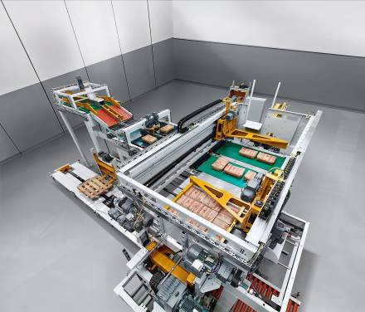
Picture 1: The BEUMER paletpac creates precise, stable, space-saving bag stacks.

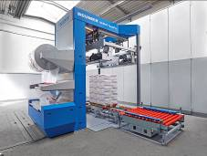
Picture 2: The easy, intuitive and reliable operation of the new BEUMER stretch hood A is especially appealing to customers.
Photo credits: BEUMER Group GmbH & Co. KG

The high-resolution picutres can be downloaded here.

The BEUMER Group is an international leader in the manufacture of intralogistics systems for conveying, loading, palletising, packaging, sortation, and distribution. With 4,500 employees worldwide, the BEUMER Group has annual sales of about EUR 900 million. BEUMER Group and its subsidiaries and sales agencies provide their customers with high-quality system solutions and an extensive customer support network around the globe and across a wide range of industries, including bulk materials and piece goods, food/non-food, construction, mail order, mail and airport baggage handling. For further information visit www.beumer.com.

