BEUMER Group supplies tailored curved belt conveying systems for the mining industry:
Simply overcoming obstacles

In the mining industry, modern cropping technologies require systems capable of transporting bulk materials efficiently from the quarry to their destination, through rough terrain and populated areas. BEUMER Group supplies customised systems such as open troughed belt conveyors and closed Pipe Conveyors. The systems operate quietly and only minimal amounts of dust or exhaust gases are emitted. Compared to trucks they are often more energy-efficient and can be adjusted to the structure of the premises. They are also able to safely handle steep sloping routes, rivers or road crossings. The system provider determines the optimum conveying route, then takes over project planning and installation. BEUMER Group also ensures that the owner remains sustainably competitive - with cost efficiency and comprehensive customer support.

"With our belt conveying systems, we design comprehensive system solutions for the mining and cement industries world-wide", says Dr. Andreas Echelmeyer. The head of the Conveying & Loading Systems sector at BEUMER Group, located in Beckum - Germany, mentions an example: The cement plant of the manufacturer Sichuan Yadong Cement Co., Ltd. is located in the Chinese province of Sichuan, near Pengzhou, some 8,000 kilometres from the BEUMER headquarters. Since 2009, the company uses a 12.7 kilometre-long BEUMER Group overland conveyor, to transport limestone from the quarry to the intermediate bin. The troughed belt conveyor runs through hilly terrain and over rivers and unstable ground. In 2016, in a second project, the system provider installed two more overland conveyors, this time with an overall length of 13.7 kilometres. These overland conveyors transport the limestone to the cement plant. "Unlike with the first order, our task now was to build the conveyor through a populated area", explains the division manager. "No material should be lost during the process and in addition, no dust was allowed to escape; the prescribed level for noise emissions was not to be exceeded."

Reduction of noise emission
The requirements could not have been more different, even for one and the same customer. However, the system provider can optimally adapt the closed Pipe Conveyors and the open troughed belt conveyors to the respective situation. In order to reduce the noise emissions, as required at Sichuan Yadong Cement, we're installing special idlers and low-noise bearings, and select the correct conveying speed for the application", describes Dr. Echelmeyer.
An essential feature of the technology is that it enables horizontal and vertical curves. Angles of inclination of up to 15 degrees are possible, depending on the characteristics of the material to be transported and the topography, with lengths of more than twelve kilometres. Due to the ability to navigate curves, considerably fewer and in some cases no transfer towers are required. This results in substantial cost savings for the customer and the system continuously transports the material even over challenging ascending and descending sections.
The open troughed belt conveyors are particularly suitable for high throughputs. Conveying capacities of up to 10,000 tons/hour are usual.

Using BEUMER calculation programs, a team of experts precisely calculates the static and dynamic tractive forces of the belt during the development phase of the system. This is the prerequisite for the safe dimensioning of the curves. BEUMER engineers select the type of drive technology and conveyor belts needed on the basis of these calculations. This ensures longevity of the entire system.

BEUMER Group has also installed a Pipe Conveyor in the Belgian town of Flémalle. It transports large quantities of fly ash from a former coal-fired power plant to the Maas river, about two kilometres away, for shipment. "We have not only adapted the conveyor to the sections of very steep mountains, but just like Sichuan Yadong Cement, the route runs over public motorways, railways and residential areas," describes Dr. Echelmeyer. "In order for the construction of the plant to be approved at all, we had to ensure that the closed transport would protect the environment from the dry and dusty material. "The fly ash had to be prevented from exiting or falling on the ground, even the smallest quantities." The noise emission played an important role too. In order to minimise the noise to an extremely low level, the experts developed special sound-absorbing elements and used them for example to encase the bridges of the Pipe Conveyor. In addition, special idlers and low-noise bearings were installed.

Taking all aspects into account
"To ensure that our customers remain competitive over a very long period of time, we always dimension our plants and systems as well as the associated production processes with regard to their long-term benefits", says Dr. Echelmeyer. It is important that the user considers not only the overall costs when making investment decisions. Therefore BEUMER Group is committed to evaluating its products comprehensively on the levels of economy, ecology and social responsibility. Usually, the total cost of ownership (TCO) is the primary focus of business activities, therefore defining sustainability solely from an economical perspective. "However we also incorporate ecological and social aspects", the division manager points out. Therefore, we follow a total value of ownership (TVO) approach. This means, we consider the conveying system in its entirety, not only from its cost side". For example we continuously look to reduce energy and resource consumption in the production cycle and in operating the machine, as well as reducing emissions to a minimum.

The energy question: Belt conveyor or trucks?
A comparison with trucks, which are still frequently used for transporting bulk materials over long distances, shows exactly what this means. Depending on the nature of the terrain, they can rapidly reach their limits: they require well-developed roads and fuel, for example and the costs of construction, maintenance and possible extensions are significant. The ecological aspect needs to be considered as well: new roads and access roads have a serious impact on the landscape. And then there's fuel consumption. The emissions caused by truck traffic are high, both with regard to toxic substances and noise and dust," explains Dr. Echelmeyer.

BEUMER Group provides their belt conveyors with environmentally safe electric drives and low-energy belts. Therefore, especially in these times of climate change and increasing greenhouse gas emissions they are considered a preferred option. The installed motors are mostly adjustable which permits the loads to be optimally distributed on the drive units under various operating conditions. If the belt conveying system conveys downhill, the system works in generative operation. The generated electric energy is fed back into the public network by a regenerative feedback unit. This way the owners can further reduce the operational costs of the entire system.

Belt conveyor or trucks? For Sichuan Yadong Cement this question was already posed during the first project, which implied the transport of limestone from the quarry to the intermediate bin. "Depending on the project, the belt conveying systems require up to 90 % less primary energy than comparable truck transports", confirms BEUMER expert Echelmeyer and refers to the concrete project-related comparison. Trucks operated with diesel fuel require a specific primary energy of 11.4 kwh for each ton of transported material. The belt conveying system which was built later on required on the contrary only 1.44 kwh. If, as in this case, 7.5 million tons of raw material are transported annually, the use of belt conveyors means a total saving of 74 million kwh per year. This corresponds to a yearly energy consumption of more than 20,000 single-family houses. This can be noticed also from a monetary viewpoint: solely by saving diesel fuel, the operational costs of the company are reduced by more than 5.5 million Euro per year.

Complex and curved
TVO also means transport route optimization. This can become very challenging when dimensioning the belt conveying system, depending on the terrain conditions. Dr. Echelmeyer's team was asked for example to design and supply an overland conveyor in Indonesia to transport clinker from the quarry to the cement plant. "The line ran through the rain forest, and the topography made it very challenging, remembers Dr. Echelmeyer. The team developed and compared different route options. "The very long land corridor in particular required highly complex planning." The team has to assess and evaluate the project properly before making a concrete offer. There is usually very little time to do this, not enough to send out an entire expedition crew. An effective alternative are aerial photographs that are evaluated with the right software on the basis of topographical data. This means that drones are becoming an increasingly important tool for BEUMER Group.

Drones – little helpers in the air
Using unmanned aerial vehicles on sites or quarries? That might sound futuristic- but it's not. "They are already part of our everyday work routine when planning, executing and documenting construction projects," the BEUMER expert reveals. And the significance of these aerial vehicles is increasing. The technology is becoming more and more sophisticated and easier to operate. They can be used quickly, without much preparation, in difficult-to-access areas and on building sites, without obstructing traffic or hindering operation. "We used a drone for example for the project in Flémalle, Belgium," reports Dr. Echelmeyer. "So we were able monitor the entire progress of the construction process."

BEUMER Group has been using drone technology for about three years now. There are two different designs. The functionality and features of copters are similar to those of helicopters. Their rotors keep them hovering in the air. Fixed-wing aircrafts, on the other hand, are more like aeroplanes. They also have a higher range. Once in operation, they are constantly moving. Copters are particularly suitable for narrow take-off and landing areas or when they have to perform at low speed. They mainly fly over medium-sized and small building sites. In addition, they are used for quarry faces in quarries and construction inspections such as lower sides of bridges. BEUMER Group opted for a copter that the team uses to work on specific projects.

From the PC in the air – and back
The employees can plan the route from their computer. They calculate the exact flight path by using the specialised software. Then, the drone flies its pre-determined route. Smartphones and tablets can also be used to control the drone.

The recorded aerial photos are corrected with regard to their perspective and evaluated photogrammetrically. The software calculates a point cloud in order to generate 3D models from the two-dimensional views, i. e. digital terrain models.

Long-term and strategic client partnerships
With BEUMER Group, the customer receives everything from one single source, starting with the query to technical dimensioning and the installation on site. If desired, the system supplier continues to support the operator with its comprehensive range of services, after the conveying system is in operation, to ensure high levels of machine availability during the entire running time. This is ensured by the BEUMER customer support with its more than 1,000 employees world-wide. "We offer various solutions," explains Dr. Echelmeyer. "They are matched individually to the respective needs of the customer, including service intervals and response times as agreed by contract." In the event of a system standstill, qualified Customer Support technicians arrive quickly on site to prevent long downtimes. Customer Support offers around-the-clock telephone support every day of the year, helping to further reduce downtime to a minimum. The technicians perform remote analyses, indicate corrective measures and offer quick and reliable solutions to correct malfunctions.

Meta title: BEUMER Group supplies tailored curved belt conveying systems for the mining industry

Meta description: The system supplier uses troughed belt conveyors and Pipe Conveyors to offer comprehensive solutions for the mining and cement industries world-wide.

Keywords: BEUMER Group; Pipe Conveyor; overland conveyor; troughed belt conveyor; bulk material; mining industry; cement

Facebook: In the mining industry modern cropping technologies require systems capable of transporting bulk materials efficiently from the quarry to the destination, through rough terrain or populated areas. We supply individual systems as open troughed belt conveyors and closed Pipe Conveyors. They operate quietly without dust and exhaust emissions. Compared to trucks they are more energy-efficiently and can be adjusted to the structure of the premises. We determine the optimum conveying route, and take over project planning and installation. We also ensure that the owner remains sustainably competitive - with cost efficiency and comprehensive customer support.

Twitter: BEUMER Group uses #troughed belt conveyors and #Pipe Conveyors to offer comprehensive solutions for #mining and #cement industries world-wide.

Xing: BEUMER Group supplies customised systems such as open troughed belt conveyors and closed Pipe Conveyors to transport bulk material from the quarry to its destination, through rough terrain or populated areas. The system provider determines the optimum conveying route, takes over project planning and installation.

14,447 characters (incl. spaces)

Captions:

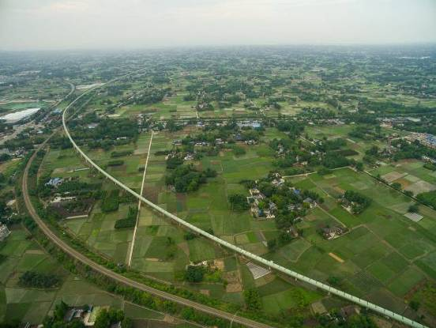

Picture 1: Project Sichuan: BEUMER Group built a 12.7 long conveyor through hilly terrain and unstable ground. It is complemented by an additional, smooth running system with a length of 13.7 kilometres.

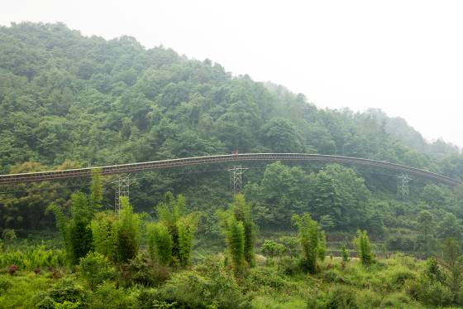
Picture 2: Sichuan project: whenever technically possible, the routing of the conveyor has been adapted to the topography.
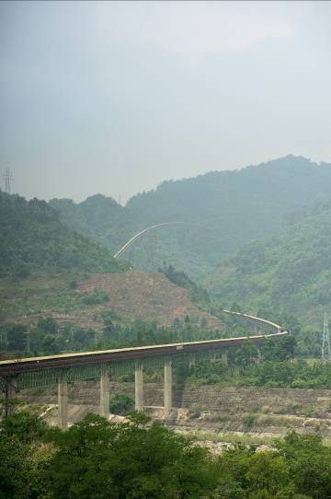
Picture 3: Sichuan project: The troughed belt conveyor runs through rough terrain and over instable ground.
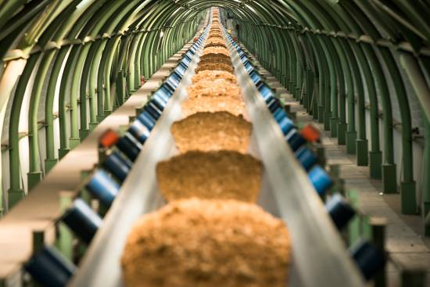
Picture 4: Sichuan project: View of the enclosed conveyor flight in the area of the bridge

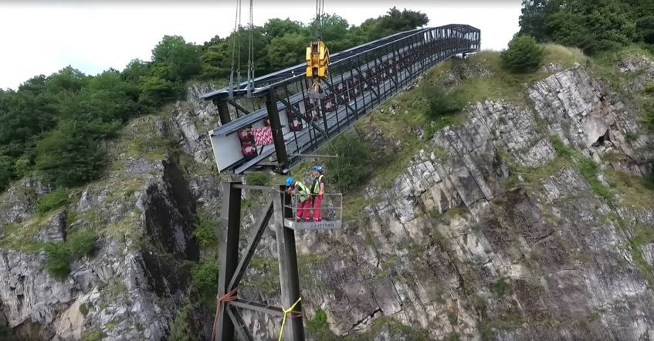
Picture 5: Flémalle project: The technicians are mounting the suspended elements of the conveyor to the steel structure. Cranes are used to exactly manoeuvre the assembly.

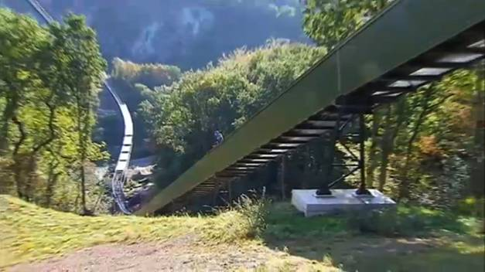
Picture 6: Project Flémalle: The line runs across country, over steep rocks. The Pipe Conveyor navigates easily over these inclines and gradients.
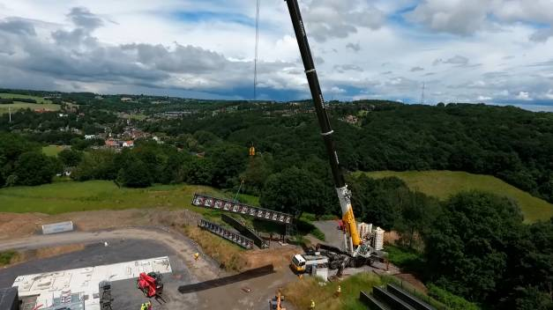
Picture 7: Flémalle project: The assembly work was demanding for BEUMER Group.

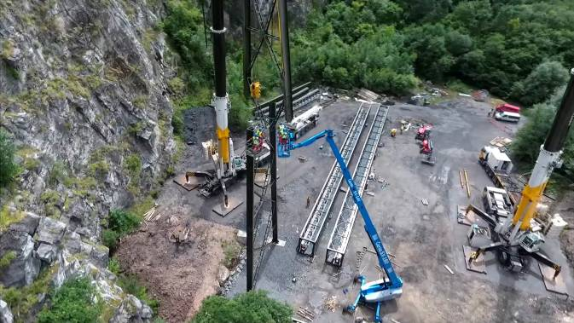
Picture 8: Flémalle project: Assembly work was continuously monitored by drones.

Photo credits: BEUMER Group GmbH & Co. KG

You can download the high-resolution pictures under the following link:

BEUMER Group is an international leader in the manufacture of intralogistics systems for conveying, loading, palletising, packaging, sortation, and distribution. With 4,200 employees worldwide, the BEUMER Group has annual sales of about EUR 770 million. The BEUMER Group and its group companies and sales agencies provide their customers with high-quality system solutions and an extensive customer support network around the globe and across a wide range of industries, including bulk materials and piece goods, food/non-food, construction, mail order, post, and airport baggage handling. For further information visit www.beumergroup.com

If you no longer want to receive press releases from BEUMER Group, please UNSUBSCRIBE here.

