Davert opts for BEUMER stretch hood A for packaging its palletised organic products:
A healthy batch of safety

Davert GmbH specialises in organic foods and stands for the continuous further development of processing methods and careful monitoring of these products, from cultivation to packaging. And this is where BEUMER Group comes in. The finished, high quality organic products like rice, legumes and cereal products like sugar, dried fruit, nuts, oilseeds and sprouting seeds must be protected from dust and pests during storage and then transported without damage to drug and health food stores. The system supplier provided the BEUMER stretch hood A for this task. It covers the mixed pallets of bags, cartons and buckets with a highly elastic stretch film, protecting them against external influences, keeping the merchandise secured during transport, even through sudden braking.

Healthy and sustainable nutrition plays an increasingly important role to consumers. Not only because it tastes better and is good for you, but also because consumers are taking a more critical look and want transparency when it comes to the production and processing of their food. Organic supermarkets and health food stores respond to these demands. Davert GmbH is a trading and manufacturing company for high-quality organic products. The company with its 150 employees is based in Ascheberg, in the southern Münster region, right next to the eponymous nature reserve Davert. "With our guarantee of origin, we are committed to fair trade and long-term business relationships world-wide," says Erwin Tenbrink, Technical Director at Davert. The company acts as a consultant for its partners when it comes to product selection and cultivation and coordinates infrastructure projects. For its customers, Davert follows a multi-channel strategy: the merchandise is sold via their own online shop and in in selected drugstores and health food retailers.

Cleanliness has the highest priority
"We are ensuring the highest degree of cleanliness to meet our strict quality standards," explains Tenbrink. Before being shipped out, the legumes, rice etc. have undergone special quality controls. The employees examine the incoming raw products and set up the required cleaning steps. In one mill for example, air flow from the aspiration channel removes stalk remnants, husks and dust from the cereal. Different sized grains are seperated using screens. Weed seeds and light particles like defective grains are also weeded out by the system, an optoelectronic sorter removes the foreign particles. "Another preventive measure is the pressure treatment that we use to prevent any pest infestation from the start," reports Tenbrink. "The sudden pressure release kills off any pests like bugs, moths or mites and their larvae and eggs, without compromising the quality of the product in any way."

In compliance with the quality assurance process, employees pack the merchandise in a variety of ways, depending on the product: rice, flour, linseed and grains are packed into bags, larger storage quantities into big bags. Packaged legumes, nuts, dried fruit and muesli is filled into boxes, honey into buckets. Depending on the store order, the team stacks the various unit loads onto mixed pallets. "Up to this point in the process, we assign the highest priority to cleanliness," explains Tenbrink: "And now it is just as important to keep this level of cleanliness and protect the products from dust and pests during storage in our high-rack warehouse." The units also have to be loaded safely onto the back of the trucks and reach the distributor without any damage. This is where the packaging comes into play.

Reliable and powerful packaging system
The managers were looking for a solution that could meet all these requirements, ensuring fast and reliable operation, high levels of availability, easy maintenance, and a small footprint. They found BEUMER Group. The single-source provider for filling, palletising and packaging technology delivered the BEUMER stretch hood A high-capacity packaging system. "The machine is very easy and safe to operate," describes Volker Feldmeyer, sales engineer at BEUMER Group and responsible for the project at Davert. "In order to make work easier for the maintenance personnel, which also means higher levels of availability, the machine does not require any platform." Maintenance work, such as changing the blades or the sealing bars, is handled at floor level. The operator simply opens a drawer, providing free access. Additional benefits include the compact design and the resulting low height and small footprint.

A film transport system, which is particularly gentle on the material, introduces the previously cut and sealed film hood into the system. On its way to the crimping and stretching unit, the sealing seam on the film hood cools down so that it can be crimped without losing time. Energy-consuming cooling units and delayed cooling times become obsolete. This means that the pallets can be packed in a shorter cycle time. Economical engines and a lower demand in compressed air optimise the energy balance. Environmental considerations are also important to Davert. In order to save resources and produce minimum waste, the company opted for this type of film wrapping. The palletised goods are also clearly visible through the smooth surface of the transparent, highly flexible film. The wrapping protects the merchandise against atmospheric influences and humidity, and ensures an aesthetic appearance on the shop floors. "The elastic film also increases the safety during transport considerably," describes Feldmeyer. At Davert, the BEUMER stretch hood A packages the pallets for high-bay storage systems: the pallet base remains unwrapped, so that the forks of the fork-lift truck won't damage the film. This prevents any remaining film from interfering during the contour check before the pallet is stored in the high-rack system.

Easily operated
The system supplier has introduced the BEUMER Group Human Machine Interface (HMI). This newly-developed operator panel with an optimised user interface and graphical navigation for operating the system offers an even more ergonomic workflow to the user. This easily understandable and intuitive interaction concept helps to define efficient working sequences. "The soft-touch panel uses pictograms to guide the user through the menu of the Siemens SIMATIC S7 machine control," explains Feldmeyer. ""The panel also gives the operator access to all required training programs and content."

"We implemented this project in close cooperation with BEUMER Group," Erwin Tenbrink is happy to report. He is entirely convinced of the great technical cooperation during the planning and installation of the system. One important aspect for him is reliable customer support, as even this high-quality machine needs maintenance and service. "If necessary, we send our service personnel to the plant to check the system and perform any required adjustments," Feldmeyer promises. "This way we can ensure high-levels of availability at any time."

7,113 characters (incl. spaces)

Meta title: BEUMER Group pallet packaging protects organic products at Davert

Meta description: The system supplier installed the BEUMER stretch hood to protect the organic products against dust and pests and to ensure that they are safely transported to the customer.

Keywords: Davert BEUMER Group Customer support BEUMER-stretch-hood Organic products Transport safety Storage in high-bay warehouses Pallet packaging

Captions:
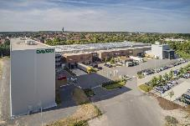
Photo 1: Davert GmbH is a German manufacturer and distributor of high-quality organic products. With 150 employees, the company is based in Ascheberg, in the Münsterland region.

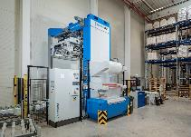
Photo 2: Davert opts for the BEUMER stretch hood A packaging system to protect the organic products against dust and pests.

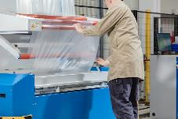
Photo 3: The machine is easy and safe to operate. No platform is required.

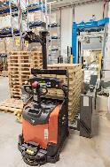
Photo 4: A fork-lift truck places the palletised merchandise on a roller conveyor, …

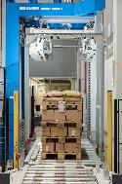
Photo 5: … on which they are transported to the packaging system.

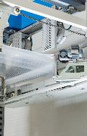
Photo 6: The pallets are packaged in short cycle times. The machine covers the products with a highly elastic stretch hood.

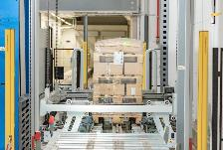
Photo 7: The merchandise remains clearly visible through the smooth film surface. It protects against atmospheric influences and humidity, and ensures an aesthetic appearance on the shop floors.

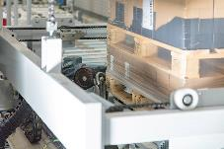
Photo 8: The BEUMER stretch hood A packages the pallets for high-bay storage systems: the pallet base remains unwrapped, so that the forks of the fork-lift truck won't damage the film.

Picture credits: BEUMER Group GmbH & Co. KG

The high-resolution picutres can be downloaded here.

The BEUMER Group is an international leader in the manufacture of intralogistics systems for conveying, loading, palletising, packaging, sortation, and distribution. With 4,500 employees worldwide, the BEUMER Group has annual sales of about EUR 900 million. BEUMER Group and its subsidiaries and sales agencies provide their customers with high-quality system solutions and an extensive customer support network around the globe and across a wide range of industries, including bulk materials and piece goods, food/non-food, construction, mail order, mail and airport baggage handling. For further information visit
www.beumer.com.

If you no longer want to receive press releases from BEUMER Group please reply with UNSUBSCRIBE.

