BEUMER Group supplies entire packaging lines tailor-made for each customer from one single source:
The right packaging

BEUMER Group supplies packaging lines and complementing intralogistics solutions customised to its users and their requirements from one single source. Serving the cement, construction and chemical industries, consumer goods market and logistics sector, the extensive product range features modular designs. One of its customers is the German retail store dm-drogerie markt GmbH & Co. KG, with its logistics centre in Weilerswist near Cologne.

When BEUMER Group installs packaging lines in the (petro)chemical industry, the process may resemble this: bulk materials from the chemical industry are transported from the silo via a conveyor line to the form fill seal system BEUMER fillpac FFS. This highly efficient filling machine forms a ready-made PE tubular film into a bag and fills it with the customer's engineering plastics such as PE, PP, PA or PS granules. Reliable, gentle and sustainable filling is also possible for salts or fertilisers. The bags are then weighed before the filling process. For this, the BEUMER fillpac FSS is equipped with an electronic calibration-capable weighing unit. It ensures that the system fills the bags with a constant quantity of material within the specified tolerances. Then the system seals the bags with a weight of up to 25 kg. It can process 2,600 bags per hour.

For the efficient filling of paper bags with bulk material, particularly cement and construction materials, the system provider offers the BEUMER fillpac R. These systems function reliably, carefully and sustainably while meeting the required throughput. The construction series is equipped with a special weighing unit as well. Depending on the requirements and on the material characteristics such as bulk density, grain size, material density or flow behaviour, BEUMER Group can offer both air and impeller filling machines from the construction series BEUMER fillpac R. The air filling machines are suitable for bagging pourable and coarse-grained products with particle sizes up to ten millimetres, whereas the impeller technology is suited for free flowing and fine-grained products like cement or gypsum. Adding the BEUMER bag placer and a ream magazine to the system makes the filling even more efficient.
Proper and stable stacks on pallets
The filled bags, which are made of different materials like paper, PE or PP and have different sizes, weights and designs (flat valve bags or valve bottom bags), have to be stacked on pallets in a stable and precise way. For this, BEUMER Group offers the BEUMER paletpac. It can be quickly assembled thanks to its modular design, is easily accessible for maintenance, can be operated intuitively and flexibly adapted to different packing patterns. Depending on the product requirements, the BEUMER paletpac can be equipped with a clamp-type or twin-belt turning device which positions the bags smoothly, quickly and exactly. For palletising cartons, boxes, canisters or trays, BEUMER Group offers the BEUMER robotpac. This space-saving, fully automatic articulated robot solves complex palletising and de-palletising challenges reliably and efficiently. The user receives gripping systems suitable for all types of packaged goods, which can be easily exchanged.

Reliable packaging of dm drugstore products
The BEUMER stretch hood high capacity packaging system is at the heart of the packaging lines. It covers the mixed pallet of merchandise with a highly elastic film hood. This can be filled and palletised bags, boxes of detergent, buckets of paint or storage jars. During transshipment and outside storage, the merchandise is protected reliably against environmental influences such as sunlight, dirt and humidity. This is important for the operators who need their products to be transported reliably and in perfect condition to the customers, products like those from dm-drogerie markt GmbH & Co. KG.

The drugstore chain has its own distribution centres, one in Waghäusel in the south-western state of Baden-Württemberg, and one in Weilerswist near Cologne in North Rhine-Westphalia. Here, the employees pre-package cardboard goods for the stores. In Weilerswist, there is also the so-called small parts distribution centre. Here, small and individual products that cannot be securely stored on pallets are packaged in containers and cardboard boxes, and then commissioned, palletised and shipped. Both distribution centres have a combined product range of 12,800 items.
Secure pallet protection
Up to 3,000 pallets of goods arrive in Weilerswist daily. They are registered and checked. They are then transported over a conveyor line to two fully automated high-bay storage facilities. Empty pallets move along 42 aisles on overhead tracks and automated guided vehicle systems. A light signal indicates which product, and how many, are to be placed on the pallet. The merchandise must be secured and protected, so that it arrives at the dm stores in perfect condition. Therefore, high demands are placed on the packaging systems. Two high-capacity BEUMER stretch hood machines are in operation. They package 90 pallets each per hour, but are designed for 100 pallets. Lorries bring the shops their goods approximately 72 hours after ordering.

Playing with colours
The systems run perfectly. The smooth surface of the film hood increases the visibility of the palletised merchandise and the BEUMER stretch hood provides considerably higher levels of availability compared to stretch wrappers; another bonus: they have more colours than other packaging systems. At dm's request, they were painted in several colours. So they fit in the coherent colour scheme of the entire distribution centre: the basic colours yellow, orange, blue and purple run through the entire design. The unique design was created by STOLLSTEINERart&business. The idea behind it is that the colours signal to the employees that all working steps are interlinked.

Like a second skin
Another solution for protecting the bags against environmental factors is the BEUMER bag-in-bag: This system packages one or several filled paper bags quickly and reliably with a weather-resistant plastic film. This ensures that the contents are perfectly protected against moisture, dust or insect infestation when they are transported or stored.
Furthermore, the system provider equips all systems of a line with the same Human Machine Interface (HMI). This operator panel provides users with an easily understandable and intuitive interaction concept, enabling them to define efficient working sequences.
And there is more at the end of this packaging line: With system solutions of BEUMER Group, the full pallets or individual bags can be forwarded to a connected warehouse or directly to the loading space of a truck. The system components are mainly transport technologies such as conveyors or vehicle-based systems. Various solutions for handling and manipulators such as robots, buffer and storage modules are available as well. As BEUMER Group always uses components from a modular system, the solutions can be expanded at any time and can grow with the customer's needs.

Software based on modular design
For best results and to ensure full material and data tracking, the filling, palletising and packaging components as well as other system components must be perfectly matched. For this, BEUMER Group has developed the modular BG Software Suite as superior data processing system. It can be adapted individually to particular tasks and products from other companies can be easily integrated. Users can extend this solution at any time and optimise their material flows. The cross-program user interface BG Fusion shows process data and reports. All available data can be accessed without having to switch between different applications.

With the BEUMER Group warehouse control system the BG Software Suite can be easily connected to the warehouse management system or the customer's ERP solution. This way, BEUMER Group ensures the communication between the different control levels for the user. BEUMER can create an intelligent connection between the individual systems, and integrate them into existing process and inventory control systems of the customer.

Online data access at any time
BEUMER Group has developed the new Operation Monitoring app. With this application for mobile devices such as smartphones or tablets, the user or the management has an overview on all relevant key figures of the complete packaging line or individual systems. The app shows the status quo of availability, performance and quality levels as well as the energy and compressed-air consumption. This ensures efficient operation of all systems. Customers can adopt the program to their specific requirements. For a better organisation and control of their logistics value chain, the task is to integrate all participants, systems, machines, and products in one dynamic system – horizontally and vertically. Thanks to this increasing networking, highly linked system structures are possible, in line with the ideas of Industry 4.0.

9,157 characters (incl. spaces)

Meta title: BEUMER Group supplies entire packaging lines tailor-made for the customer

Meta description: BEUMER Group provides different industries with packaging lines and complementing intralogistics solutions from one single source.

Keywords: Packaging line filling palletizing packaging chemical petrochemical building materials intralogistic solutions BEUMER fillpac FFS BEUMER fillpac R BEUMER bag placer BEUMER paletpac clamp-type turning device twin-belt turning device BEUMER stretch hood BEUMER bag-in-bag Customer Support

Captions:
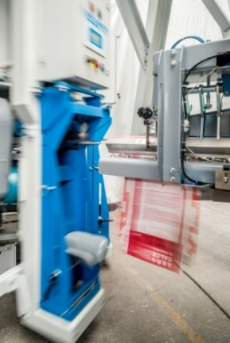
Picture 1: The BEUMER bag placer applies the valve bag with precision on one of the filling spouts of the BEUMER fillpac R.

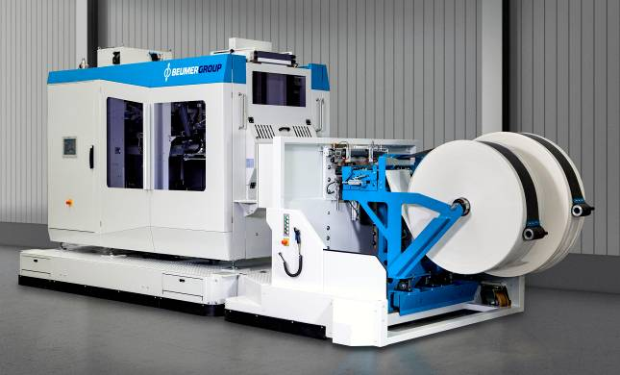
Picture 2: BEUMER fillpac FFS: high throughput, availability and a compact design are key features of the new system.

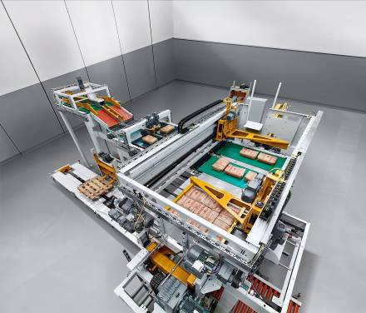
Picture 3: The BEUMER paletpac creates exact, stable, space-saving bag stacks.
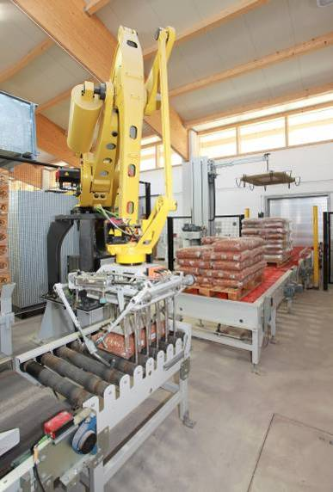
Picture 4: The BEUMER robotpac series palletises and depalletises a wide variety of packaged goods with specially designed gripping systems.

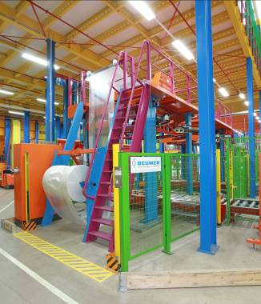
Picture 5: The BEUMER stretch hood high-capacity packaging systems at dm convince with their performance and their unique colour scheme.

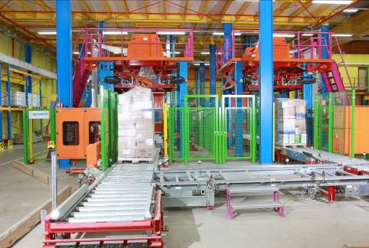

Picture 6: The packaged products are protected reliably against environmental factors, dust and humidity.
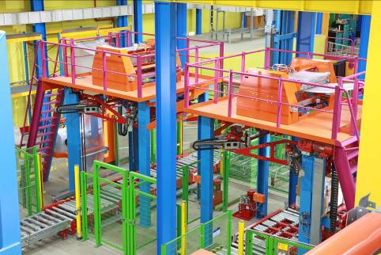

Picture 7: Painted in yellow, orange, green, blue and purple: the systems fit in perfectly with the colour scheme of the entire distribution centre.

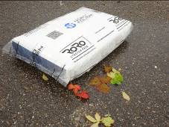
Picture 8: The BEUMER bag-in-bag packages one or several filled paper bags quickly and reliably in a weather-resistant plastic film.

Picture credits: BEUMER Group GmbH & Co. KG
You can download the high-res pictures here: http://newcloud.a1kommunikation.de/index.php/s/X6y6DXXbmkcS20e

The BEUMER Group is an international leader in the manufacture of intralogistics systems for conveying, loading, palletising, packaging, sortation, and distribution. With 4,200 employees worldwide, the BEUMER Group has annual sales of about EUR 770 million. The BEUMER Group and its group companies and sales agencies provide their customers with high-quality system solutions and an extensive customer support network around the globe and across a wide range of industries, including bulk materials and piece goods, food/non-food, construction, mail order, post, and airport baggage handling. For further information visit www.beumergroup.com

