BEUMER Group at bauma 2019:
Reliable across rough terrain

At bauma, which will take place in Munich from 8 to 14 April, BEUMER Group will provide information on their efficient transport solutions for the mining industry, among other areas. Overland conveyors and Pipe Conveyors transport various raw materials over long distances and often through rough terrain. This is generally faster, more cost-efficient and environmentally friendly than trucking. The system supplier also offers comprehensive technology for the cement and building materials industries and is the only supplier to provide complete packaging lines from a single source – from filling and palletising to transport packaging of the pallet.

The overland conveyors and Pipe Conveyors of BEUMER Group can be used by companies in the mining industry to transport various bulk materials, even over long distances and often through rough terrain. High angles of inclination and tight curve radii enable individual routing adapted to the respective task and topography. BEUMER Group relies on camera-equipped drones for the planning, projection, implementation and documentation of these systems. Using special software solutions, the system supplier evaluates the aerial photographs photogrammetrically to generate digital terrain models.

The product range of the system supplier includes stackers and bridge reclaimers for storage yards, whether with or without blending bed systems. These stack bulk material and guarantee a maximum blending effect. Users can also efficiently homogenise large quantities of different bulk materials and bulk material qualities and thus ensure the uniformity of the raw materials used. For efficient loading, BEUMER Group supplies ship loaders with fixed booms and extendable telescopic belt conveyors, as well as bulk loading heads, which are used to load bulk materials into silo vehicles quickly and without dust.

BEUMER Group will present economic solutions for companies from both the cement and building materials industries at the trade fair. In cement plants, clinker with temperatures of 500 to 800 degrees is transported from the kiln cooling system to the silos. With its belt apron conveyors, BEUMER Group offers robust solutions for efficient transport. A belt instead of a chain as the traction element allows higher speeds and a slimmer design while still delivering the same level of performance. These conveyors are therefore particularly suitable for modernisations.

When it comes to filling, palletising and packaging cement, BEUMER Group offers complete packaging lines from a single source - a unique selling point in this industry. The system supplier offers the BEUMER fillpac filling machine for different requirements in various versions. The unique feature of this filling technology is that it can handle a wide range of materials, from very fine to coarse structures. In addition, various palletising solutions and a high-performance packaging system with sophisticated features are available.

Against the background of the global climate debate, the use of so-called alternative fuels and raw materials (AFR) in the energy-intensive cement production is steadily increasing. BEUMER Group offers tailor-made systems for the entire material flow chain in cement plants - from receiving and unloading the delivery vehicle to storing, sampling, conveying and dosing the solid alternative fuels.

BEUMER at bauma: hall B2, booth 413

3,447 characters (incl. spaces)

Meta-Title: bauma 2019: BEUMER Group offers efficient transport solutions for the mining industry

Meta-Description: Overland conveyors and Pipe Conveyors transport, for example, coal or ores over long distances and often across rough terrain.

Keywords: BEUMER Group; bauma 2019; fillpac; paletpac; robotpac; stretch hood; Pipe Conveyor; overland conveyor; bulk material; belt apron conveyor; AFR; blending beds; mining; loading technology; packaging lines; single-source provider; cement

SocialMedia: At bauma (8 to 14 April in Munich), BEUMER Group will provide information on efficient transport solutions for the mining industry in hall B2, booth 413. Overland conveyors and Pipe Conveyors transport, for example, coal or ores over long distances and often through rough terrain. This is generally faster, more cost-efficient and environmentally friendly than trucking.

Captions:
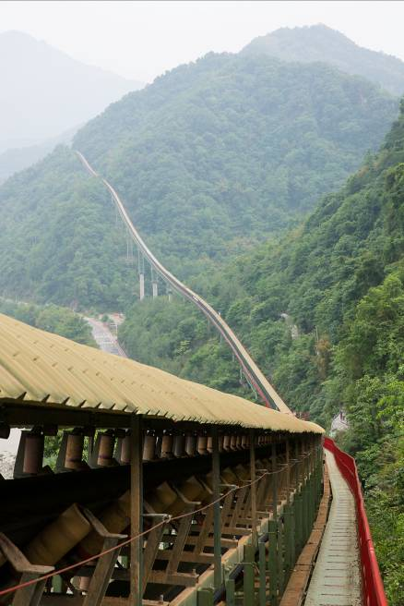
Photo 1: Overland conveyors often run through rough terrain and over unstable ground.

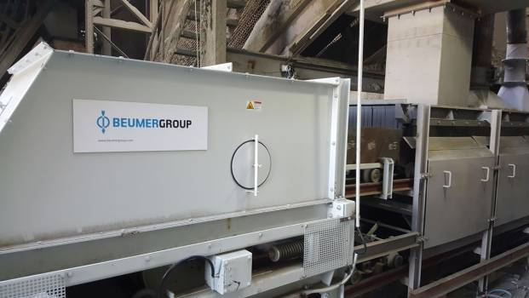
Photo 2: BEUMER Group provides cement manufacturers with belt apron conveyors for the transport of hot clinker.

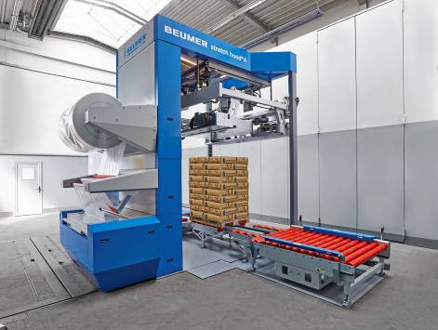
Photo 3: The BEUMER stretch hood covers full pallets with a thin film hood. This ensures that the packaged products reach their destination undamaged and are well protected against moisture and weather influences.
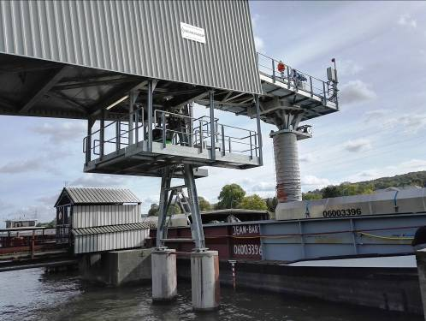
Photo 4: With loading systems from BEUMER Group, the bulk material is safely transferred into the ship's cargo hold.

Picture credits: BEUMER Group GmbH & Co. KG

BEUMER Group is an international leader in the manufacture of intralogistics systems for conveying, loading, palletising, packaging, sortation, and distribution. With 4,200 employees worldwide, the BEUMER Group has annual sales of about EUR 770 million. The BEUMER Group and its group companies and sales agencies provide their customers with high-quality system solutions and an extensive customer support network around the globe and across a wide range of industries, including bulk materials and piece goods, food/non-food, construction, mail order, post, and airport baggage handling. For further information visit www.beumergroup.com

