BEUMER Group at POWTECH 2019:
Secure packaging

BEUMER Group will exhibit its expertise as a system provider for complete high-capacity packaging lines at POWTECH 2019 in Nuremberg from April 9 – 11, hall 1, booth 627. BEUMER Group optimizes the performance of each machine, its components and the high-level controls to ensure high throughput of the lines for (petro)chemical products and building materials.

The behaviour of powders and bulk material can change entirely according to operating conditions, handling methods and the intended use, whether it is for (petro)chemical products or building materials. This impacts the flow behaviour, which has a considerable influence on how to optimally design the conveying, filling, palletising and packaging systems. BEUMER Group designs, constructs and installs systems that are tailored in detail to industry-specific requirements.

The BEUMER fillpac R filling machine fills bulk material from the building materials industry and other industrial pulverized goods into different bag sizes and types like valve bottom and flat valve bags in an efficient and gentle way and with the required throughput. The structure of the materials can be very fine to very coarse. The BEUMER bag placer and the ream magazine supply the rotary filling machine with empty bags to ensure the high throughput. The highly efficient form fill seal system BEUMER fillpac FFS is used in the chemical and petrochemical industries. It forms bags from a prefabricated tubular PE film and fills them with the product. The customers can select the optimal machine performance class from this product family depending on their requirements.

BEUMER Group offers different palletising solutions, depending on the packaged items. The BEUMER paletpac is suited best for bulk material. It is incorporated into high-performance packaging lines to process even sensitive and valuable products as well as products with special flow characteristics in a gentle and efficient manner. Depending on the product requirements, these palletisers can be equipped with a clamp-type or twin-belt turning device which turns the filled bags quickly into the required position for stacking, ensuring their dimensional stability without any deformations.

Products for the (petro)chemical industries are filled in special bags, barrels, canisters, cartons or buckets. To palletise them, BEUMER Group offers its space-saving articulated robot, the BEUMER robotpac. Depending on the packaged items, BEUMER Group equips the robot with the appropriate gripping tools which can be easily and automatically changed, if the packaged items change. The fork gripper for example was designed specifically for palletising cardboard boxes, the finger gripper for bagged goods. For maximum performance, BEUMER Group offers a double gripper for both types. They also offer parallel grippers for dimensionally stable packed items, suction grippers for items with a smooth surface and many other special grippers and combination tools.

Packaged items stacked accurately on pallets can then be transported successfully to the downstream packaging system – for example, the BEUMER stretch hood. It covers the palletised goods with a highly stretchable film. During transshipment and outside storage, the merchandise is protected reliably against environmental influences such as sunlight, dirt and humidity.

BEUMER at the POWTECH 2019, hall 1, booth 627

3,427 characters incl. blanks

Meta title: POWTECH 2019: BEUMER Group exhibits its high level of expertise in providing packaging lines from one single source.

Meta description: BEUMER Group as a single-source provider optimizes the performance of each machine and components, whether it is for chemical products or building materials.
Keywords: BEUMER Group; POWTECH 2019; BEUMER fillpac; BEUMER FFS; BEUMER paletpac; BEUMER robotpac; BEUMER stretch hood; bulk material; chemicals; building materials; single-source provider

SocialMedia: BEUMER Group will exhibit its expertise as a system provider for complete high-capacity packaging lines at POWTECH in Nuremberg from April 9 – 11, in hall 1, booth 627. BEUMER Group as a single-source provider optimizes the performance of each machine, its components and the high level control to ensure high throughput of the lines, whether it is for chemical products or building materials. The customer receives a complete line with optimum throughput.

Captions:
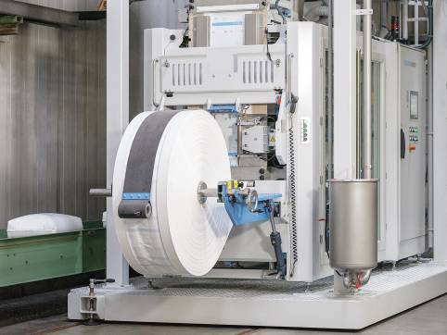
Picture 1: BEUMER fillpac FFS: High throughput, availability and a compact design are key features of the system.

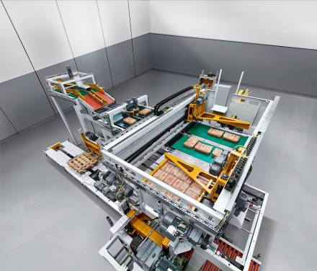
Picture 2: The BEUMER paletpac creates exact, stable, space-saving bag stacks.

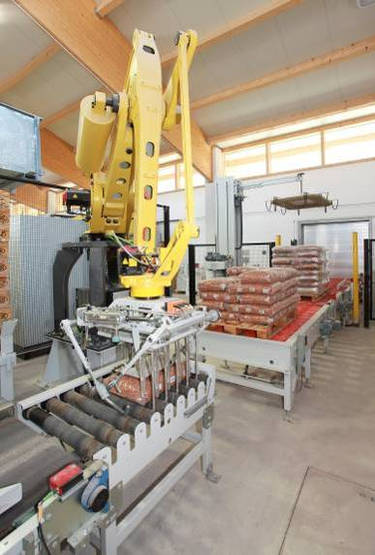
Picture 3: The BEUMER robotpac series palletises and depalletises a wide variety of packaged goods with specially designed gripping systems.

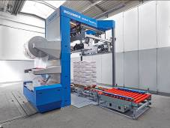
Picture 4: The easy, intuitive and reliable operation of the new BEUMER stretch hood A is especially appealing to customers.
Photo credits: BEUMER Group GmbH & Co. KG
BEUMER Group is an international leader in the manufacture of intralogistics systems for conveying, loading, palletising, packaging, sortation, and distribution. With 4,200 employees worldwide, the BEUMER Group has annual sales of about EUR 770 million. The BEUMER Group and its group companies and sales agencies provide their customers with high-quality system solutions and an extensive customer support network around the globe and across a wide range of industries, including bulk materials and piece goods, food/non-food, construction, mail order, post, and airport baggage handling. For further information visit www.beumergroup.com

